NASA COLLEGE SCHOLARSHIP FUND, INC.
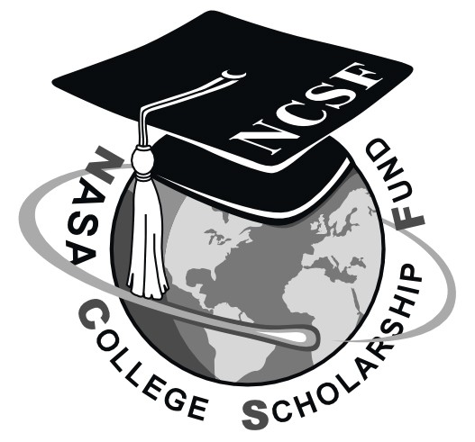
NASA Johnson Space Center
Mail Code: AH, Building 1, Room 970
2101 NASA Parkway
Houston, TX 77058

Application deadline is March 31, 2022.

Applications must be received electronically by the deadline.

Email to jsc-nasa-college-scholarship@mail.nasa.gov.

Applicant’s name: __________________________________________________________________

High school grade point average: ___________________out of_______________________________

College grade point average: ______________________out of________________________________

Number of high school credits: _________________________________________________________

Number of college hours, if any: ________________________________________________________

Date of high school graduation: _________________________________________________________

What field of study does applicant plan to pursue? __________________________________________

Complete the following checklist and include it with your package:
- Completed Page 1
- Completed sponsor information sheet. (Page 3)
- Completed and signed verification sheet (Page 4)
- Honors/advanced school courses: Listing of honor, premium, or advanced courses and semester credit hours earned.
- High school/College special recognition: In descending order of importance, list any special recognition applicant received for excellence in high school or college work, such as honors, prizes, or scholarships.
Extracurricular Activities:
- School activities: In descending order of importance, list extra-curricular school activities in which applicant participated while in high school or college, such as publications, debating, dramatics, club work, musical organizations, student government, or athletics. Please note if you served as an officer or captain in any activity.
- Out-of-school activities: In descending order of importance, list out-of-school activities in which applicant participated.
- Tell why you are motivated to attend college and how you hope to utilize your degree after you graduate. (Limit to approximately 300 words.)
- Recommendation Letters: Provide 3 electronic recommendation letters from instructors or other knowledgeable individuals not related to the applicant (1 page, letter size) to jsc-nasa-college-scholarship@mail.nasa.gov. To help with our application redaction process, please avoid any text references to gender (he/she), school name, or other personal geographic identification in the letters. Examples of references are school counselors, teachers, and community leaders. Their statement should recommend you for our merit scholarship and briefly state why they believe you should be selected. Recommendation letters should include the author’s name, address, phone number, and email address.
- A copy of all high school and college (if any) official transcripts. If the high school or college will not provide you with an official transcript, the Scholarship Committee will accept unofficial transcripts. If the student is taking accelerated or honors or premium-type courses, please ensure that the school indicates which courses are accelerated or honors or premium to permit an equitable evaluation of grades.
- The application deadline is March 31,2022. All completed application forms, transcripts, and materials must be emailed electronically by the deadline to:
jsc-nasa-college-scholarship@mail.nasa.gov

Incomplete applications will be considered ineligible.
The information below is required but will NOT be provided to the selection committee.
Sponsor’s name (i.e., Parent or Legal Guardian):

Mr./Mrs./or Miss (circle one): _____________________________________________________

Sponsor’s home address: ______________________________________________________

______________________________________________________

______________________________________________________

Office address: _______________________ NASA Installation: _________________________

Mail Code/Stop: _________ City: _______________ State: ______ Zip Code: ___________

Office phone: ( ) _____________________ Home phone: ( ) ________________________

Dependent’s full name: ________________________________________________________________

Relationship of dependent to Sponsor (i.e., son, daughter, etc.): ________________________________

Name, address, and phone number of applicant’s high school(s) and dates attended:
____________________________________________________________________________________
____________________________________________________________________________________
____________________________________________________________________________________
____________________________________________________________________________________
____________________________________________________________________________________

List colleges (with addresses) to which applicant has been accepted for the next term: ____________________________________________________________________________________
____________________________________________________________________________________
____________________________________________________________________________________
____________________________________________________________________________________
Which college is applicant most likely to attend? ____________________________________________

By executing this application, I hereby authorize the officials of the NASA College Scholarship Fund, Inc., to contact any educational institutions I have attended for purpose of verifying the data provided and for purposes of gaining additional information of the applicant;

__________________________________ was lawfully claimed as an exemption on the U. S. Income
(Applicant/Dependent’s Full Name)

Tax Return of ______________________________________ who is/was employed by NASA (Full Name)

at _______________________________, ________________________________,
(Name of NASA Facility) (Organization, Address)

NASA Employee Number: _________________________.
(UUPIC Number)

If sponsor is not the same as above named individual who claimed applicant on U. S. Income Tax

Return, enclosed is proof of Divorce or Legal separation between ______________________________
(Claimant)

And_____________________________, Dated_______________________.
(Sponsor)

Please state relationship of dependent to NASA employee, detailee, or retiree:

__________________________________________________________________________

Sponsor Eligibility Verification
I certify that I have been employed by NASA since _______________________________________
(Month/Year - Must be a minimum of two years as of January 2022)

I certify that the information provided in this application is current and correct.

______________________________________________________ ________________________
Dependent/Applicant’s Signature Date

______________________________________________________ ________________________
Sponsor’s Signature Date

