NASA SHARED SERVICES CENTER

Accounts Receivable – Non-Reimbursable (Employee Debt, FOIA, etc.)
Service Delivery Guide

NSSC-FM-SDG-0008
Revision: A
April 17, 2008

Approved by

_______Signature Pending____
Joyce M. Short
Deputy Director

______________________
Date

_____Signature Pending ______
Terry Bowie
NASA, Deputy Chief Financial Officer

______________________
Date
Document History Log

Status  (Basic/Revision/Cancelled) | Revision Date | Description of Change
Basic | 02/21/08 | Basic Release
Revision A | 04/17/08 | [Briefly state changes made]

Table of Contents

Introduction 5

Processes 8

Metrics 34

System Components 35

Customer Contact Center Strategy 36

Cross Functional Flowchart 37

Appendix A…………………………………………………………………………………..52

Appendix B…………………………………………………………………………………..55

Appendix C…………………………………………………………………………………..91

Accounts Receivable – Non-Reimbursable (Employee Debt, FOIA, etc.)

Introduction

The National Aeronautics and Space Administration (NASA) Shared Services Center (NSSC) will process collections for all NASA Centers, in accordance with the following regulations:

A. Statement of Federal Financial Accounting Standard No. 1, “Accounting for Selected Assets and Liabilities”, September 1995; http://fasab.gov/pdffiles/sffas-5.pdf

B. Treasury Financial Management supplement, “Managing Federal Receivables” [Hardcopy only]

C. “Federal Claims Collection Standards” 31 CFR 900-904;

http://www.access.gpo.gov/nara/cfr/waisidx_04/31cfrv2_04.html

D. “Debt Collection Authorities under the Debt Collection Improvement Act of 1996” 31 CFR 285;

http://www.access.gpo.gov/nara/waisidx_04/31cfr285_04.html

E. OMB Circular A-129 "Policies for Federal Credit Programs and Non-Tax Receivables," November 2000;

http://www.whitehouse.gov/omb/circulars/a129/a129rev.html

F. “Debt Collection Improvement Act of 1996” [Public Law 104-134]

G. 26 CFR 1.6050P-1 (IRS 1099-C, Collection of Debt)

H. United States General Ledger; http://fms.treas.gov/ussgl/current.html

I. Federal Acquisition Regulation; http://www.access.gpo.gov/cgi-bin/cfrassemble.cgi?title=200348

J. Treasury Report on Receivables (TROR); http://www.fms.treas.gov/debt/dmrpts.html

K. Financial Management Requirements: http://www.nasa.gov/offices/ocfo/references/ocfo_fmr_detail.html

In accordance with Federal regulations and NASA policy, the NSSC is responsible for billing services and required reporting for all receivables. Non-Reimbursable receivables include Freedom of Information Act receivables, Payroll/Travel Overpayments, Vendor Debt Recovery, Legal Actions, Employee Phone Bills, Lease Payments, etc. The NSSC shall provide billing services including assembling, reviewing, processing, recording, reporting, and reconciling commercial and government bills, (Intra-Governmental Payment and Collection System {IPAC’s}), etc. The NSSC shall use Core Financial software – SAP R/3 – to perform the financial management activities. Financial Management is required to use Business Warehouse (BW) for reporting, query and reconciliation activity. NSSC is required to adhere to the NASA Financial Management Requirements (FMR), NASA’s Enterprise Performance Support System (EPSS), and other applicable Federal regulations and NASA policies and procedures. The NSSC shall process receivables from the receipt of the initial notice of indebtness to the final collection based on acceptance by NASA.

Legislation

A. National Aeronautics and Space Act of 1958 (42 U.S.C. 2451 et. seq.) This Act authorizes NASA “to enter into and perform such contracts, leases, cooperative agreements, or other transactions as may be necessary in the conduct of its work and on such terms as it may deem appropriate, with any agency or instrumentality of the United States, or with any State, Territory, or possession, or with any political subdivision thereof, or with any person, firm, association, corporation, or educational institution” Section 203. Additionally, the Act authorizes NASA “to use, with their consent, the services equipment, personnel, and facilities of Federal and other agencies with or without reimbursement, and on a similar basis to cooperate with other public and private agencies and instrumentalities in the use of services, equipment, and facilities.” In addition, Section 205 of the Act states, “The Administration, under the foreign policy guidance of the President, may engage in a program of international cooperation in work done pursuant to this Act, and in the peaceful application of the results thereof, pursuant to agreements made by the President with the advice and consent of the Senate.” Agreements using these authorities are referred to as Space Act Agreements. The NASA Space Act Agreements Manual establishes guidelines for entering into Space Act agreements.

B. Federal statutes other than the Space Act also authorize and govern reimbursable agreements for certain types of facilities and activities.

1. Economy Act of 1932, 31 U.S.C. 1535 This Act provides authorization for Federal agencies to request and perform interagency reimbursable work. Under the Act, such reimbursable work must be in the best interest of the Government, and goods and services are less expensive or more conveniently provided by Federal agencies than by commercial vendors.

2. Commercial Space Launch Act, 49 U.S.C. Chapter 701. This statute governs the sale, by NASA, of launch property for fair market value and the sale of launch services for direct cost only. The charge for launch services or reentry services is an amount equal to the direct costs, including the basic pay of Government civilian and contractor personnel, the Government incurred because of acquisition of the services.

3. Fees and Charges for Government Services and Things of Value, 31 U.S.C. 9701. This Act requires that charges be fair; and based on (A) the costs to the Government; (B) the value of the service or thing to the recipient; (C) public policy or interest served; and (D) other relevant factors. User charges are ordinarily deposited into Treasury miscellaneous receipts, but may be retained by NASA where authorized by law. Detailed procedures for user charges are included in the Office of Management and Budget (OMB) Circular A-25.

4. Land Remote Sensing Policy Act of 1992, 15 U.S.C. 5601-5602. This Act prohibits charging depreciation and other costs not specifically attributable to fulfilling users’ requests for Landsat 4 through 6 and Landsat 7 data. The Congress has directed in Section 8501(13) states that data shall be made available to all users at the cost of fulfilling user requests.

5. Commercial Space Competitiveness Act - Use of Government Facilities 15 USC 5807 This Act provides authority for NASA to use its space-related facilities on a reimbursable basis to support commercial space activities, and to charge only direct cost.

6. National Historic Preservation Act, 16 U.S.C.470h-3 The National Historic Preservation Act provides Federal Agencies the authority to lease historic property and retain the proceeds to defray the cost of administration, maintenance, repair, and related expenses incurred by the agency with respect to property that is on the National Register.

7. Enhanced-Use Lease (EUL) of Real Property Demonstration, 42 U.S.C. 2459j This section of the Space Act gives the Administrator authority to lease NASA real property to other Federal Agencies and non-federal entities and use the proceeds of the lease agreement to cover the full costs to NASA in connection with the lease. In addition, amounts received in excess of costs associated with the lease shall be available for maintenance, capital revitalization, and improvements of the real property assets of the centers selected for this demonstration program, and shall remain available until expended. The statute limits the use of this authority to no more than two NASA Centers. The Ames Research Center and Kennedy Space Center are NASA’s EUL demonstration sites.

C. In addition, various statutes govern financial accounting and reporting for reimbursable work.

1. Chief Financial Officers Act of 1990, 31 U.S.C. 902. This statute requires a biennial review of costs of services provided versus charges imposed.
2. Custodians of Money, 31 U.S.C. 3302. This statute requires all monies to be deposited to Treasury, unless otherwise provided by law.

Processes – Accounts Receivable – Non-Reimbursable (Employee Debt, FOIA, etc.)

Process – Creating AR Invoice

Roles & Responsibilities

Purpose of chart is to show division of task responsibility between the Centers, NSSC, Competency Center, etc. Division of task responsibility does not absolve Center CFO’s of overall responsibility for the Center financial data and performance.

Roles and Responsibilities | Action | Tips
Step 1  NSSC Document Imaging Department  Receive Notice of Indebtness | A notice of Indebtness from the Center is received by the Accounts Receivable Department via Remedy, or via SAP, employee contact, Center contact. The Accounts Receivable Department researches whether the account exists for this customer in the Open Items report. The notice of Indebtness includes any employee overpayment including travel, training, vendor overpayment or any other miscellaneous overpayments.  Output: Notice of Indebtness | Use T-code F-21 to Analyze Open Items.  F.21 - Analyze Open Items (End User Procedure)  Use T-code XD03 to check customer file.  Note: Travel overpayment notifications come in several ways – the employee creates a credit in Travel Manager and it passes through the interface; the employee contacts the NSSC of an overpayment; the Center contacts the NSSC about an overpayment; Travel Department audit. The NSSC Travel Department audits all travel vouchers greater than $2500, plus a random sampling of all other travel vouchers. Communication between Travel and Accounts Receivable is vital to record all indebtnesses. Bills of Collection for travel overpayments are not generated for less than $50 due to cost/benefit. For payroll debt, the Payroll Department receives information on payroll debt through the Department of Interior (DOI) DataMart report on a bi-weekly basis.
Step 2  Receivables Processor  Check for Customer Account | Start the transaction using the menu path or transaction code XD03 to view Customer Accounts.  XD02, XD03 - Change or Display A Customer Account (End User Procedure)  Output: Verify Customer Account has been created in SAP. | Use transaction code XD03 to search for the customer’s name to determine if already established. When choosing a customer that is already established, ensure the address is the same. For a vendor, use FBL1N. Using transaction code FBL5N, check to see if the customer was previously used for reimbursable bills.  FBL5N - Customer Line Item Display (End User Procedure)  Do not use the same customer for both reimbursable and direct billings. Even though the customer may be the same, establish a separate customer account so that direct bills are not mingled with reimbursable bills.
Step 3  Customer Master Processor  Create Customer Account in SAP if it does not exist. | Start the transaction using the menu path or transaction code XD01.  XD01 - Create a Federal Customer Account (End User Procedure)  Output: Customer account has been created. | If customer account needs changing, use T-Code XD02.  XD02, XD03 - Change or Display A Customer Account (End User Procedure)  Note: Due to Segregation of Duties conflict, the Customer Master Maintainer will enter/edit the account, the Receivables Processor will verify entry in SAP is correct, and sign off approval to the Customer Master Maintainer the printed copy.
Step 4  Receivables Processor  Create AR invoice. | Start the transaction using the transaction code FB70  FB70 - Create/Reverse AR Invoice (End User Procedure)  Output: Accounts Receivable invoice is created and mailed to customer. | Print and mail the invoice to the customer and place a soft copy and any backup documentation in the customer's file in TechDoc. All files will be maintained electronically; if needed, the files can be printed. Include a copy of the Pay.gov insert, located at N:\Accounts Payable_Accounts Receivable\Accounts Receivable\Pay.Gov, title Pay Gov Bill Insert.doc.  Reconcile with S_ALR_87012173 at month end  Note: To reprint bills, use FB12 to create the request, and F-64 to print the requested bill.  FB12 - Create Correspondence Bill (End User Procedure)  F.64 - Maintain Correspondence Requests (End User Procedure)
What if Invoice is deemed not valid?  Receivables Processor  Reverse AR invoice | If Invoice is deemed not valid, reverse AR invoice.  FB08 - Reverse AR Invoice (End User Procedure)  If document has already cleared, will need to reset clearing document as well. Use T-Code FBRA.  FBRA - Reverse Clearing Document (End User Procedure) | Note: The only time FBRA is used to clear a document is if a payment has been posted to the bill. If the bill is invalid and a payment was received then a customer would be entitled to a refund and this is coordinated with A/P.  Note: An invalid invoice requires documentation before reversing for audit purposes.  Note: If document has been cleared, then a payment has been posted against this invoice. This means that the Customer Payment Processor will have to reset and reverse the invoice.
What if Debt is Rescheduled?  Receivables Processor | If Customer is unable to pay, NASA may accept a written installment agreement in accordance with 14 CFR, 1261.402 and 1261.411. The debt must be paid off within 3 years at no less than $50 per installment. The current value of Funds Rate would be used to determine the interest charged and any administrative charges and/or penalties should be disclosed on the agreement as provided in FMM 9051-4e. Should installment be based on an employee voluntary payroll deduction, the following must be sent to MSFC to authorize and forward to the Department of the Interior:  - Copy of the center bill of collection.  - Amounts scheduled identifying the number pay periods to be withheld.  - For A-7 (Memorandum to collection by payroll deduction)  - These would be sent to appropriate staff for processing.  - Identify to DOI that a check is the preferred form of payment.  To create installment invoice in system, use T-Code FB01.  FB01 - Create/Update Installment (previous Installment) (End User Procedure) | Center Directors are authorized to act on compromise offers on debts of $100,000 or less; compromise offers on debts over $100,000 must be referred to the Department of Justice for further action. Compromise decisions are to be sufficiently documented in writing.  Debts may be referred to the Department of Justice in accordance with the provisions of 14 CFR 1261.417, OMB Circular A-129, and the authorities cited in 14 CFR 1261.402. Cases of fraud may be sent to Justice at any time. Debts transferred to Treasury for collection will be referred to the Department of Justice as appropriate by the Treasury Department. Centers have the option of referring delinquent Federal employee accounts to the Department of Justice to obtain a judgment in accordance with section 124 of P.L. 97-276.
What If Collection Requires an A/P Credit Memo?  Receivables Processor | When the cash is received, the AR staff with AP roles is notified via Remedy ticket and they will create the vendor credit memo and clear their outstanding Credit Memo against the Vendor. AR can create a Credit Memo using T-Code FB75 and clear against the invoice which effectively removes the invoice. They also have the ability to just reverse the invoice and it also effectively removes the invoice. | To inquire by vendor, use T-Code FBL1N.  Note: The transaction codes FB65 and F-52 are performed by AR staff with A/P roles. The transaction performed by A/R roles should be to post a T-code FB75 with a DG document type. This records a credit memo against the outstanding accounts receivable, causing the two to net to zero. Whenever A/P roles records the entry for the collection, A/R records a credit memo to offset the outstanding bill amount.

Process – Accounts Receivable – Creating Payroll AR Invoice

Roles & Responsibilities

Roles and Responsibilities | Action | Tips
Step 1  NSSC Document Imaging Department  Receive Notice of Indebtness | A notice of Indebtness from the Center is received by the Accounts Receivable Department via Remedy or via SAP, employee contact, Center contact. The Accounts Receivable Department researches whether the account exists for this customer in the Open Items report. The notice of Indebtness includes any employee overpayment including travel, training, vendor overpayment or any other miscellaneous overpayments.  Output: Notice of Indebtness | Use T-code F-21 to Analyze Open Items.  F.21 - Analyze Open Items (End User Procedure)  Use T-code XD03 to check customer file.  Note: Travel overpayment notifications come in several ways – the employee creates a credit in Travel Manager and it passes through the interface; the employee contacts the NSSC of an overpayment; the Center contacts the NSSC about an overpayment; Travel Department audit. The NSSC Travel Department audits all travel vouchers greater than $2500, plus a random sampling of all other travel vouchers. . Communication between Travel and Accounts Receivable is vital to record all indebtnesses. Bills of Collection for travel overpayments are not generated for less than $50 due to cost/benefit. For payroll debt, the Payroll Department receives information on payroll debt through the Department of Interior (DOI) DataMart report on a bi-weekly basis.
Step 2  Receivables Processor  Check for Customer Account | Start the transaction using the menu path or transaction code XD03.  XD02, XD03 - Change or Display A Customer Account (End User Procedure)  Output: Verify Customer Account has been created in SAP. | Use T-Code XD03 to check customer file. Search on customer name, city, and postal code. For a vendor, use FBL1N.
Step 3  Customer Master Processor  Create Customer Account in SAP if it does not exist. | Start the transaction using the menu path or transaction code XD01.  XD01 - Create a Federal Customer Account (End User Procedure)  Output: Customer account has been created. | If customer account needs changing, use T-Code XD02.  XD02, XD03 - Change or Display A Customer Account (End User Procedure)  Perform this procedure when you need to establish a new Non-Federal Customer Account (Reimbursable, WCF-SEWP, WCF-NSSC or Non-Reimbursable).  Note: Due to Segregation of Duties conflict, the Customer Master Maintainer will enter/edit the account, the Receivables Processor will verify entry in SAP is correct, and sign off approval to the Customer Master Maintainer the printed copy.
Step 4  Receivables Processor  Create Payroll AR invoice. | Start the transaction using T-code FB70  FB70 - Create AR Invoice for ePayroll (End User Procedure)  Output: A payroll invoice is created. | Perform this procedure upon notification that an employee owes money to NASA.  Print and mail the invoice to the employee and place a soft copy and any backup documentation in the employee's file in TechDoc. . Include a copy of the Pay.gov insert, located at N:\Accounts Payable_Accounts Receivable\Accounts Receivable\Pay.Gov, title Pay Gov Bill Insert.doc.  Reconcile with S_ALR_87012173 at month end  Note: The NSSC Payroll Office is currently working as a liaison for the Center with Department of Interior, not MSFC. Payroll deductions are garnishments and are not entered into on a voluntary basis. (Exception – payroll deduction can be an option of payment.)  Note: To reprint bills, use FB12 to create the request, and F-64 to print the requested bill.  FB12 - Create Correspondence Bill (End User Procedure)  F.64 - Maintain Correspondence Requests (End User Procedure)
What If Invoice Is Deemed Invalid?  Receivables Processor | If Invoice is deemed not valid, reverse AR invoice.  FB08 - Reverse AR Invoice (End User Procedure)  If document has already cleared, will need to reset clearing document as well. Use T-Code FBRA.  FBRA - Reverse Clearing Document (End User Procedure) | Note: An invalid invoice requires documentation before reversing for audit purposes.  Note: The only time FBRA is used to clear a document is if a payment has been posted to the bill. If the bill is invalid and a payment was received then a customer would be entitled to a refund and this is coordinated with A/P.

Process – FOIA Process

Roles & Responsibilities

Roles and Responsibilities | Action | Tips
Step 1  Center FOIA Office  Create FOIA Letter | - The FOIA Office at the Center creates the FOIA Letter/Bill.  - The FOIA Office then sends the letter/bill to the customer, and forwards a copy to the NSSC Document Imaging Department.  Output: FOIA Letter. | Need to establish FOIA POC’s for each center.
Step 2  NSSC Document Imaging Department  Scan FOIA Letter into Remedy | - The NSSC Document Imaging Department receives the FOIA letter/bill in the mail, and scans it into the Tech Doc system.  - The NSSC Receivables Processor receives the FOIA letter/bill via a Remedy ticket.  Output: Remedy Ticket for FOIA Letter created in Tech Doc system.
Step 3  NSSC Receivables Processor  Customer Account Analysis | - The NSSC Receivables Processor will determine if a customer account needs to be established. T-Code XD03 will display Customer Account information.  XD02, XD03 - Change or Display A Customer Account (End User Procedure)  - If the customer account has not been created, the Receivables Processor will provide the necessary information to the Customer Master Maintainer to create a new customer account in SAP.  Output: Customer Account Verified/Created | Use T-Code XD03 to query customer list  Use T-Code XD01 to create Customer Account  XD01 - Create a Federal Customer Account (End User Procedure)  Note: Due to Segregation of Duties conflict, the Customer Master Maintainer will enter/edit the account, the Receivables Processor will verify entry in SAP is correct, and sign off approval to the Customer Master Maintainer the printed copy.
Step 4  NSSC Receivables Processor  A/R Invoice Created | - Once the Customer Account has been verified/created, the Receivables Processor creates the A/R Invoice. The Customer number derives the debit (a 1310 account), credit 5993.0000, debit 5994.0000, and credit 2985.0000.  - The Customer Payment Processor tracks the receivable until the collection is received  Output: A/R Invoice | Use T-Code FB70 to create A/R Invoice  FB70 - Create AR Invoice (End User Procedure)  Note: FOIA information is sent to the customer along with the bill; create the Receivable once the letter has been received by the NSSC.
Step 5  NSSC Receivables Processor/Customer Payment Processor  Payment is Received and Posted | After check is received and posted, notify the FOIA office at the center that generated the letter.  Output: Customer payment is received and posted against customer account | Use T-Code FD11 to analyze account detail  FD11 - Analyze Delinquent Bills (End User Procedure)  Use T-Code F-28 to post payment to receivable.  F-28 - Post Incoming Payments (End User Procedure)  Use T-Code FB70 to post Interest, Penalty or Administrative charges.  FB70 - Post Interest, Penalty, or Administrative Charges (End User Procedure)  Note: The combination to the safe(s) should be changed on a semi-annual basis or as employees leave to maintain security integrity.  Note: Deposit Processor Supervisor will review and reconcile the deposit log, Paper Check Conversion Summary Report, check batch listing, SF-215 and CA$HLINK Report at least weekly.
Step 6  Receivables Processor  Post Interest/ Penalty/Administrative Charges | T-Code FB70 is used to create interest, Penalty, or administrative charge invoices. Follow the running of the Dunning process.

Process – Receipt of Cash/Checks

Roles & Responsibilities

Roles and Responsibilities | Action | Tips
Step 1  NSSC Mailroom Personnel/  Document Imaging  Receive/Scan/  Deliver Cash and/or Checks | - Mail is delivered daily to the NSSC secure mailroom and all checks are scanned into TechDoc.  - Remedy ticket is created and assigned to the Accounts Receivable Group Level 2 (Service Providers). The Summary/Category/Type/Item are Financial Management – Accounts Receivable – Check/Financial Management/Accounts Receivable/Check.  - Mailroom personnel will place courtesy phone call to Financial Management and give check/cash to NSSC Civil Servant for deposit.  - Mail run occurs at 3:00 pm each day. Collections will be compiled in batch format, recorded in log book, and held in locked safe/cabinet overnight, for distribution the following business day. Collections of less than $5,000 may be accumulated and deposited when the total reaches $5,000; however, deposits will be made by Thursday of each week, regardless of the amount accumulated. For auditing purposes, reports will be generated to ensure accuracy and accountability.  Output: Open, scan and deliver checks/cash to SAP Collection Processor and Remedy ticket created. | Note: All checks must be processed through Document Imaging. If the NSSC receives a check outside of this process, the check must be immediately sent to the Document Imaging Department for proper processing.  Only the Collection Agent and his Alternate and the NSSC’s Security Department will have the combination to the Safe.  Note: The combination to the safe(s) should be changed on a semi-annual basis or as employees leave to maintain security integrity. . The NSSC has a standing On Demand Service SWR (Stennis Work Request) with Jacobs (FOSC Contract) to include lock smith service. E-mail Jacobs POC that the combination lock on a Mosler safe needs to be changed or serviced.  Note: Cutoff for Check processing is 4:00 p.m. daily. If Accounts Receivable is notified after 4:00 p.m., the checks will be processed the next appropriate time.
Step 2  NSSC Deposit Processor  Create batch in POS | - The Collection Processor accepts Remedy ticket.  - For Paper Check Conversion (PCC) the Deposit Processor receives the checks, and logs into POS (Point of Sale).  - To find the next consecutive batch number, log into CA$HLINK, select <Inquiry>, then <Agency Voucher Query>. Enter the ALC, then enter the voucher date range of beginning of current fiscal year through present date. Check for origin “FRB PCC”, and use the next available number as the deposit ticket number.  - Select Center (location) from the Agency Location Code (ALC) drop down on the right side of the screen. Select <Customer Not Present>. Select either <non-personal> or <personal> check. Select <Start Scan>.  - Enter amount of check, customer name, center name from drop down box, select type of payment from drop down box, enter agreement number if available, and enter batch identification (id) (the number determined from step 3 above). Place check on scanner with the number (routing, check & account) facing up and to the right side. The light must be green. Wait for the check copy to appear on screen. Hit enter. This franks (or “stamps”) the check. Remove check.  - If you receive an error reading the check, click <Manual Input> and enter the following: Letter “O” check # Letter “o” space Letter “t” Routing Number Letter “t” space Account Number Letter “O”.  - Repeat Step 4 for all additional checks for same location.  Output: Batch created in POS | Research which Center funds belong via SAP, e-mail, phone calls, web forms, etc.
Step 3  Deposit Processor  Makes Deposits | - Click Batch List on the right side of the screen. Do not select this until all batches have been processed. Verify that dollar amount and count (number of checks processed) on batch list matches actual checks on hand.  - Save Batch List to Adobe PDF.  - Print Batch List, select <Done>, and click Batch Close. Click Close All, and select Yes to confirm.  - Save as Adobe PDF (batch will not close if this step is not completed). Batch will begin to upload.  - Follow prompts on screen. Open Batch Manager. Check status of transmission (status should be Acknowledge). Exit.  - Keep one copy of Batch List and attach one to check and backup information if printed.  - Secure checks until deposit is confirmed via CA$HLINK next a.m.  - Print copy of batch list to transmit information to ELVIS, which will print the SF-215.  - Verify Change Request has been created in Remedy and input information into Deposit Spreadsheet. Check link image and verify this is the correct link (check).  Output: Deposits made and verified.
Step 4  NSSC Customer Payment Processor  Post Deposits in SAP | The Deposit Processor creates a reconciliation packet and sends to TechDoc. The packet will contain PCC summary report, the PCC batch listing, the PCC SF215, and the FRB Preliminary Voucher Report from CA$HLINK. This will generate a Remedy ticket that will be routed to the NSSC Customer Payment Processor. The Customer Payment Processor will post information from remedy ticket into SAP.  F-28 - Post Incoming Payments (End User Procedure)  (Jury Duty???????)  Once the check has been posted in SAP, update the Remedy CH ticket to reflect the posting information and resolve the CH ticket. Enter the SAP Document number on the AR tab. Also enter the SAP Document number in the Activity log along with the customer or vendor number.  Deposit Processor will run Remedy Report twice weekly to verify that all checks have been posted and the document number was entered into the Remedy Change Request. | Agency shall safeguard and destroy the original paper check processed through PCC OTC that was received through the mail or at a “drop box” location no later than fourteen (14) days after the settlement date checks will be destroyed by shredding after receipt of checks is verified via the FRB preliminary voucher report.  T Code: F-28  If FOIA non app fund  Note: To post Jury Duty payments, use T-Code F-30.  F-30 - Update Status of Receivable to Clear (End User Procedure)  A spreadsheet is located on the N-drive detailing the WBS/Fund/Center, etc. to post by Center.  Note: All checks must be posted within 7 days of receipt. If checks are found to be over 7 days, the CS will contact the SP to identify the problem and assist with resolution.
Step 5  Deposit Processor  Confirms Deposits | Confirm deposits on CA$HLINK after 9:30 a.m. CST.  - Log into CA$HLINK (this is a web based software loaded on desktop).  - Select Inquiries.  - Select FRB Preliminary Voucher. (This will give you what was deposited the previous day.)  - Enter ALC number (This creates one report for each ALC.) Do not enter multiple ALC numbers. Print one page for each ALC.  - Enter voucher date as the next business day after deposit was made.  - Select process period as “All”.  - Click <Submit>.  - Verify that amounts match Batch List/Pay.gov.  - Save as PDF file.  - Choose Printer Icon.  - Under printer option, change Name: dropdown to Adobe PDF.  - Save file to N;\Accounts Payable_Accounts Receivable\Accounts Receivable/Check Collections/Deposit Confirmations.  - Name as CL (Center) MMDDYYYYPCC.  - Select Agency Voucher Query. (This will show you any additional collections, i.e. Pay.gov, credit card collections, stop payments on collections, etc.)  - Enter ALC number. (Creates one report for each ALC.) Do not enter multiple ALC numbers. Print one page for each ALC. (Check all ALC’s).  - Enter a date range for the previous few days to confirm there have been no collections from another source or any stop payments.  - Click <Submit>.  - verify that amounts match Batch List/Pay.gov  - Save as pdf.  - Choose Printer icon.  - Under printer option, change Name: dropdown to Adobe PDF  - Save file to: N:\Accounts Payable_Accounts Receivable\Accounts Receivable\Check Collections\Deposit Confirmations.  - Name as: CL (Center) MMDDYYYYPCC.
Step 6  Deposit Processor  Print 215 Deposit Report | Print 215 Deposit Report.  - Log into web based PCC (ELVIS) https://www.pccotc.gov/pcc5webapp/  - Select <Reports> icon on the left side of the page.  - Select <215 Deposit Ticket Report>.  - Verify date is current date, Center is NASA, and Include Subordinates box is checked.  - Submit request.  - Save as PDF.  - Choose File/Print.  - Under printer option, change Name: dropdown to Adobe PDF.  - Save file to: N:\Accounts Payable_Accounts Receivable\Accounts Receivable/Check Collections/Deposit Confirmations  - Name as: 215 DEP MMDDYYYY.  - Select 5515 Debit Voucher Report  - Verify date is current date, Center is NASA, and Include Subordinates box is checked.  - Submit request.  - Save as pdf.  - Choose>File>Print  - Under printer option, change Name: dropdown to Adobe pdf  - Save file to: N:\Accounts Payable\Accounts Receivable\Accounts Receivable\Check Collections\deposit Confirmations.  - Name as: 5515 DEBIT MMDDYYYY  - Log out of PCC. | Note: There will not be a 215 for any Pay.gov payments.
Step 7  Deposit Processor  Consolidate all PDF files | Consolidate all PDF files into one file for each Center.  - Open PDF of 215 Deposit for that date.  - Go to Menu>Document>Insert pages.  - Find CA$HLINK file for that date/Center.  - Insert pages “AFTER”.  - Choose OK.  - Repeat steps to add Batch List PDF for that Center.  - Save file as “(Center) Recon Pkg MM/DD/YYYY”.  - Create new folders:  - Recon Pkg – save all Reconciliation Packages for each Center in this folder.  - Back up – save all back up information for all Centers in this folder.  - Corrections – save any corrections into this folder.
Step 8  Senior Reimbursable Accountant  Reconciles Deposits | The Senior Reimbursable Account (or Supervisor) will review and reconcile the deposit log, Paper Check Conversion Summary Report, check batch listing, SF-215 and CA$HLINK Report at least weekly. | ACaRT – Agency Cash Reconciliation Tool
What if Payment is Made via Cash?  Collection Processor/Deposit Processor  Cash Receipt | If payment of debt is made by cash, the cash is delivered to the Collection Processor. The Collection Processor makes a copy of all cash presented, produces a receipt for the customer, and completes an SF-215. The Collection Processor then forwards the SF-215 and the cash to the Deposit Processor, who deposits the cash on Thursday or when at least $5K. If it is not Thursday or at least $5K, it is stored in the secure vault. | Per Bureau of Engraving, bills may be photocopied if reproduced at 75% image size or less or 150% image size or more. Photocopy one side only. Bureau of Engraving link http://www.bep.treas.gov/document.cfm/18/117  Reference for CFR Title 18, Section 504 governing black & white photocopy of cash:  http://uscode.house.gov/uscode-cgi/fastweb.exe?getdoc+uscview+t17t20+366+0++%28black%20and%20white%29%20%20AND%20%28%2818%29%20ADJ%20USC%29%3ACITE%20AND%20%28USC%20w%2F10%20%28504%29%29%3ACITE%20%20%20%20%20%20%20%20%20
What if Paper Check Conversion is Offline?  Collection Processor/Deposit Processor  Manual Deposit of Checks | If Paper Check Conversion is offline, Collection Processor records payment in Deposit Log in SAP, T-Code FF68, and prints SF-215 Deposit Slip from SAP in accordance with Financial Management Requirements (FMR) Volume 15, Chapter 4, and immediately hand delivers the checks to the Deposit Processor. The Deposit Processor will put all checks in the FM A/R Safe until next deposit opportunity. The Deposit Processor will also print the SF-215 from SAP, make copies of the checks, and take to the bank for deposit. The Deposit Processor will receive the signed/dated Confirmed Copy, Agency Copy, and Memo tickets back from the Bank. The day after the deposits are made, the Deposit Processor verifies in CA$HLINK that checks were received by the Treasury. The Deposit Processor prepares a packet for TechDoc containing SAP Check log, CA$HLINK Report, confirmed, Agency and Memorandum copies of the Deposit ticket, and any other supporting documentation.
How is the Bank of America Rebate Check posted?  NSSC Customer Payment Processor | Bank of America Rebate checks arrives to the AR department via Remedy ticket,  Customer Payment Processor will receive JV voucher number from Civil Servant. Customer Payment Processor will complete NSSC journal voucher and submit to Robert Poncet for approval.  Payment Processor will use the following steps to post the JV into SAP using T-Code FB50:  Document Date: Date of Deposit  Reference: Paper check conversion ID plus line (XXXXXXXX-XXX)  Document Header Text: JV Number, BOA rebate check (month)  Document Type: SA  Enter the following in the fields on the Accounting Distribution portion of the screen.  Select Simulate to go to the Document Overview screen.  Review the simulation results and verify that the accounting line data is correct. Make any necessary adjustments and Click to post the document. | BOA mails the rebate in the month following the month of charges qualifying for the rebate.
  Field Name | G/L Account | G/L Account
  GL acct | 1010.5215 | 6100.2520
  D/C | Debit | Credit
  Amount | XXX.xx | XXX.xx
  Business Area | 10 | 10
  Trading Partner | NONFED | NONFED
  WBS Element |  | 384161.01.02.01
  Funds Ctr | 10 | 10
  Cmt Item | CASH | 2520
  Fund | WCNX04546R | WCNX04546R
  Cost Center |  | 10XB000
  Order # |  | FC000000
What are the steps for entering Journal Vouchers (JV’s)?  NSSC | To enter any Journal Vouchers (including the BofA JV), open the JV Log spreadsheet, located at N:\Financial Accounting Branch\JV log\FY 2008 JV Log, titled “JV Log.xls”. Complete all necessary information to claim next JV # assigned. Complete the JV Template on the next tab, and print completed template. For Accounts Receivable, have Senior Accountant sign before appropriate Approving Official signs. | Note: Follow FMR Volume 6, Chapter 11, JV Policy dated 11/08/07, located at N:\Accounts Payable_Accounts Receivable\Accounts Receivable\Miscellaneous, titled “FMR Vol 6 Ch 11 JV POLICY 11-08-07 Signed.pdf” and  “JF POLICY COVER MEMO.pdf”.
What are the steps in Remedy for receiving checks?  NSSC | - A check arrives at the NSSC, and is scanned into TechDoc by Document Imaging.  - Document Imaging creates a Remedy ticket for the check routing to Level 2 (SP), and also provides a courtesy call to the CS.  - The SP Customer Payment Processor (CPP) receives the Remedy ticket, and researches to verify that the check should be deposited by the NSSC. The SP CPP will document this information by completing the Center and Type of Receivable fields on the AR tab of the Remedy ticket. For researching purposes, enter, also on the AR tab, the Customer Name, Customer Address, Dollar Amount (of the check received), Date of Check (Date check was written), and mark <Yes> if Unidentified Check. Inserts comments if Unidentified Check is marked yes.  - The SP CPP will then route the Remedy ticket to Level 3, so the CS Deposit Processor (DP) can process the check through Paper Check Conversion (PCC).  - Upon processing through PCC, the CS DP will record on the AR tab of the Remedy ticket the Deposit Ticket number (voucher number if a Pay.gov payment) and the check sequence number. On Activity Tab, in work log, enter the following: Batch ID, Line Number, Auto generated Batch number at top of page, Date of deposit, and IRN number for check. If payment by Pay.gov, enter the voucher number from transaction statement. The CS will then route back to Level 2 (SP CPP)  - The CS DP will send a copy of the deposit information to Document Imaging to attach to the original Remedy ticket.  - If the deposit should be posted in SAP by the NSSC, the SP CPP will post based upon the information provided on the AR tab in Remedy. If the Center is to post the deposit in SAP (i.e. Advance), the Remedy ticket will be matched with the Advance notification Remedy ticket, and an e-mail will be automatically generated to the Center. (If no Advance notification was sent by the Center, a manual e-mail will have to be created by the CPP to the Center detailing the Batch ID and the Check Sequence number.)  - Upon posting in SAP by the NSSC, the SP CPP will record the SAP document number on the AR tab and resolve the Remedy ticket. If the Center posts the deposit, the Item is changed to “Accounts Receivable”, and resolved.
What if a Payment comes via Pay.gov?  Deposit Processor | The Deposit Processor will monitor the Pay.gov website daily to pull payments made via the web. When these payments are found, the Deposit Processor will generate a pdf file of the payment, and attach to the newly created Remedy ticket.  Create TechDoc file for any payments from Pay.gov.  - Have the PDF file saved from Pay.gov open to use for information purposes when populating the fields in the TechDoc file.  - Open TechDoc.  - Go to folder FM/AR/Pay.gov.  - At menu on left side of page, click <Create Document>.  - Populate the following fields:  - Number (FM_AR_PG_mm-dd-yy_hh.mm.ss)  - Title (use the name of the person/company where payment originated).  - Doc Type (AR-Accounts Receivable).  - Doc Category (PrivAct – Privacy Act Information).  - Uncheck both boxes (Distribution List/Notification List).  - Point of Contact (enter your name).  - Organization (FM – Financial Management).  - Web Search (Campus).  - Reason (Backup Documentation).  - Click <Next>.  - Amount Received (amount of payment).  - Date Issued.  - Payor Name.  - Official Record (yes).  - Vital Record (no).  - Click <Next>.  - Access (check owner “O” and Shared Lists).  - Add in Shared Lists the following:  - FM FSB-SP.  - FM FSBIG.  - IT>DM.  - Click <Next>.  - Click <OK>.  - Release from menu on left.  - Generation (01).  - Revision (1).  - New Doc.  - Click <OK>. | To pull payments made via Pay.gov, access pay.gov at https://www.pay.gov/paygov/. Enter user name and password. Click <Login>. Click <Report List> on left side of screen. Open “Collection Search Query”. Enter effective to and from date range in mm/dd/yyyy format. Click <Submit>. Click <Download>. Click <Save Report>. Click <Save>. Name report as a PDF file, and save in the Deposit Confirmation file located on the N-drive. Payments will be listed as credit card or debit. The naming convention is “Paygov(Center) MMDDYYYY”.  Create Remedy Change Request for any payments from Pay.gov and assign to AR-Checks L2. Add link to TechDoc file.
How do I Upload Documents to TechDoc?  Deposit Processor | Upload documents to TechDoc.  - Log into TechDoc.  - Go to: FM>AR>CHECK_COLLECTIONS (find file associated with check you are processing) OR: FM>AR>PAY.GOV.  - Click on White Paper Icon – this will open the revisions.  - Go to left column and choose <Reserve>.  - Enter reason (ex. Attaching additional documentation).  - Click <OK>.  - Go to left column and choose <Replace>.  - Enter reason (ex. Attaching additional documentation).  - Browse for file (N:\Accounts Payable_Accounts Receivable\Accounts Receivable\Check Collections\Deposit Confirmations).  - Leave box unchecked.  - <Normal Fetch Access>.  - Click <OK>.  - Go to left column and choose <Release>.  - Enter version not revision (any file not release will populate generation field).  - Enter reason (ex. Attaching additional documentation).  - Uncheck <Watermark> box.  - Click <OK>.  - Repeat steps for each Center for which a deposit was processed. | Note: After backup documentation has been uploaded into TechDoc, take backup documentation and place in locked shredder box.  Note: Shred checks using shredder.
What if a Check Needs to be Returned?  Deposit Processor | Follow the below procedures to return a check to a Customer.  - Check will be returned to Customer via Federal Express.  - The Tracking number and delivery confirmation number will be added to the Remedy Change Request for documentation.  - Print out of Federal Express Tracking information should be scanned and uploaded to TechDoc and attached to the check.  - Checks must be returned to original payer with an explanation of why check is being returned.  - You must have a physical address for return. No P.O. Boxes are accepted by Federal Express.  - Contact the Customer and verify the physical address listed on the check and notify them that a check is being returned and reason.
What if a Check is Posted to the Incorrect ALC?  Deposit Processor | If a check is posted to the incorrect Agency Location Code (ALC), follow the below procedures.  - Contact the PCC (Paper Check Conversion) Help Desk at 1-800-624-1373.  - You will need IRN number of check and ALC’s for both Centers (to/from).  - Retain all documentation regarding this transaction.
What if Payment is made via Fedwire?  Deposit Processor | For payments made via Fedwire, follow instructions above to access CA$HLINK. If a payment is made via Fedwire, it will appear in the Origin column as “FEDWIRE”. Click on the <Details> button in the “REX/ACH Info or Agency Fedwire Message Info column”. This will take you to the Agency Fedwire Message Summary Report screen. Click on the <Details> button again. The next screen will be entitled “Agency Fedwire Message Detail Report For Fedwire ID XXXXXXX”. To download the Report, click on the printer icon and the report is saved as a pdf file. Save to the N-drive as noted above.

Process – Dunning

Roles & Responsibilities

Roles and Responsibilities | Action | Tips
Step 1  NSSC Account Maintainer Processor  Run A/R Aging Report | - Run the A/R Aging Report, using T-Code ZCF_ARAging.  - NASA allows a 15 day grace period for all customers; therefore the aging report should be run on the 45th, 75th, and 105th day after bill date.  Output: A/R Aging Report. | Use T-Code ZCF_ARAging to run A/R Aging Report.
Step 2  NSSC Account Maintainer Processor  Analyze A/R Aging Report | - To ensure that all receivables have been accounted, review A/R Aging Report for accuracy, comparing to manual spreadsheet maintained on the N-drive.  - Use T-Code FBL5N to review customer accounts in detail.  FBL5N - Customer Line Item Display (End User Procedure)  Output: Analyzed A/R Aging Report | Use T-Code FBL5N to review customer accounts  Manual spreadsheet will include date of original bill, customer name, and amount for each open receivable.
Step 3  NSSC Account Maintainer Processor  Calculate Interest/Penalty/Admin Fee | Run SAP Dunning via T-Code F150. Process in progress; will be complete at a later date.  Output: Calculate Interest/Penalty/Admin fees. | The Dunning Report (T-Code F150) calculates the interest and penalty per overdue invoices and prints the letters.
Step 4  NSSC Account Maintainer Processor  Prepare delinquent letters | Located in TechDoc are delinquent letters for 45, 75, and 105 days. Prepare appropriate letter for each customer. Store completed letters in TechDoc in appropriate customer folder. (Note: More information provided as process is finalized.)  Output: Delinquent letters sent to customers and NSSC has electronic records of all correspondence with customers. | TechDoc has delinquent letter templates.
Step 5  NSSC Account Maintainer Processor  Journal entry principal/interest/penalty/admin fees | - Start the transaction using the menu path or T-code FB70.  FB70 - Post Interest and Penalty (complex posting) (End User Procedure)  Output: Principal, interest, penalties and/or administration charges posted in SAP. | Use T-Code FB70 for interest and penalty calculated by the Dunning Program journal voucher.  Perform this procedure when a customer's bill becomes delinquent.  The dunning process calculations are cumulative. Therefore, if the dunning process is run for a bill when it is 45 days old and when it is 75 days old (as it should be), the amount calculated in the run on the 75th day will contain interest for both the 45th and 75th days (e.g. if a bill has been included in more than one dunning run, the calculation from previous runs must be subtracted from the amount calculated in the current run to obtain the current amount that should be posted). Because penalty isn't calculated until a bill is 105 days old, no adjustment to the penalty amount calculated in the dunning process is necessary.
What If Aged Debt is from Current NASA employee?  NSSC Customer Payment Processor | If aged debt is from a current NASA employee, after providing 30 days notice to employee, submit payroll and travel bills to payroll for offset. Post when notified payment deducted from Payroll.  Payroll Actions and Receivables (Job Aid)
What if Debt has not been collected over 180 days?  NSSC Customer Payment Processor | If no payment has been received after Final Notice is sent and bill is 180 days delinquent, non-federal customers owing more than $100 are turned over to Treasury for Collection (Treasury Form SF-329). If under $100 is owed, amount can be written off with approval of Deputy CFO. | Debts are written off at 2 years mandatory and remain at Treasury for 6 years.
What if Debt transferred to Treasury has been collected?  NSSC Customer Payment Processor | If debt that has been transferred to the Treasury has been collected by the Treasury, use T-Code F-30 to record payment in SAP. Will receive notification via IPAC.
Process – Allowance for Doubtful Accounts

Roles & Responsibilities

Roles and Responsibilities | Action | Tips
Step 1  NSSC Account Maintainer Processor  Run A/R Aged Bill Report | Run the Aged Bill Report, and analyze delinquent bills. Use T-Code FD11 to analyze open receivables.  FD11 - Analyze Delinquent Bills (End User Procedure)  Output: A/R Aged Bill Report. | Use T-Code ZCF_ARAGING for aging report.  Use T-Code FD11 to analyze open receivables.
Step 2  NSSC NASA Accounts Receivable  Determination for Balance for Allowance for Doubtful Accounts | Based upon the input from the OCFO, the NSSC NASA Accounts Receivable personnel will determine the Allowance for Doubtful Accounts balance. This amount will be input into SAP.  Output: Balance updated for Allowance for Doubtful Accounts.
Step 3  NSSC Account Maintainer Processor  Enter Journal Voucher | The NSSC Account Maintainer Processor receives information from the NSSC NASA Accounts Receivable, and enters the journal voucher into SAP, using T-Code FB50.  Output: Journal voucher entered into SAP | Use T-code FB50 is used to enter journal voucher  FB50 - Record Allowance for Doubtful Accounts (End User Procedure)
Step 4  NSSC Account Maintainer Processor  Write off bill | The NSSC Account Maintainer Processor receives authorization, and then enters the journal voucher in SAP to write off the bill. If the customer is non-federal, and the amount is less than $100, the Deputy CFO can approve write-off. If less than $20,000 is owed, the CFO has the authority for write-off. Amounts between $20,000 and $100,000 need approval from NASA Headquarters in order to be written off after the Treasury collection process finds it uncollectible. For debts that exceed $100,000, only the Department of Justice has the authority to suspend or terminate collection actions. Use document type WO to enable search capabilities should the customer pay NASA in the future. Use GL accounts 1319 (principal), 1349 (interest), and 1369 (penalty). Use special G/L Indicator Codes Y (penalty/admin fee) or Z (interest).  Output: Delinquent bill written off | Use T-Code F-30 is used to write off delinquent Accounts Receivable deemed uncollectible.  F-30 - Write Off Bad Debts (End User Procedure)  Reference Chapter 14 of the Code of Federal Regulations (CFR) 1261.417.  Write-off is mandatory for public delinquent debt that has not been collected within two (2) years.  Debts will be eligible for write-off when the following conditions exist:  - Reasonable collection efforts have been exhausted. (Interpreted to mean “demand letters” have been sent in 30-day increments with no success.)  - The item is delinquent by 180 days or more.  - There is more than a 50% chance that the receivable will result in a loss.  - The cost of further collection action will probably exceed the amount that could be collected.  Criteria for more than a 50% chance that the receivable will result in a loss are as follows:  - The agency is unable to collect any substantial amount through its own efforts or through the efforts of others;  - The agency is unable to locate the debtor;  - Costs of collection are anticipated to exceed the amount recoverable;  - The debt against the debtor has been discharged in bankruptcy.
Step 5  NSSC Account Maintainer Processor  Send 1099-C to IRS | The NSSC Account Maintainer Processor reports all accounts receivable write-offs to the IRS via Form 1099-C.  Output: 1099-C is sent to the IRS | Reference Internal Revenue Service (IRS) Instructions for form 1099-C
Step 6  NSSC Account Maintainer Processor  Send Write-Offs to Treasury | The NSSC Account Maintainer Processor logs on to the Treasury website and enters all information for write-offs per Treasury instructions. (Need instructions here.)  Output: The Write-Offs are sent to the Treasury Department via internet entry.

Process –OCFO Reporting

Roles & Responsibilities

Roles and Responsibilities | Action | Tips
Step 1  NSSC Customer Payment Processor  Run reports necessary for TROR Report | In order to collect all information necessary to populate the TROR report, run the following reports:  FBL5N for reporting period (new receivables, accruals, interest/late charges,); S_ALR_87012173 (customer open items report); GR55/Z6TB (reconciliation of Customer open items report); ZCF_ARAGING (aging accounts receivable); FMFG_E_1099_C (1099-C reports); GR55/ZAOF (Allowance for losses); and ZFI_AR_STATUS (Accounts Receivable Status report).  Output: Necessary reports to populate TROR Report. | Instructional online workbook is located at http://www.fms.treas.gov/debt/trorworkbk.html  EPSS Job Aid  General - Treasury Report on Receivables (TROR) Due From the Public (Job Aid)  Note: Use FBL5N to query International Receivables monthly for NATS report.
Step 2  NSSC Customer Payment Processor  Complete TROR Report | Based upon the information from reports generated in Step 1 above, complete the TROR Report, following the Job Aid and/or the instructional online workbook.  Output: Completed TROR Report. | TROR report is due by the 5th working day after month end. All 4th quarter reports are due by November 15th.  Note: Use the information gathered for the TROR to complete Section 3 of the FIDO report. Accounts Payable will complete all other sections.
Step 3  NSSC Accounts Receivable Team  Complete Periodic Monitoring Controls Reports | Follow below guidelines to complete Periodic Monitoring Controls Report.  www.nasa.gov/pdf/133293main_fmr_volume_19_final.pdf  Run SAP Report ZFI_ACCT_BAL_EX_RPT. Input General Ledger accounts 1310.0000, 1340.0000, 1350.0000, and 1410.0000. Enter Fiscal Year and Business Area. Execute report. Perform any necessary reconciliations/clean-up. Ensure that any Account Balance Exceptions actually belong to the NSSC and not Headquarters. Run SAP Report S_ALR_87012173. Enter customer account numbers 1784-1823. Ensure “Open Items” is marked, and change date to period end date. Make Dynamic Selections of Business Area 10 (Headquarters) and GL Account 1310. Execute report, and make any necessary reconciliations/corrections.  Output: Completed Periodic Monitoring Controls Report. | Utilize new queries created by Competency Center by drilling down on ZFI_AR; new queries include ZFI_AR__R_BIL_NACC – Billing Documents Missing in Accounting; ZFI_AR_R_BRQ_NBIL – Resource Related Billing – Unbilled Billing Request; ZFI_AR_R_RRB_RJCT – Resource Related Billing – Rejected Amounts; and ZFI_AR_R_BRA_BILN – Resource Related Billing – Billed Billing Requests (New SO)  Note: Currently the NSSC has no Reimbursables/Receivables created in the NSSC’s name, so the reports show no exceptions/no balance. The Cover Page for submittal is located at N:\Financial Accounting Branch\Periodic Monitoring Controls , PMCA Chapter 4-Accounts Receivable.doc.  Note: The 10% Variance Report will remain at the Centers.
Step 4  NSSC Accounts Receivable Team  General Ledger Reconciliation | The NSSC Accounts Receivable Team will be responsible for reconciling Accounts Receivable General Ledger accounts. This reconciliation will include unprocessed items. This reconciliation will occur monthly.

Metrics

Initiating Office/Entity | Deliverable (Output) | Receiving Office/Entity | Metric
NSSC Accounts Receivable | [Name of deliverable] | [Name of office/entity] | Number of checks/cash received  Goal = [Describe]
NSSC Business Office | [Name of deliverable] | [Name of office/entity] | [Describe metric]  Goal = [Describe]
NSSC Debt Collection Agent

System Components
Existing Systems

IT System Title | IT System Description | Access Requirements | IT System Interfaces
Remedy | System for receiving and tracking receipts | User role at NSSC
SAP | Integrated Financial Management System | User role at NSSC
TechDoc | System for storing, reporting, and documenting data | User role at NSSC

New Systems

Generic System Title | Business Requirements for System | Access Requirements | IT System Interfaces
Customer Contact Center Strategy

The NSSC Contact Center Service Delivery Guide provides details regarding menu positioning, routing, and escalation of inquiries for this activity.

Cross Functional Flowchart Process Flow
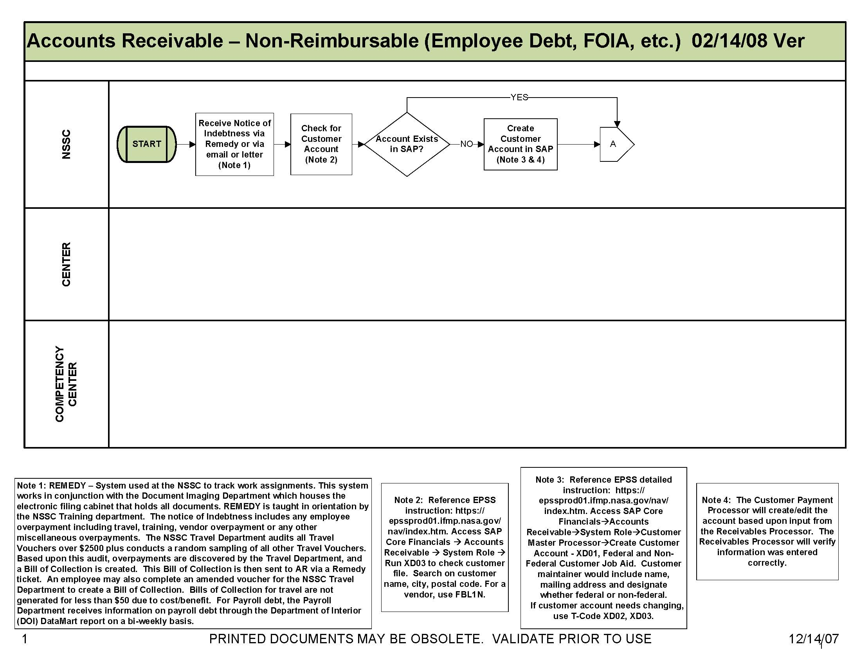

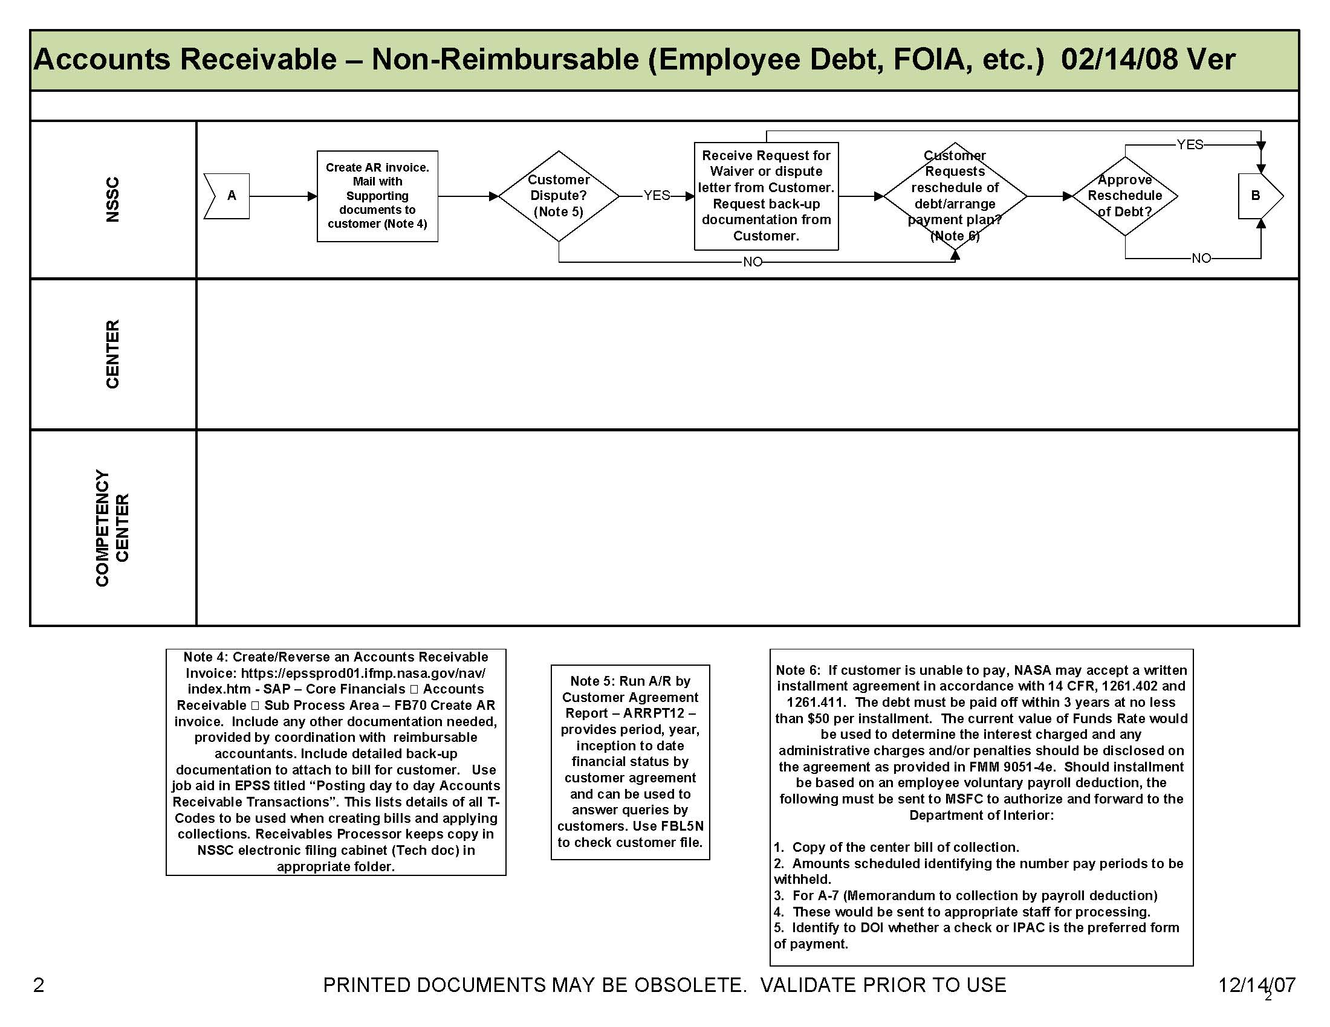

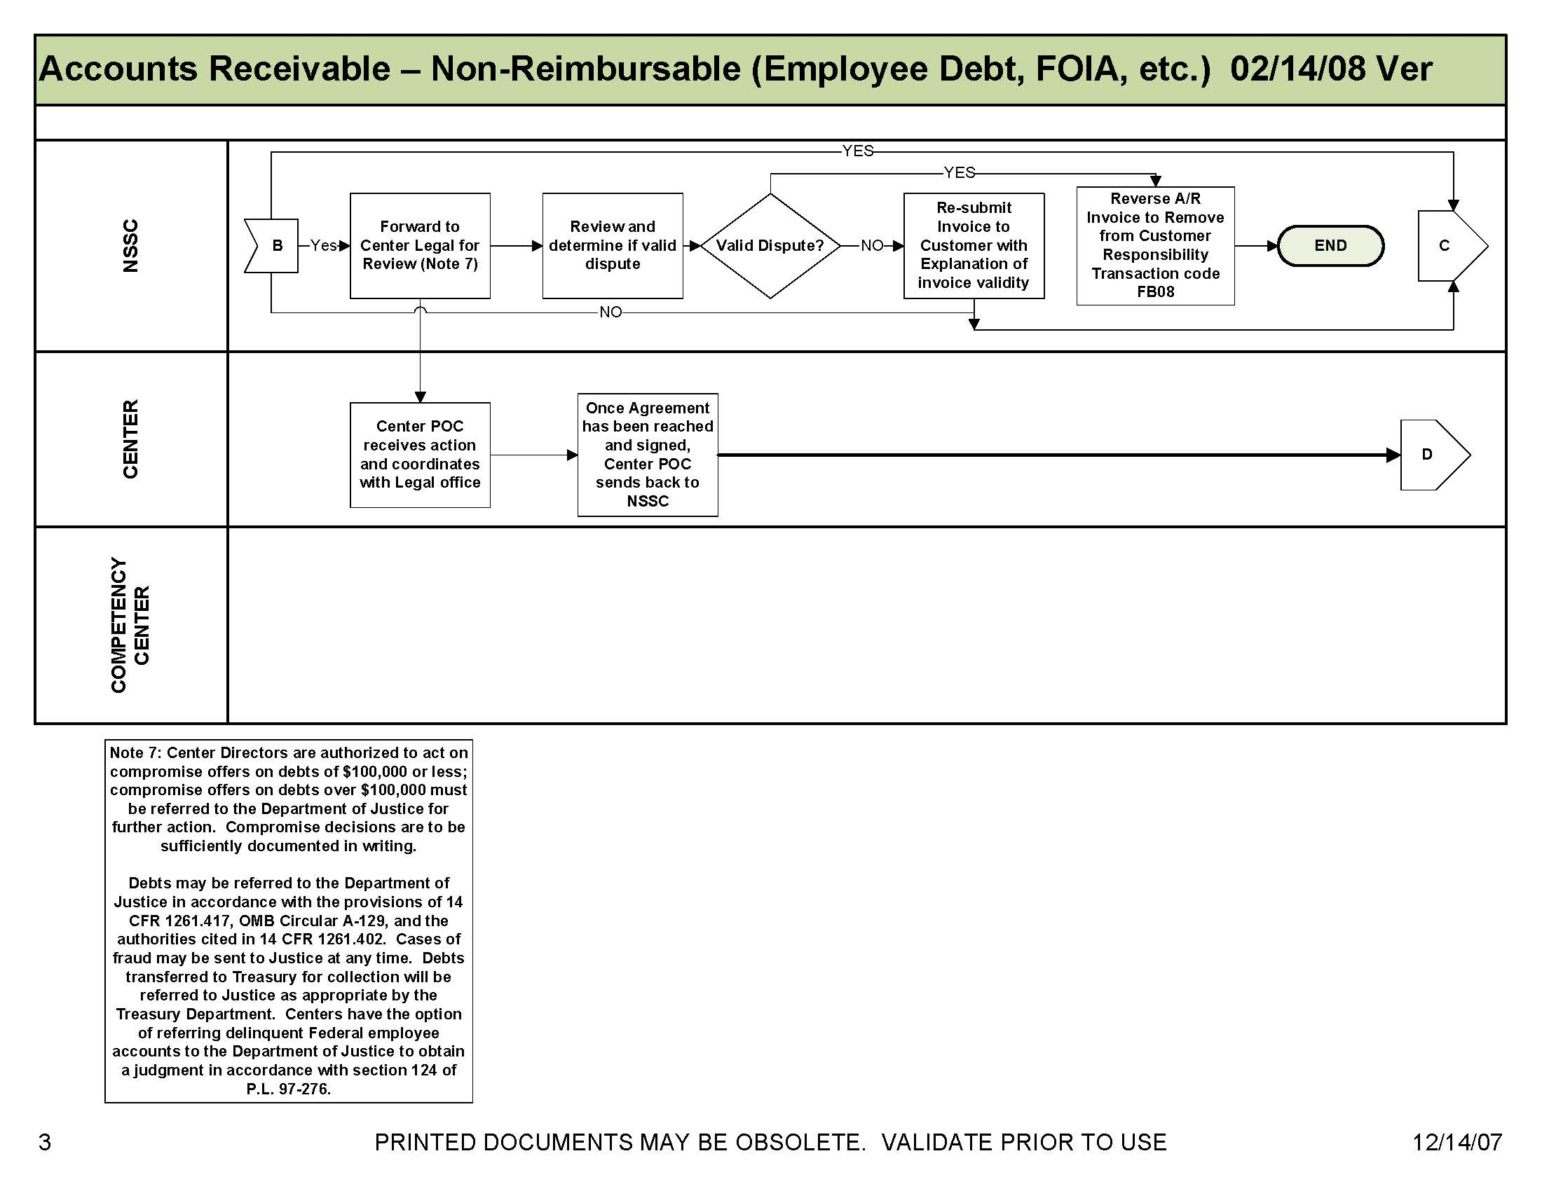

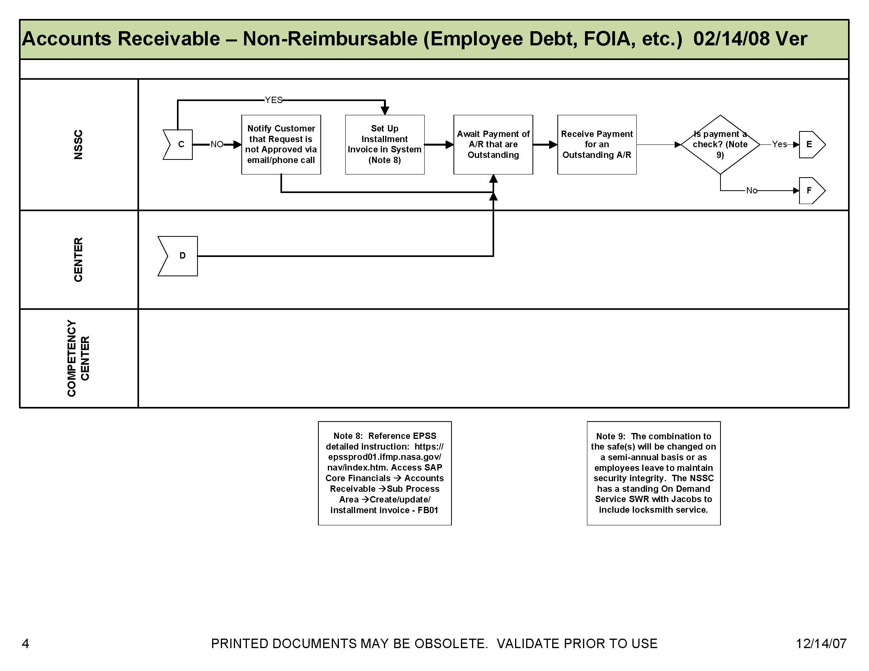

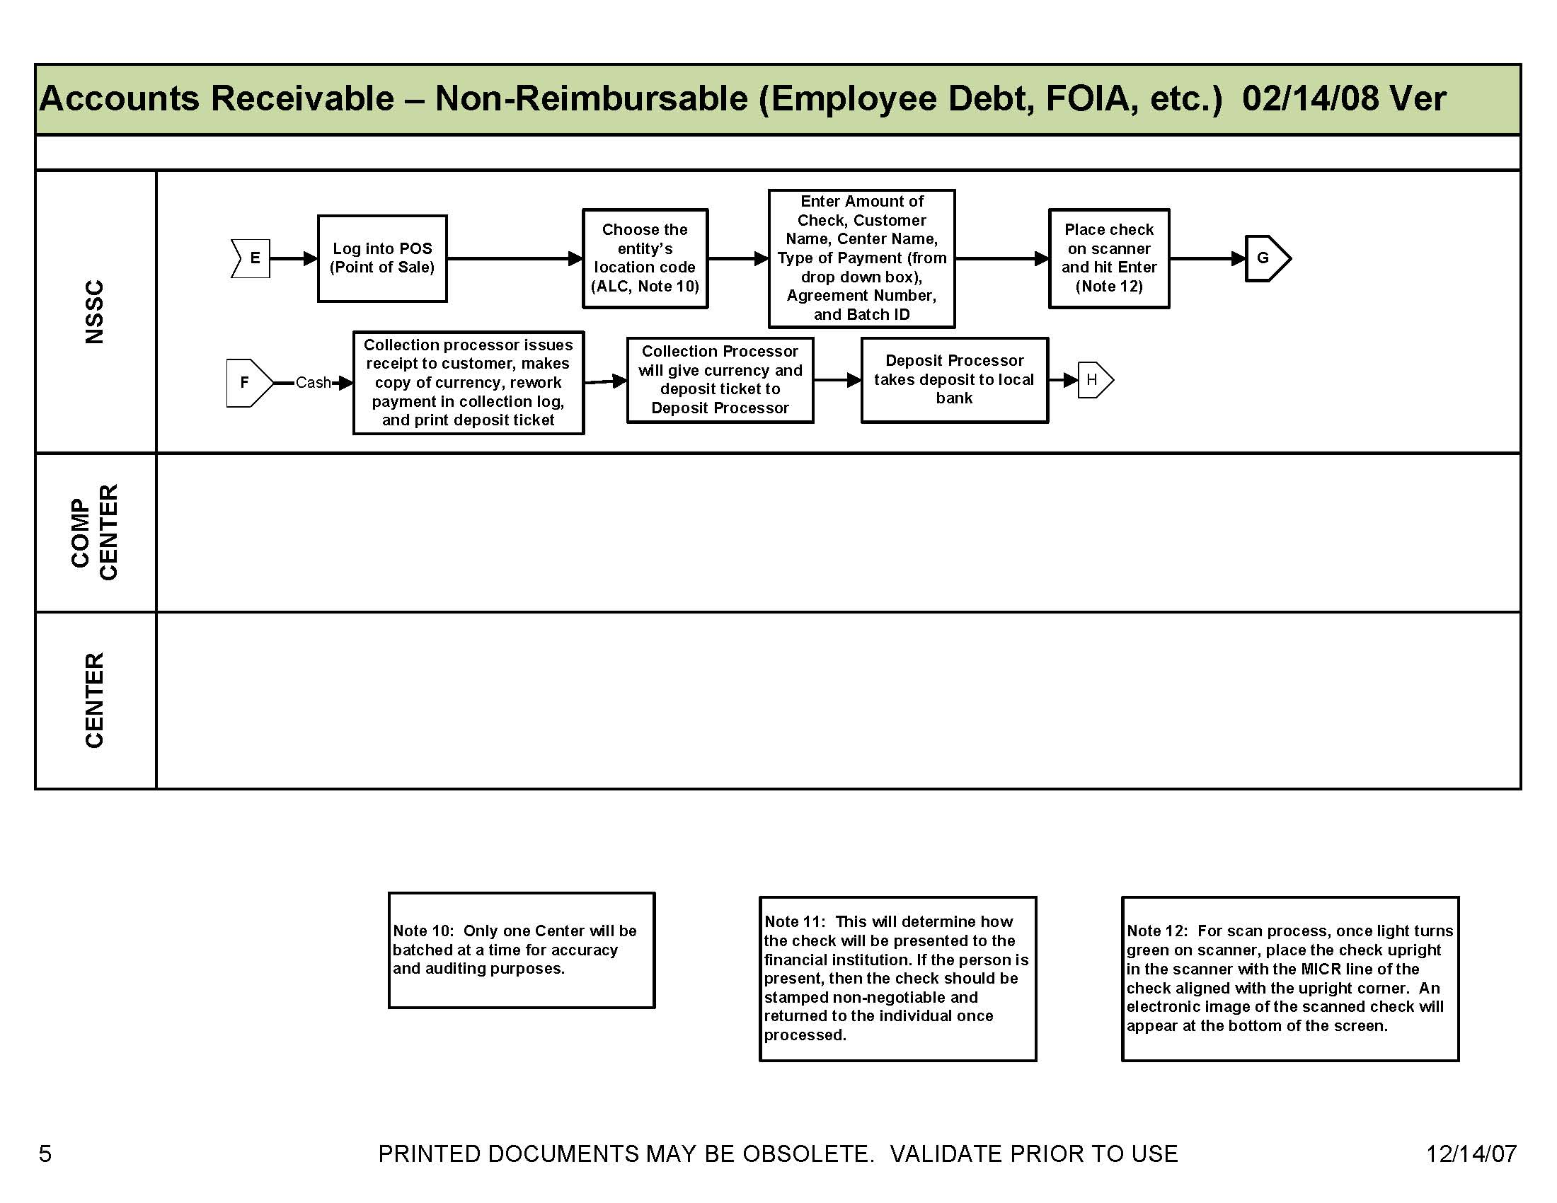

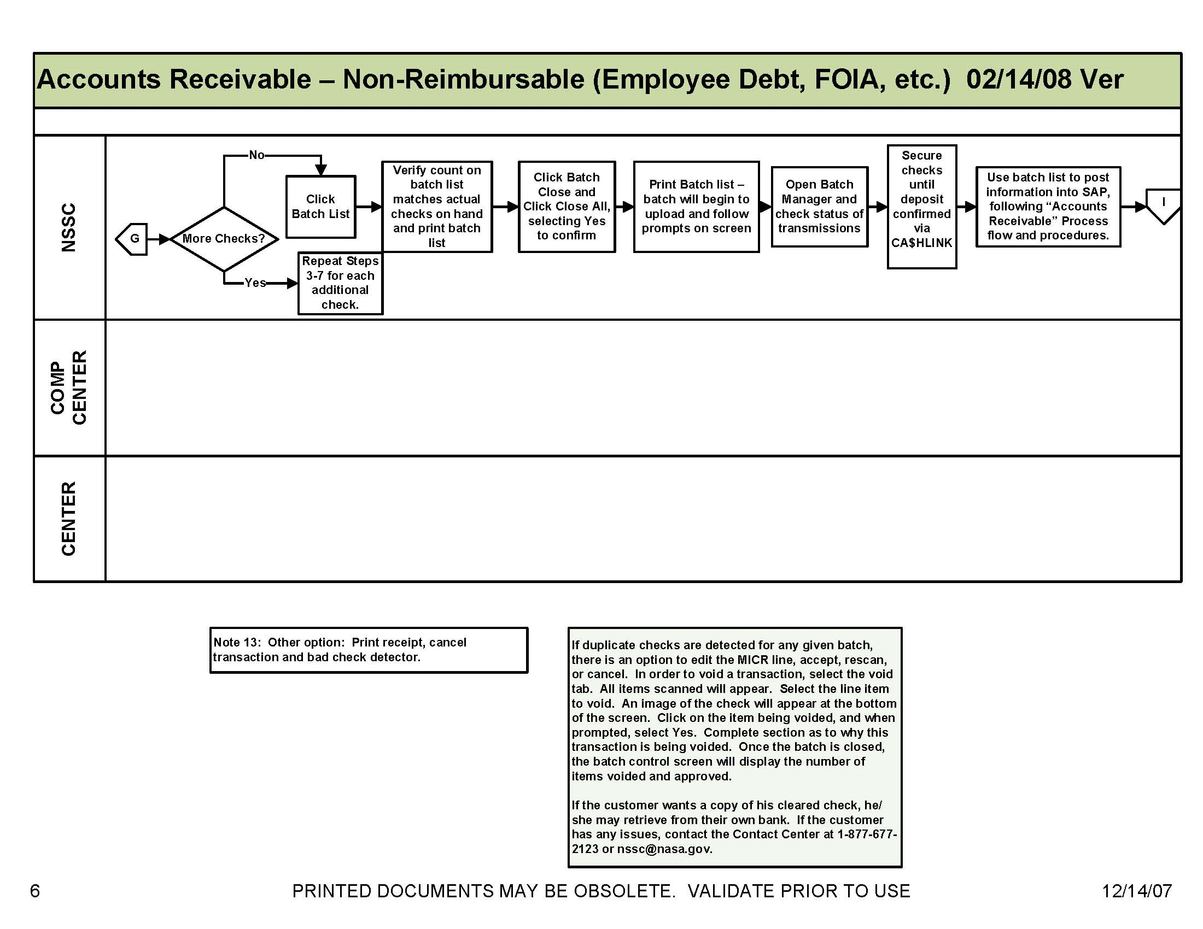

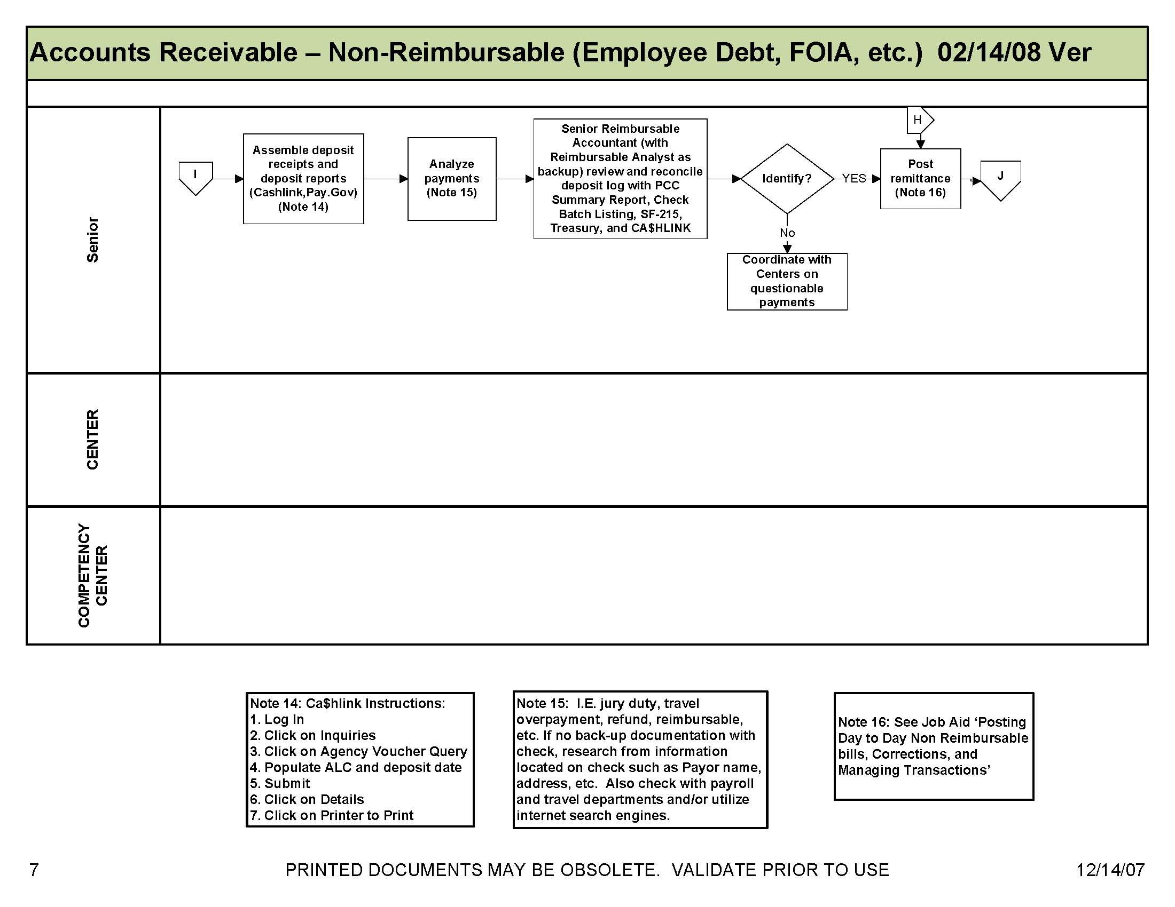

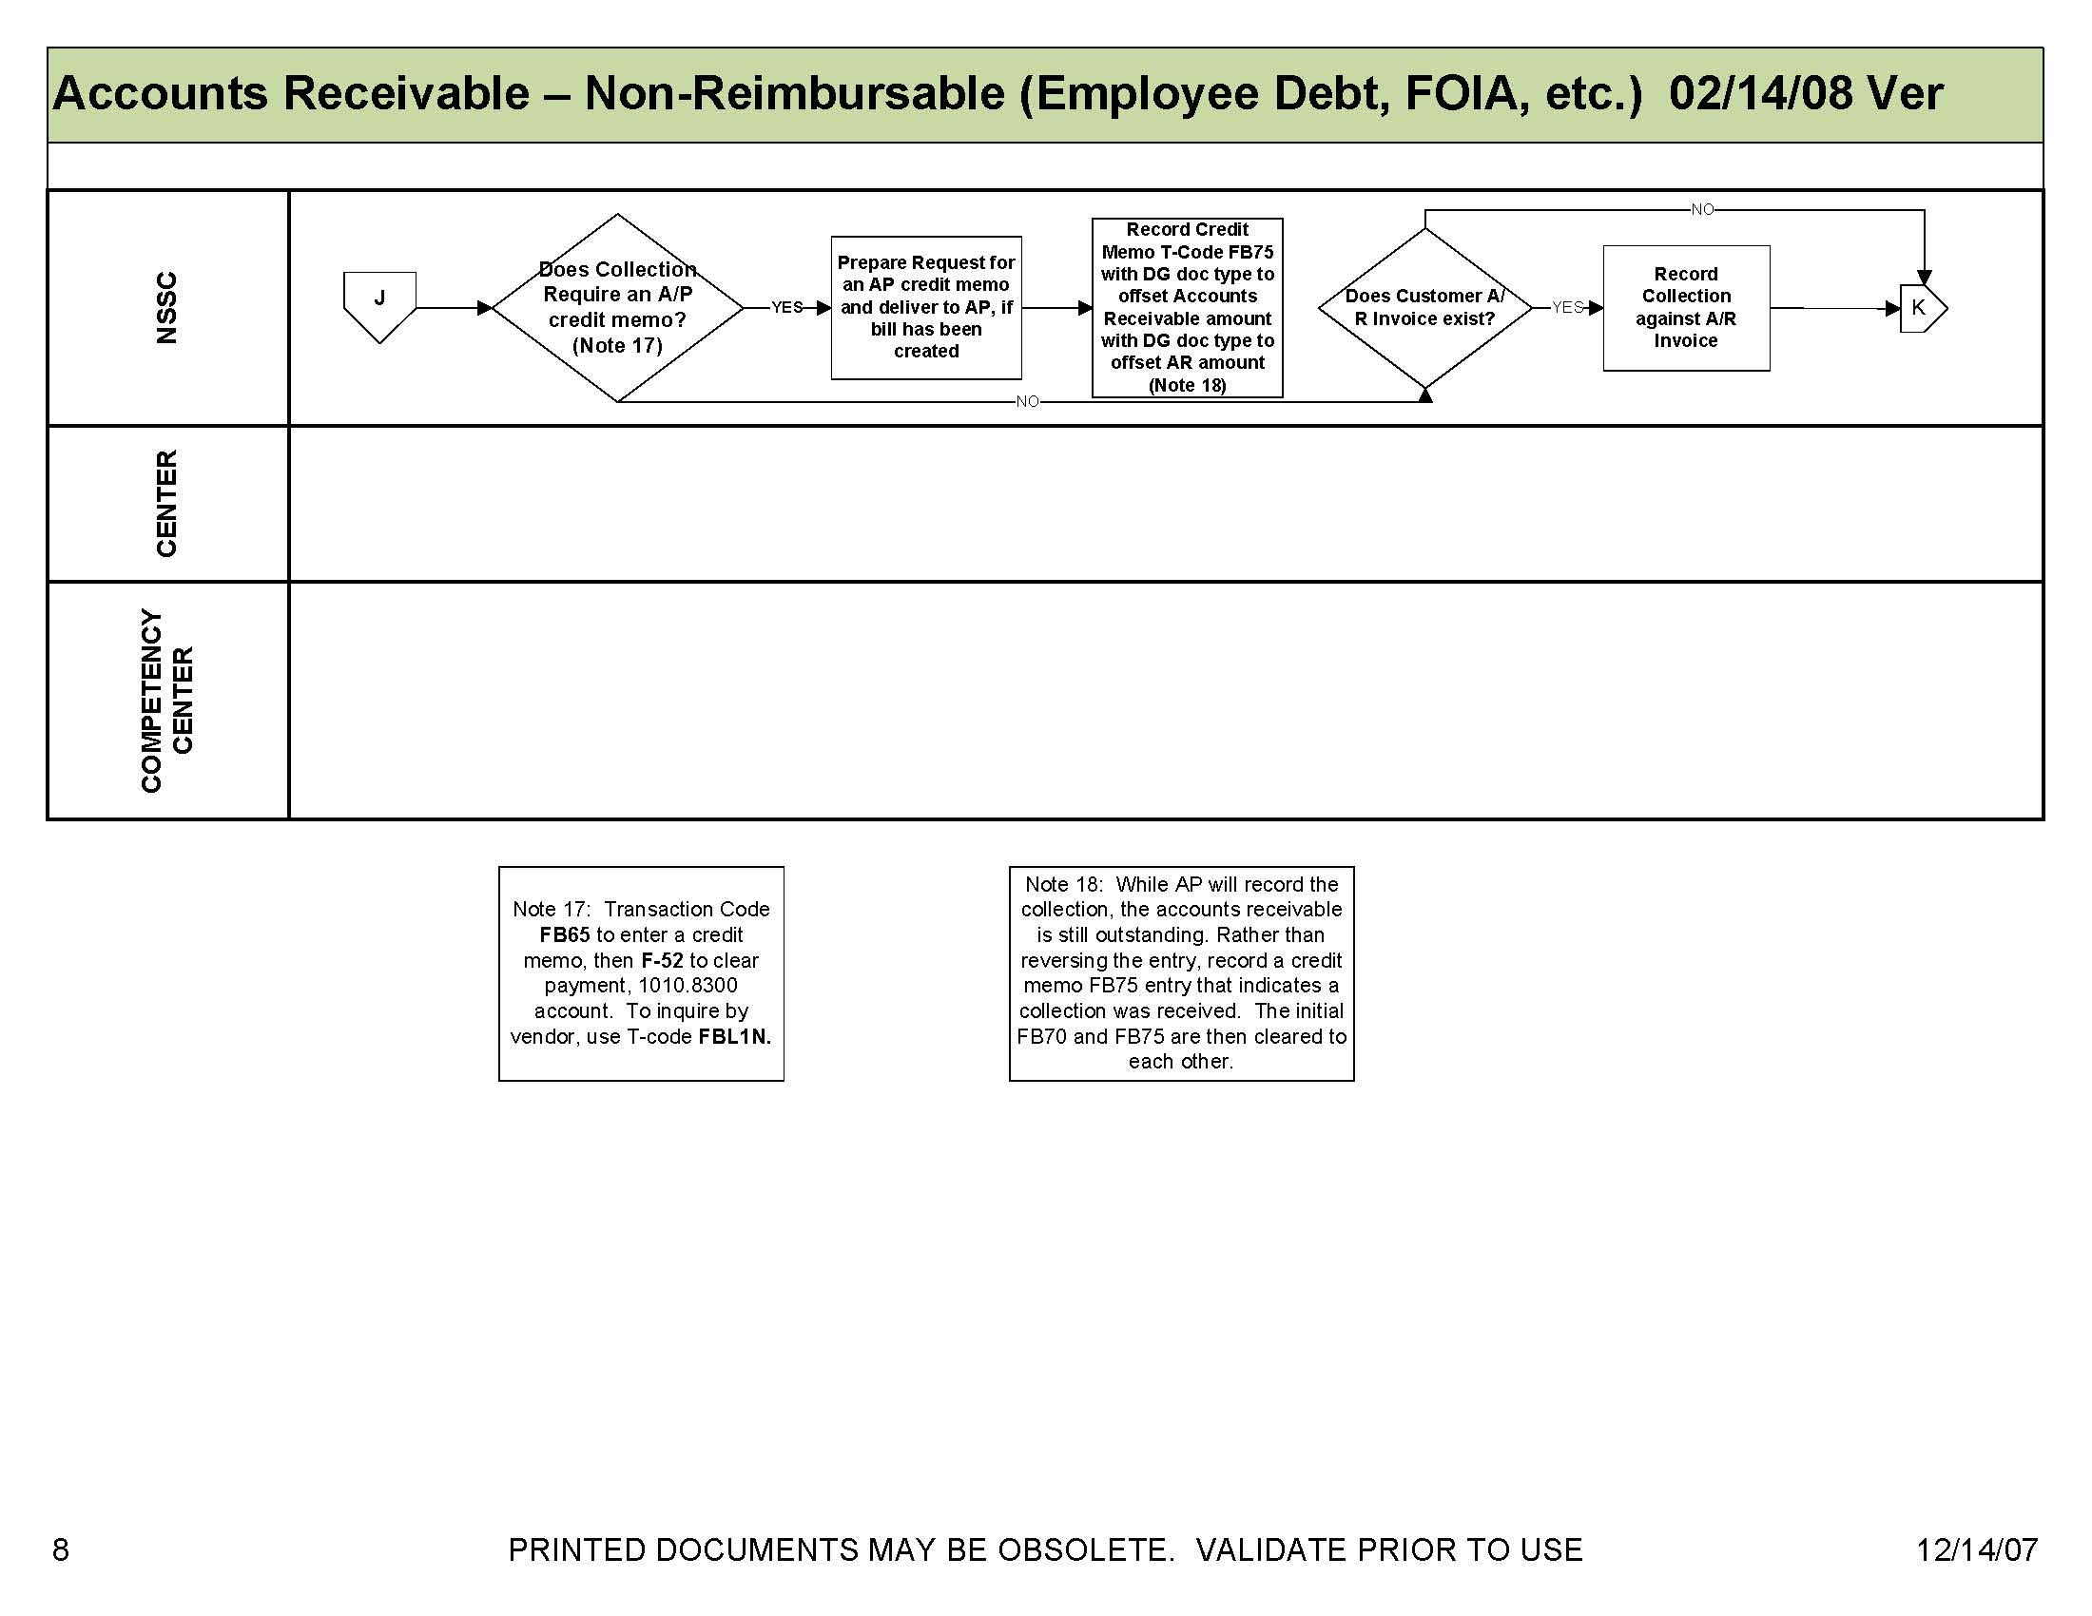

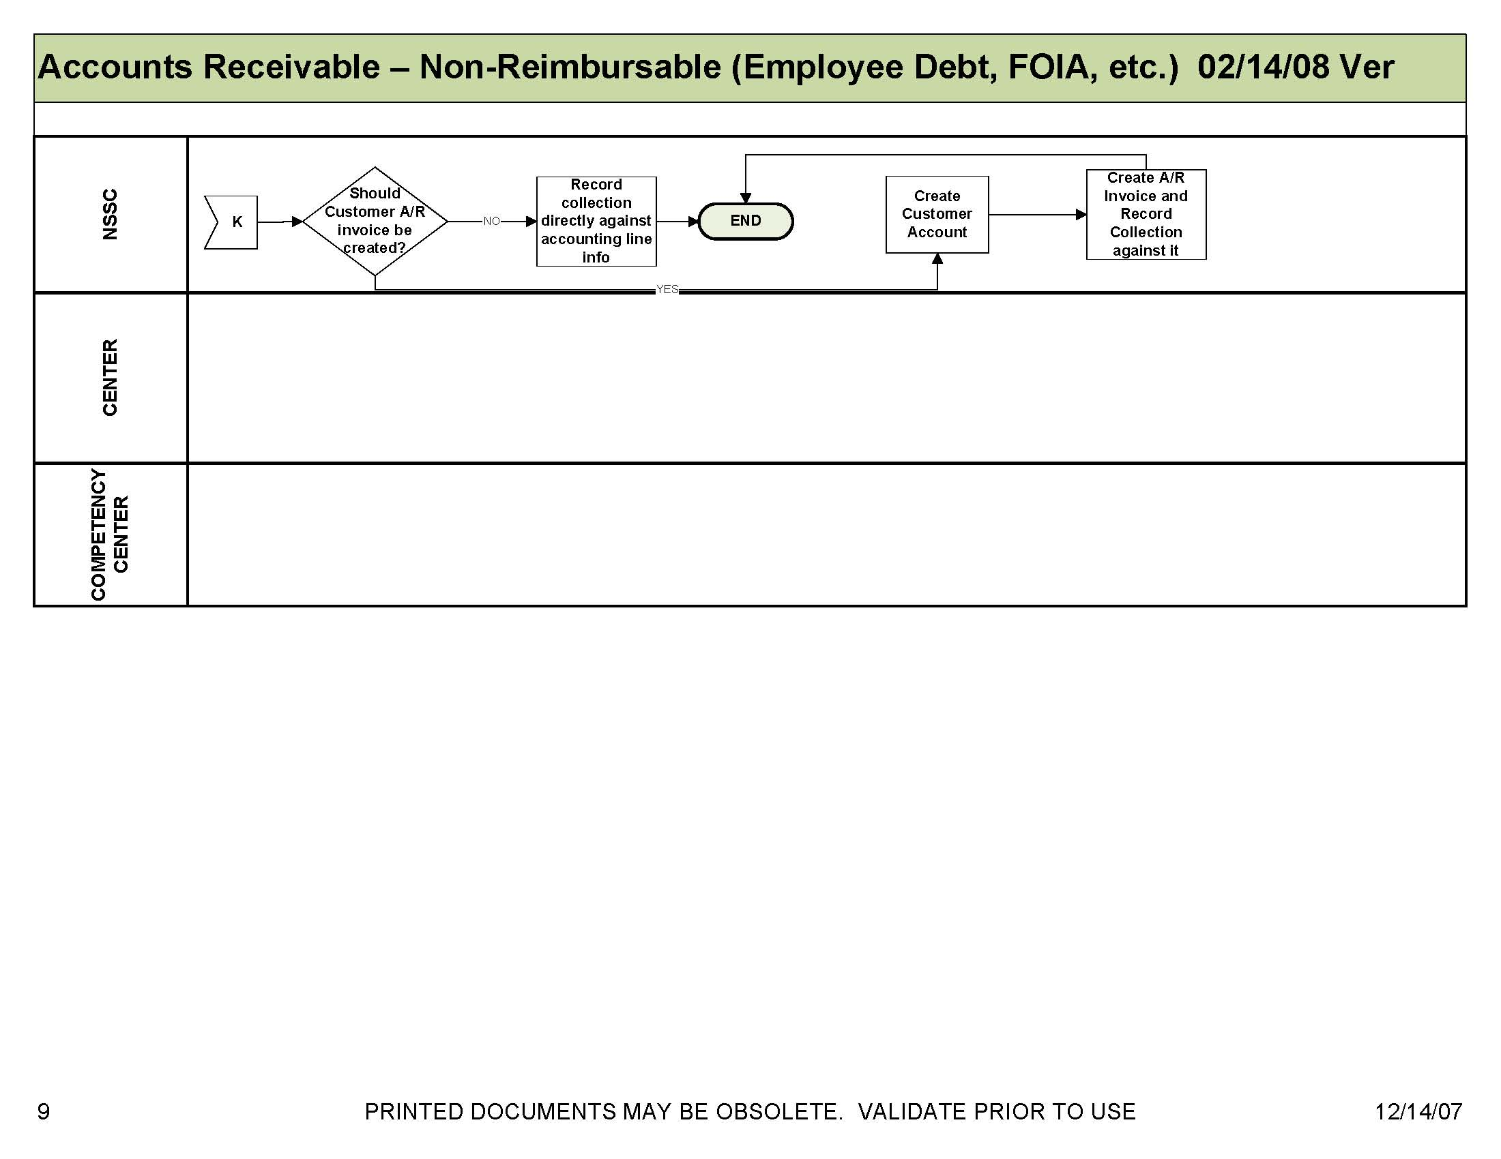

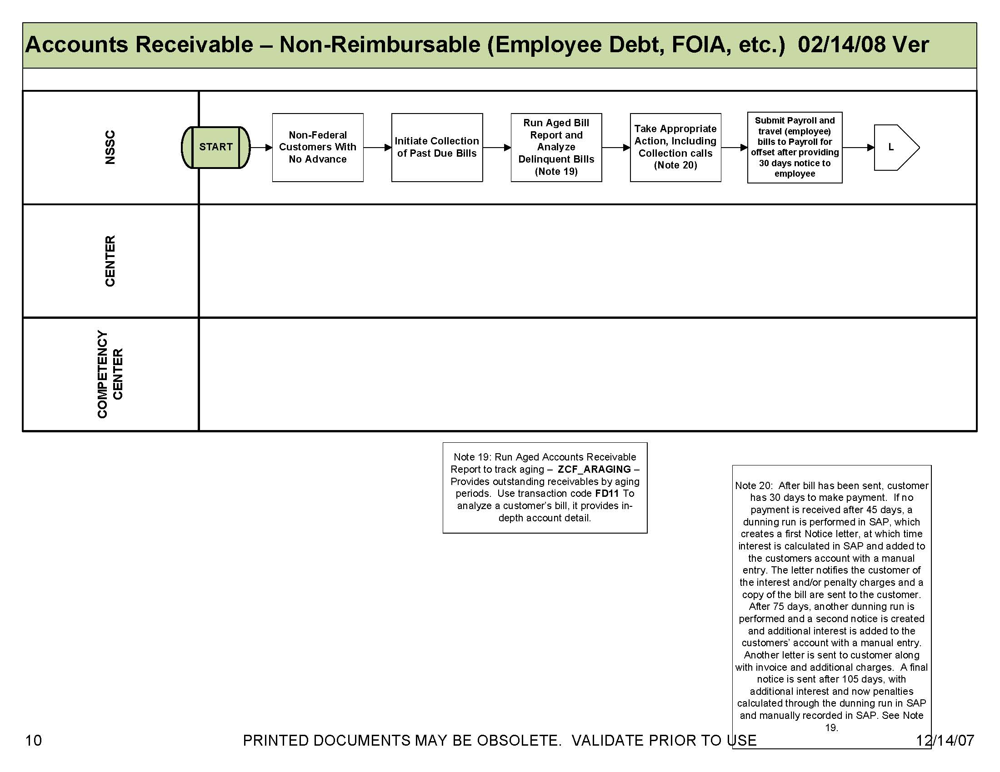

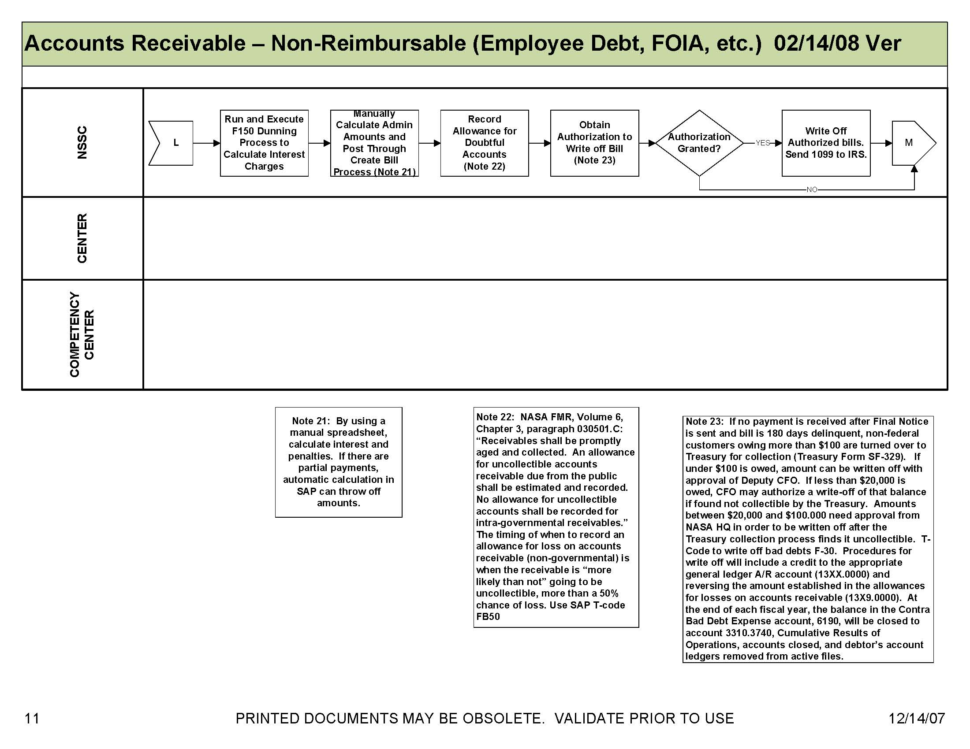

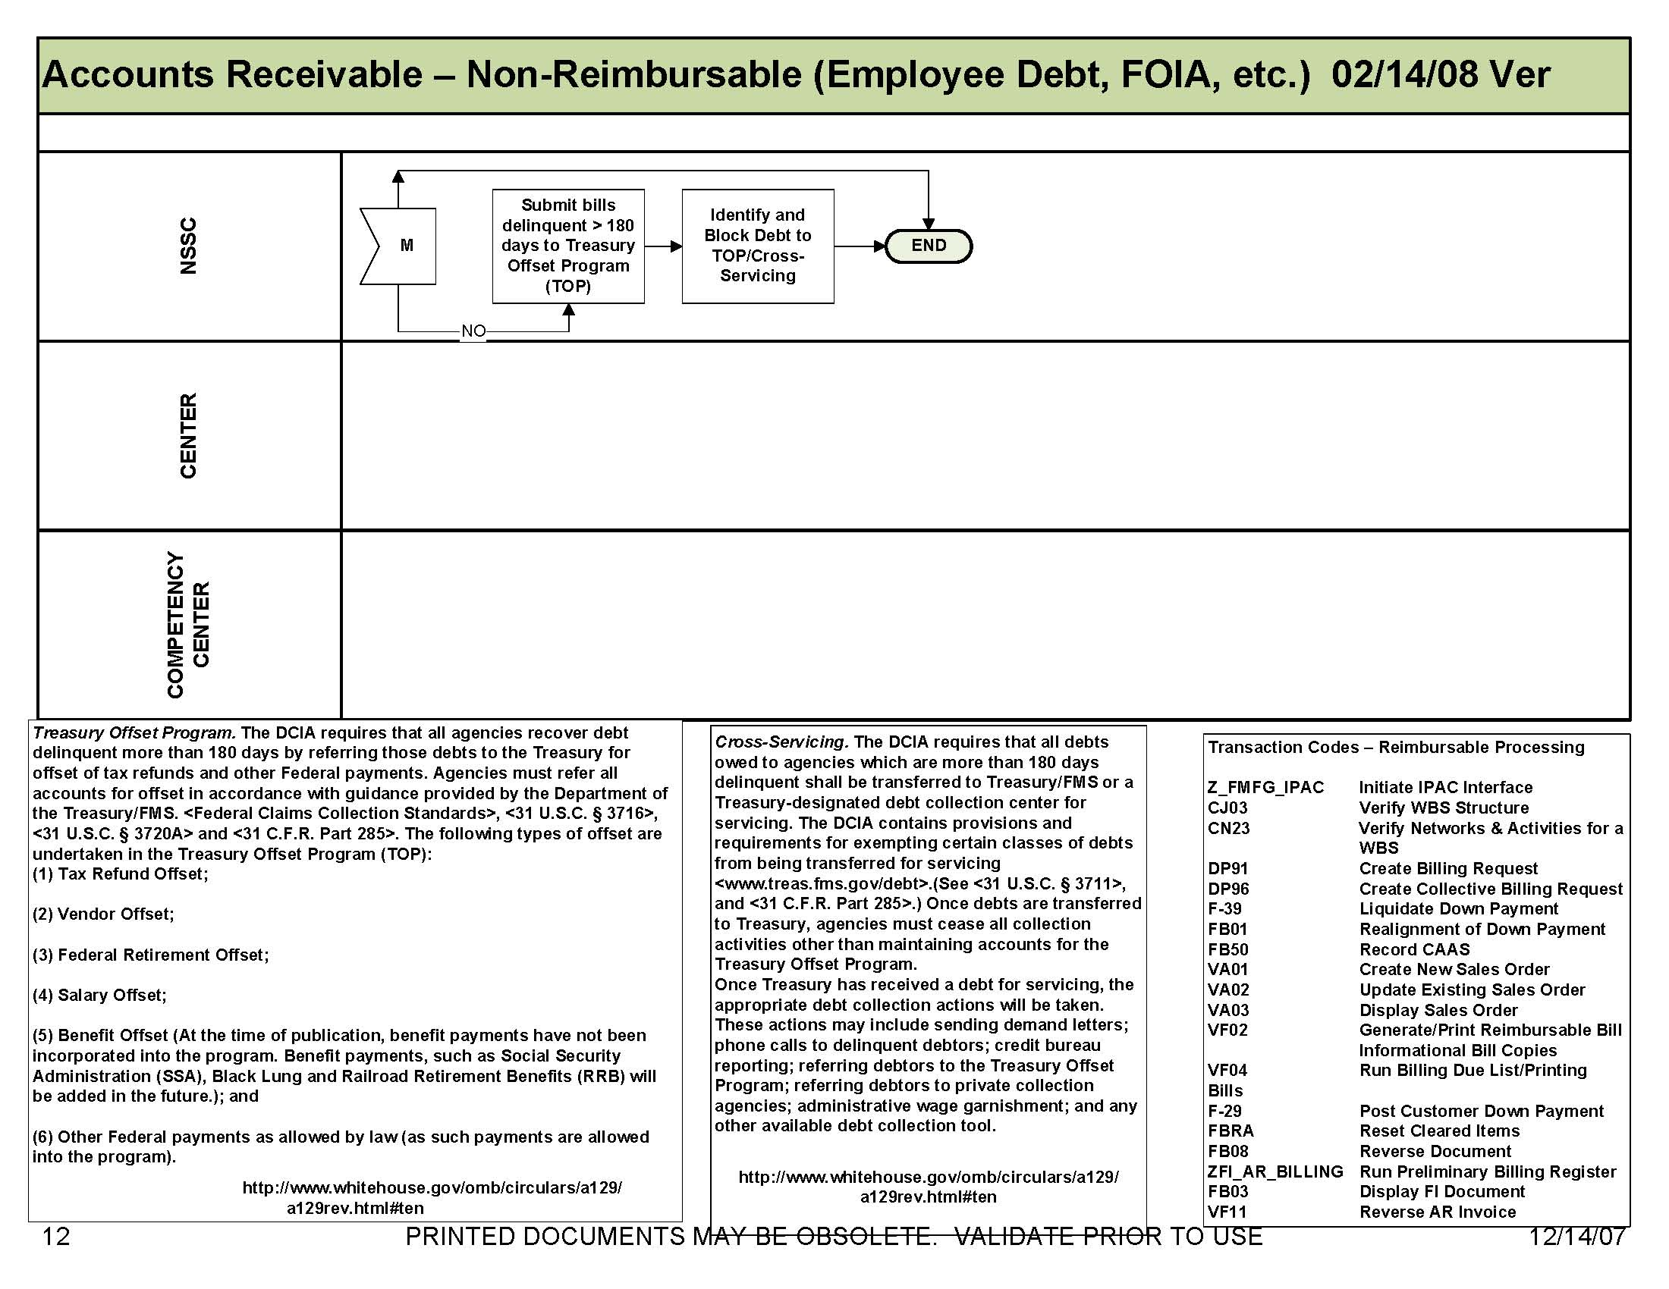

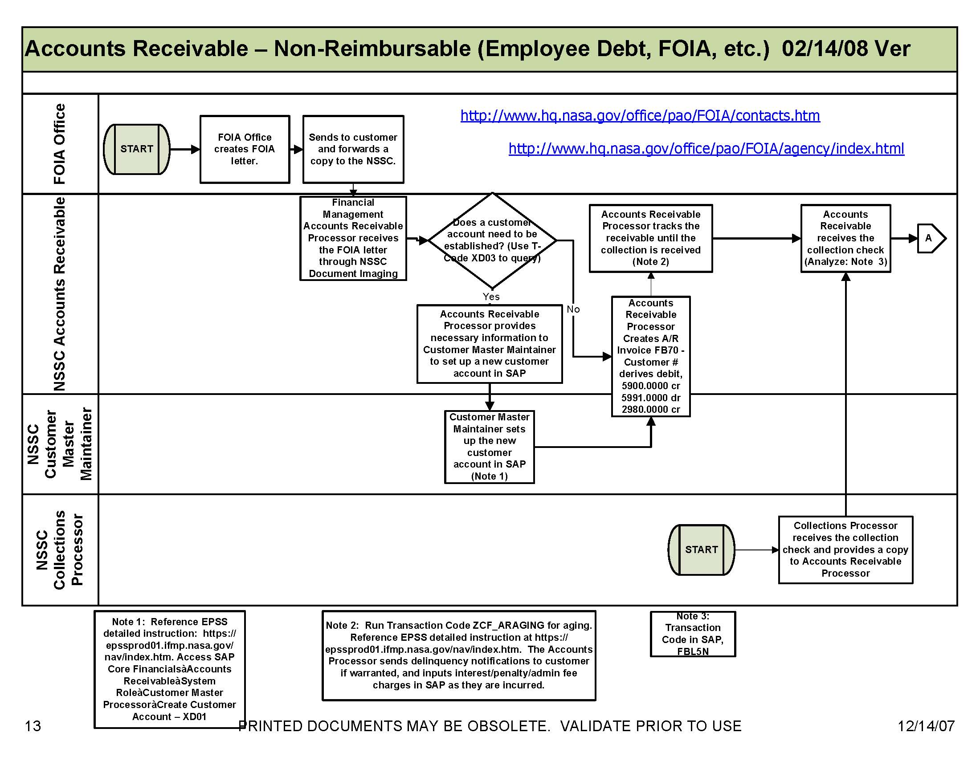

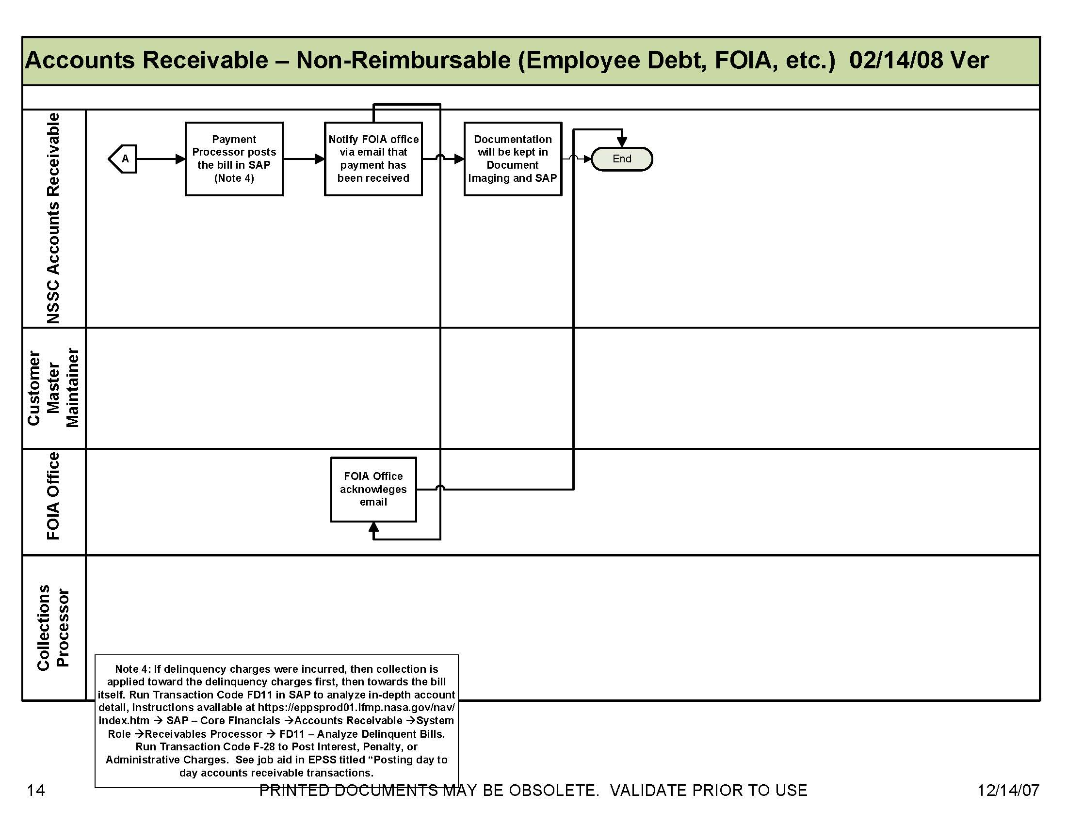

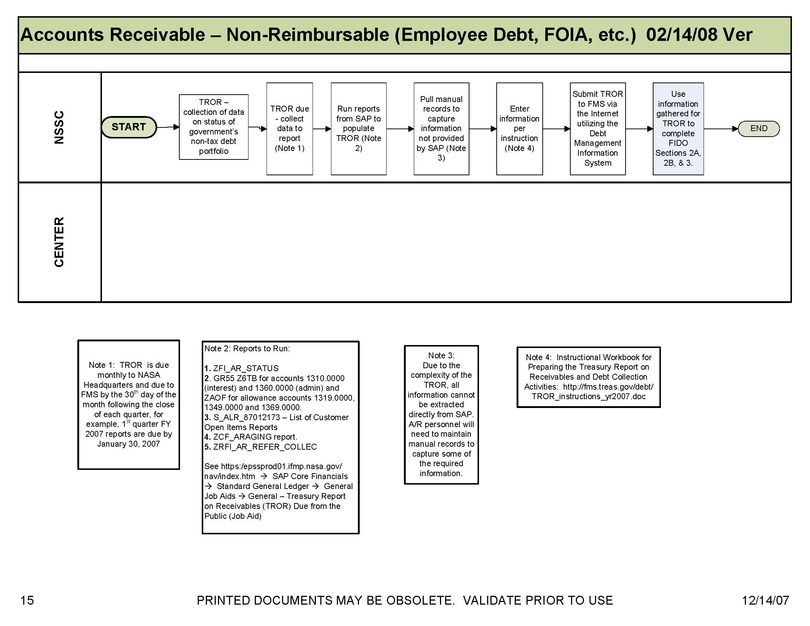

Appendix A - Acronyms and Abbreviations

ACH | Automated Clearing House
ACaRT | Agency Cash Reconciliation Tool
AMS | Acquisition Management System
AP | Accounts Payable
AR | Accounts Receivables
BW | Business Warehouse
CFO | Chief Financial Officer
CRCS | Central Resources Control System
CS | Civil Servant
DAB | Data Analysis Branch
DCFO | Deputy Chief Financial Officer
DIT | Disbursement in transit
EDI | Electronic Data Interface
EFT | Electronic Funds Transfer
EDM | Electronic Document Management
EPSS | Enterprise Performance Support System
ETM | Electronic Travel Manager
FAR | Federal Acquisition Regulation
FBWT | Fund Balance with Treasury
FI | Financial Invoice
FIDO | Federal Interagency Databases Online
FM | Financial Management
FMD | Financial Management Division
FMR | Financial Management Regulations
FMS | Financial Management Services
FTE | Full -Time Equivalent
GAO | Government Accountability Office
GOALS | Government On-Line Accounting Link System
GWA | Government Wide Accounting
HHS | Health and Human Services
HQ | Headquarters
IDOC | Interface Document
IEMP | Integrated Enterprise Management Program
IPAC | Intra-Governmental Payment and Collection System
IT | Information Technology
JV | Journal Voucher
LOC | Letter of Credit
MIPR | Military Interdepartmental Purchase Request
NAMIS | NASA Aircraft Management Information System
NATS | NASA Audit Tracking System
NPD | NASA Policy Directive
NSMS | NASA Supply Management System
NSSC | NASA Shared Services Center
NTE | Not to Exceed
OCFO | Office of the Chief Financial Officer
OJT | On the job training
ORR | Operational Readiness Review
OQA | Office of Quality Assurance
PBI | Policy and Business Integration Office
PCC | Paper Check Conversion
PMS | Payment Management System
POC | Point of Contact
RFO | Regional Finance Office
SAP | Systems, Application and Products in Data Processing
SF | Standard Form
SGL | Standard General Ledger
SPS | Secure Payment System
SP | Service Provider
SVU | SAP Version Update
TROR | Treasury Report on Receivables due from the Public
TWAI | Treasury Web Application Infrastructure
ULO | Un-Liquidated Obligations
VIP | Vendor Invoice Processor
VPP | Vendor Payment Processor
WFE | Work-Force Equivalent
WYE | Work Year Equivalent

Appendix B

Table of Contents

Introduction 5

Process 6

Metrics 7

System Components 8

Customer Contact Center Strategy 9

Cross Functional Flowchart 10

Improper Payments Audit

Introduction

The National Aeronautics and Space Administration (NASA), Office of the Chief Financial Officer (OCFO) is responsible for complying with the Improper Payments Information Act of 2002 (Public Law No. 107-300). This law requires agencies to annually identify programs and activities susceptible to improper payments, estimate the annual amount of improper payments and submit that estimate to Congress. For improper payments that exceed $10 million, the agency must report the actions it is taking to reduce improper payments and address the root causes for the improper payments.

The Defense Authorization Act for Fiscal Year 2002 added a new subchapter to the 4 U.S. Code (31 U.S.C. §§3561-3567) that requires agencies that enter into contracts with an annual total value in excess of $500 million to carry out a cost-effective program to identify errors made in paying contractors and to recover amounts erroneously paid to contractors.

Federal agency guidance for adherence to these two laws is provided by the Office of Management and Budget (OMB) Circular A-123, Management’s Responsibility for Internal Control, Appendix C, Requirements for Effective Measurement and Remediation of Improper Payments. This OMB guidance governs the improper payment risk assessment process and reporting, and the recovery audit program of all Federal agencies.

This document provides internal NASA guidance on the implementation of NASA’s Recovery Audit Program.

References

Section 831 of the Defense Authorization Act (2002) “Recovery Auditing Act” U.S. Code (31 U.S.C. §§3561-3567)

OMB Circular A-123, Appendix C “Requirements for Effective Measurement and Remediation of Improper Payments”

NASA Financial Management Requirements Volume 15, Chapter 6 “Prompt Payment”

NASA Accounts Receivable and Write-Off interim policy dated June 12, 2007

Process

Scope of Recovery Audit

The recovery audit will examine only completed fixed-price and time and material contract payments within a given fiscal year. Cost-type contract payments are excluded from this effort because these are already examined by DCAA and resolved through the contract closeout process.

Terms

Recovery Audit is a review and analysis of the agency’s books, supporting documents, and other available information supporting its payments that are specifically designed to identify overpayments or duplicate payments to contractors that result from payment errors.

Payment errors result from errors in invoices or financing requests; failure to reduce payments by applicable sales discounts, cash discounts, rebates or other allowances; payments for items not received; mathematical or other errors in determining payment amounts and executing payments; and the failure to obtain credit for returned merchandise.

Overpayment is any payment in excess of the amount that should not have been made under statutory, contractual, administrative, or other legally applicable requirements. Examples of overpayments include but are not limited to: (1) a payment that is greater than the contractual value of goods received or services performed (2) an early or accelerated payment for goods or services (The payments referenced refer to payments made in advance of contractual or statutory agreement. This does not refer to payments where all the proper documentation has been received, approved, and the regularly scheduled payment date is moved up to facilitate month end reporting.), (3) a payment that does not properly deduct the full available discount.

Note: (2) Per FMR Vol. 15 Chapter 6: NASA shall make payments no more than seven days prior to the payment due date, but as close to the due date as possible, unless the agency head or designee has determined on a case-by-case basis for specific payments. The Deputy Chief Financial Officer for Finance (DCFO (F)) must use this authority cautiously, weighing the benefits of making the payment early against the good stewardship inherent in effective cash management practices. Written determinations to approve early payments shall be retained in the payment file.

Note: (3) SAP system configuration deducts discounts for credit memorandums from the Net amount of the invoice versus the Gross; this constitutes a full discount.

Collections for the purpose of the guidance include activities undertaken by the NASA Shared Service Center to recover amounts erroneously paid to contractors.

Communication

The following outlines guidelines for communications between HQ, Contractor, and the Centers during the Recovery Audit.

The HQ Office of the Chief Financial Officer is responsible for the management of the Recovery Audit Program. HQ CFO provides input to the contracting officer in the selection of the Recovery Audit Contractor. Management of the audit is delegated to the Director, Office of Quality Assurance (OQA). The Director, OQA oversees preparation of the audit plan and facilitates communications between the Contractor and Center personnel to obtain electronic and hard copies of documents. Recovery Audit issues that cannot be resolved between the Contractor and Center CFO are elevated to the Director, OQA for resolution.

An entrance conference will be held at each Center prior to the commencement of Recovery Audit activities. The purpose of the meeting is to clearly define the Contractor, Center, and HQ

roles and responsibilities. The Center CFO will designate a Recovery Audit Liaison as the point of contact for all information requests.

The Director, OQA will provide periodic updates to the Center CFOs on the status of the Audit Recovery work and findings. The Center CFO will provide the Director, OQA with a monthly status report by the 15th day of each month for the previous month on recommended debts submitted by the Contractor for validation and status of collection activities.

The Recovery Audit Contractor shall not make direct contact (verbally or in writing) with the agency’s contractors/vendors. All communications are to go through the NSSC, Center CFO or designee.

Roles and Responsibilities

- The Office of the Chief Financial Officer (OCFO) has primary responsibility for general program oversight to include acting as the contracting officer technical representative (COTR), giving guidance to Center CFO organizations, and ensuring that Centers properly and consistently carry out their assigned responsibilities.

- The OCFO, Office of Quality Assurance, ensures the execution of the program objective. This includes preparation of Agency guidelines, criteria for the determination, collection, and disposition of funds recovered.

- The Center Chief Financial Officer reviews Contractor findings/evidence and makes final determination whether recommended debts will be posted for collection following agency guidelines/criteria. The NSSC will handle all activities related to the collection of funds, including all correspondence with the agency’s contractors.

- The Contractor prepares and implements an audit recovery plan to sample transactions, analyze discrepancies, and identify overpayments (i.e., payment errors) that are submitted to Center Chief Financial Officer (CFO) for review in accordance with NASA guidelines. The Recovery Audit Liaison designated by Center CFO will be the point of contact for inquiries/requests from the OQA/Contractor. Unless otherwise specified, all documentation requests, submission of overpayment packages, dissemination of information, and correspondence with Contractors is routed through the Liaison.

- NASA Shared Service Center (NSSC) is responsible for mailing out the initial inquiry letters to selected vendors requesting a statement/reconciliation of NASA accounts. When debts are identified by the Contractor and validated by the Center CFO the NSSC will conduct collection activities to recover funds. After funds are received, the NSSC shall carry out appropriate disposition of the funds.

Recovery Audit Procedures

The following information describes NASA’s procedures to identify, analyze, post, and collect erroneous payments on completed fixed-price and completed time and materials contract payments made within a given fiscal year for the current period of the contingency contract performance.

NASA uses a Contractor to perform recovery audit services on a contingency basis. The Contractor shall employ statement and transaction audit procedures to identify possible
payment errors. The Recovery Auditor develops and implements the strategy for identifying contract overpayments.

Collection Procedures

NSSC shall carry out the collection of debts identified during the recovery audit. Collection activities shall follow the NASA Accounts Receivable and Write-Off interim policy dated June 12, 2007. Posting of the collections in the core financial system shall be in accordance with the Improper Payment Options document.

All funds collected, all administration expenses incurred, and contingency fee payments made as part of the recovery audit program shall be specifically accounted for. The identity of all funds recovered shall be maintained as necessary to facilitate the crediting of recovered funds to the correct appropriations and identify applicable time limitations associated with the funds recovered. The NSSC will provide a monthly accounting of all identified debts, amounts collected, and disposition of funds. Note: discuss with NSSC process of posting, alerting Center about recoveries, and paying the Contractor.

Use of Funds Collected
Note: Need to discuss with NSSC process of verifying appropriate disposition of funds and tracking.
Funds collected under the recovery audit program shall be available for the following purposes:

- To reimburse the actual expenses incurred by NASA to administer the program.

- To pay contractors for recovery audit services.

Recovered funds that are not used to reimburse incurred administrative expenses or pay contingency fee to the recovery audit contractor:

- Shall be credited to the appropriations from which the overpayment was made, and will be available for the purposes and period for which such appropriations are available; or

- If no such appropriations remain available, the funds recovered shall be deposited in the Treasury as miscellaneous receipts.

In the event amounts recovered due to interim payment errors made under ongoing contracts (i.e., duplicate progress payments or cost reimbursement claims) are not available to pay the recovery audit fee, because these amounts are still needed to make subsequent payments under the contract; NASA will pay contractor out of the appropriate Center administrative funds. Note: need to decide how this process will work.

When required or authorized by other provisions of law, any funds remaining after reimbursement of incurred administration expenses and paying recovery audit contractors, shall be credited to a non-appropriated fund, revolving fund, working capital fund or trust fund.

Recovery Audit Contractor Contingency Fee Payment

The Collections are to be tracked separately to facilitate (1) payment to the recovery audit contractor once the funds are actually recovered by NASA and (2) credit of any excess funds to the correct appropriation. OMB guidance requires all funds collected and all direct

administration expenses incurred as part of the recovery audit program shall be specifically accounted for.

Following the recovery of the funds, the NSSC shall calculate the payment to the recovery audit contractor based upon contractual contingency fee percentage. The percentage shall be applied only to the principal amount collected. Interest or penalty resulting from debt collections shall not be factored into the contingency fee payment.

Corrective Action Plans

For each overpayment determined valid by the Center CFO, the recovery audit contractor shall analyze the reason payment error occurred, and recommend cost effective controls to prevent such overpayments in the future, as a normal part of their contract work. The Center CFO in consultation with OQA is responsible for taking appropriate action(s) to address the identified control deficiency to preclude future reoccurrence of the payment error. A corrective action plan shall be prepared and maintained detailing the following:

- Payment error identified
- Root cause of error
- Planned actions to address deficiency
- Responsible official
- Target completion date
- Actual completed date
- Evidence root cause has been eliminated

Corrective action plans shall be provided to the OQA no later than 30 days after the debt is determined to be valid by the Center CFO. Quarterly updates shall be provided to OQA on the status of corrective actions (January 10, April 10, July 10, and October 10). Unless otherwise approved by the OCFO/OQA, all corrective actions shall be implemented within one year of the Center OCFO debt determination.

Processes – Recovery Audit Procedures

Roles & Responsibilities

Roles and Responsibilities | Action | Tips
Recovery Audit Procedures  Step 1  Recovery Auditor – Contractor  Prepares and implements an audit recovery plan | Purpose  The Recovery Auditor – Contractor prepares and implements an audit recovery plan to sample transactions, analyze discrepancies, and identify overpayments (i.e., payment errors) that are submitted to Center Chief Financial Officer (CFO) for review in accordance with NASA guidelines. | The Recovery Audit Liaison designated by Center CFO will be the point of contact for inquiries/requests from the OQA/Contractor. Unless otherwise specified, all documentation requests, submission of overpayment packages, dissemination of information, and correspondence with Contractors is routed through the Liaison.
Step 2  Recovery Auditor - Contractor  Initial Listing and Letter | Prepare initial listing and letter to selected vendors requesting a statement/reconciliation of NASA accounts.
Step 3  NASA Shared Services Center – Civil Servant/SP  Mailing initial letter | NASA Shared Service Center is responsible for mailing out the initial inquiry letters to selected vendors requesting a statement/reconciliation of NASA accounts.
Step 4  Recovery Auditor – Contractor  Follow-up to initial letter | The Recovery Auditor will follow-up via letter/fax/phone to non-responding contractors/vendors. | Note: This is a standard industry practice used by Recovery Audit Contractors to identify payment errors. Based upon the level of response and information received NASA management in consultation with the Contractor will make a determination whether to conduct further audit of payments for the period being audited. If management decides to pursue further Recovery Audit activity, the following guidelines/process will be followed.
Step 5  Recovery Auditor – Contractor  Request documentation | The Recovery Auditor will submit document requests related to possible payment errors to the appropriate NASA Center thru the NASA Audit Tracking System (NATS). Requests should be provided at least one week prior to the requested due date. Documentation that may be requested by the Contractor includes; contracts, invoices, purchase orders, receiving documents, and the actual payment(s) to identify possible payment errors. In the performance of this work the Contractor is prohibited from:  - Requiring production of any records or information by the agency’s contractors. Only duly authorized employees of the agency can compel production of information in accordance with contract terms;  - Establishing or otherwise having a physical presence on the property or premises of any other agency contractor for the purpose of performing the contract;  - Acting as an agent for the Federal Government in the recovery of funds erroneously paid to contractors;  - Using or sharing sensitive financial information with any individual or organization, whether associated with the Federal Government or not, that has not been released for use by the general public;  Disclosing any information that identifies an individual, or reasonably can be used to identify an individual, for any purpose other than performing the recovery audit.
Step 6  Recovery Auditor – Contractor  Calculates the proper amount | Once a payment error is identified, the Contractor calculates the proper amount to be collected. The information along with supporting evidence of the payment error is provided to the Center Chief Financial Officer (Center CFO) for validation.
Step 7  NASA Center CFO or Designee – Civil Servant  Validate debt/payment error | NASA Center CFO’s or designees will review and validate whether recommended debts are posted for collection or deemed invalid, within 90 days depending on the extent of verification required. | The Center has a maximum of 90 days to validate whether the payment is an error. Depending upon the amount of investigation required by the Center the time required to validate debts submitted by the Contractor will vary.
Step 8  NSSC – Civil Servant/SP  Collection of debt | If the center CFO determines the debt to be valid, the item is referred to the NSSC for collection. NSSC is responsible for all collection, tracking, and reporting activities related to Recovery Audit funds. Note: Need to discuss with NSSC how this process will work. | Note: a special mail stop for collections should not be set up at the Center.
Step 9  Recovery Auditor – Contractor  Prepare a Weekly Summary of Recoveries | The Contractor will provide a “Weekly Summary of Recoveries” report on the status of ongoing recovery activities. The Contractor will provide an annual report to the OCFO by September 14 of each year, on the results of the recovery audit. The results of each year’s recovery audit effort will be reported in the NASA Performance and Accountability Report. | The report is submitted to the Director OQA. Only those debts submitted and approved by the Center CFO shall be reported for collection purposes.
Step 10  Director, OQA – Civil Servant  Prepare periodic updates on the status of the audit | The Director, OQA will provide periodic updates to the Center CFOs on the status of the Audit Recovery work and Findings. | The type of information to be included in this report to the Centers and the frequency of this report is TBD.
Step 11  Center CFO – Civil Servant  Prepare monthly status report for the previous month on recommended debts | The Center CFO will provide the Director, OQA with a monthly status report by the 15th day of each month for the previous month on recommended debts submitted by the Contractor for the validation and status of collection activities. | OQA will prepare a template for this report to be used by all Centers.
Process – Collection Procedures

Roles & Responsibilities

Roles and Responsibilities | Action | Tips
Collection Procedures  Step 1  NSSC – Civil Servant/SP  Collection of validated debts | NSSC shall carry out the collection of debts identified during the recovery audit. Collection activities shall follow the NASA Accounts Receivable and Write-off interim policy dated June 12, 2007 and the DRAFT Accounts Receivable Service Delivery Guides for Direct and Reimbursable activity.
Step 2  NSSC – Civil Servant/SP  Post collection of Improper Payments/Recovery Audit Funds | Posting of the collections in the core financial system shall be in accordance with the following Improper Payment Options.
Improper Payment Options  Step 2a  NSSC – Civil Servant/SP  Scenario I  Posting of Collection when the  - Contract is open  - Project is open  - Fund is either unexpired or expired. | - A/R sets up a receivable for the vendor.  T-code: FB70  - A/P creates a credit memo against the contract for the amount recovered less the percent to be paid to the Recovery Audit Contractor.  T-code: MIRO  Clear Credit Memo to cash: F-52  - A/P creates a credit memo for the Recovery Audit Contractor percentage of the payment  T-code: FB65  The credit memo will be against the vendor that received and repaid the improper payment.  Clear Credit Memo to Cash: F-52  - A/R reverses the receivable in step 1  - A/P pays the Recovery Audit Contractor percentage using a FI Invoice T-code: FB60  Pay Invoice: F110 | Notes:  - Any collections for improper payment related to a cancelled appropriation should be collected into 803200 (Collection of Receivables from Cancelled Accounts). Subsequent payments to the Recovery Audit Contractor will be made from the current appropriation (1% set aside for payment of cancelled payables)  Recovery of improper payments against an open contract will result in a shortage of available funds for disbursement if the contract is paid in full at the current contract value. Additional funds will need to be obligated to cover the fee that is being charged for the recovery of the improper payment.
Step 2b  NSSC – Civil Servant/SP  Improper Payment Options Scenario 2  Posting of Collection when the  - Contract is closed  - Project is closed  - Fund is either unexpired or expired. | - A/R sets up a receivable for the Recovery Audit Contractor  T-code: FB70  - A/P creates a credit memo citing the vendor that received the improper payment. The credit will be used to process the payment for the Recovery Audit Contractor against the project WBS.  The vendor should be in SAP even though the contract is closed. If the vendor master record does not exist the center will need to submit an SR to have it added.  Clear Credit Memo to cash: F-52  - A/R reverses the receivable in step 1  - A/P pays the Recovery Audit Contractor percentage using a FI Invoice  T-code: FB60  Pay Invoice: F110 | Notes:  - Any collections for improper payment related to a cancelled appropriation should be collected into 803200 (Collection of Receivables from Cancelled Accounts). Subsequent payments to the Recovery Audit Contractor will be made from the current appropriation (1% set aside for payment of cancelled payables)  - Recovery of improper payments against an open contract will result in a shortage of available funds for disbursement if the contract is paid in full at the current contract value. Additional funds will need to be obligated to cover the fee that is being charged for the recovery of the improper payment.
Step 2c  NSSC – Civil Servant/SP  Improper Payment Options Scenario 3  Posting of Collection when the  - Contract is closed  - Project is closed  - Fund is expired. | - A/R sets up a receivable for Recovery Audit Contractor  T-code: FB70  - Use JV to process the amount for percentage to Recovery Audit Contractor  - Use JV to process the amount for Misc. Receipts if refund can not be identified against a specific WBS  - A/P pays Recovery Audit Contractor percentage using FI Invoice  T-code FB60  - Pay Invoice: F110  Reverse Receivable. | Notes:  - Any collections for improper payment related to a cancelled appropriation should be collected into 803200 (Collection of Receivables from Cancelled Accounts). Subsequent payments to the Recovery Audit Contractor will be made from the current appropriation (1% set aside for payment of cancelled payables)  - Recovery of improper payments against an open contract will result in a shortage of available funds for disbursement if the contract is paid in full at the current contract value. Additional funds will need to be obligated to cover the fee that is being charged for the recovery of the improper payment.
Step 3  NSSC – Civil Servant/SP  Prepare a monthly accounting of all identified debts, amounts collected, and disposition of funds. | NSSC will provide a monthly accounting of all identified debts, amounts collected, and disposition of funds. Note: Discuss with NSSC process of posting, alerting Center about recoveries, and paying the Contractor. Also need to discuss with NSSC process of verifying appropriate disposition of funds and tracking.
Step 4  NSSC – Civil Servant/SP  Calculate the payment to the recovery audit contractor | Following the recovery of the funds, NSSC shall calculate the payment to the recovery audit contractor based upon contractual contingency fee percentage. The percentage shall be applied only to the principal amount collected. Interest or penalty resulting from the debt collections shall not be factored into the contingency fee payment. Note: Discuss with NSSC process of paying the Contractor.

Process – Corrective Action Plan

Roles & Responsibilities

Roles and Responsibilities | Action | Tips
Corrective Action Plan  Step 1  Recovery Auditor – Contractor  Prepare corrective action plan | For each overpayment determined valid by the Center CFO, the recovery audit contractor shall analyze the reason payment error occurred, and recommend cost effective controls to prevent such overpayments in the future.  A corrective action plan shall be prepared and maintained detailing the following:  - Payment error identified  - Root cause of error  - Planned actions to address deficiency  - Responsible official  - Target completion date  - Actual completed date  - Evidence root cause has been eliminated  Corrective action plans shall be provided to the OQA no later than 30 days after the debt is determined to be valid by the Center CFO.
Step 2  NASA Center - CFO/NSSC/OQA  Implement the corrective action plan | The Center CFO in consultation with OQA is responsible for taking appropriate action to address the identified control deficiency to preclude future reoccurrence of the payment error.  Quarterly updates shall be provided to OQA on the status of corrective actions (January 10, April 10, July 10, and October 10). Unless otherwise approved by the OCFO/OQA, all corrective actions shall be implemented within one year of the Center OCFO debt determination. | Until the AP function transitions to the NSSC, the Centers will be responsible for implementing appropriate corrective action. Decisions related to process controls will be determined by the NSSC Transition Team in consultation with NASA Management.
Metrics

Initiating Office/Entity | Deliverable (Output) | Receiving Office/Entity | Metric
[Name of office/entity] | [Name of deliverable] | [Name of office/entity] | [Describe metric]  Goal = [Describe]
[Name of office/entity] | [Name of deliverable] | [Name of office/entity] | [Describe metric]  Goal = [Describe]
[Name of office/entity] | [Name of deliverable] | [Name of office/entity] | [Describe metric]  Goal = [Describe]

System Components
Existing Systems
[Use system descriptions from RFP J-03 Technical Exhibit 9 (TE 9 – Existing IT Systems).]

IT System Title | IT System Description | Access Requirements | IT System Interfaces
 |  | [List roles that receive access.]
[Remove unused rows]

New Systems
[Use system descriptions from RFP J-03 Technical Exhibit 8 (TE 8 – New IT Systems).]

Generic System Title | Business Requirements for System | Access Requirements | IT System Interfaces
SAP | System used to process financial transactions | Current NASA Government employees and SP will have access to SAP | SAP/IEMP
Remedy | System used to track all incoming documents to the NSSC; supports internal activities. | Current NASA Government Employees and SP will have access to Remedy | Tech Doc Document Management System
NASA Audit Tracking System (NATS) | System used to submit document requests to the appropriate NASA Center | Current NASA Government Employees and Recovery Audit Contractor

Appendix A

Sample of Vendor Letter
National Aeronautics and Space Administration 
Headquarters
Washington, DC 20546-0001

<Date>

<Vendor Name>
<Rem_1>
<Rem_2>
Vendor #:<Vendor_nbr>
Attention: Credit Manager

Sir/Madam:

As part of an effort to identify improper payments, NASA is conducting a review of our outstanding Accounts Payables. Since your company is one of our vendors, we are requesting your assistance and cooperation in providing our contractor, PRG Schultz, with a current statement of our account(s) showing all open transactions. This should include all open invoices, open credit memos, unapplied cash, erroneous payments, duplicate payments, allowances, charge backs, rebates, and items in dispute.

Should you not be able to provide an open item statement, please send us a copy of your aged trial balance of our account(s) or any other source that will allow us to review all open items. If there is a zero balance on our account(s), please indicate such below.

Since this is an Accounts Payable special project, we have established a separate mailing address for this request. Please return the requested information, along with this letter to:

NASA – Improper Payments Project
C/O PRG-Schultz
Attn: Amie Bourgoine
2233 S. Presidents Dr. Suite F
West Valley City, UT 84120
Phone #: 877-258-4516 x 6629
Fax#: 800-763-8771

Please continue to mail all invoices, regular monthly statements, and other correspondence, as usual, to the current NASA address on file.

Please return this letter (or a copy of it) indicating your name, title, phone, e-mail and fax number with the requested correspondence as soon as possible. Please do not send copies of invoices to the above address. Questions regarding this request should be directed to Amie Bourgoine at 877-258-4516 x 6629.

Sincerely, 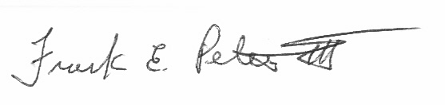
Frank E. Petersen, III
Director, Office of Quality Assurance
NASA, Office of the Chief Financial Officer
Suggested Vendor Contact:

Name: ___________________

Title:_____________________

Telephone: _______________

Fax: ____________________

E-mail address: ___________

___ Place an (x) here to indicate account has no outstanding invoices, debits, or credits.

Customer Contact Center Strategy

The NSSC Contact Center Service Delivery Guide provides details regarding menu positioning, routing, and escalation of inquiries for this activity.

Sample of Visio Cross Functional Flowchart Process Flow



Office of the
Chief Financial Officer

Recovery Audit Program Administration Guidance

February 19, 2008
The National Aeronautics and Space Administration (NASA), Office of the Chief Financial Officer (OCFO) is responsible for complying with the Improper Payments Information Act of 2002 (Public Law No. 107-300). This law requires agencies to annually identify programs and activities susceptible to improper payments, estimate the annual amount of improper payments and submit that estimate to Congress. For improper payments that exceed $10 million, the agency must report the actions it is taking to reduce improper payments and address the root causes for the improper payments.

The Defense Authorization Act for Fiscal Year 2002 added a new subchapter to the 4 U.S. Code (31 U.S.C. §§3561-3567) that requires agencies that enter into contracts with an annual total value in excess of $500 million to carry out a cost-effective program to identify errors made in paying contractors and to recover amounts erroneously paid to contractors.

Federal agency guidance for adherence to these two laws is provided by the Office of Management and Budget (OMB) Circular A-123, Management’s Responsibility for Internal Control, Appendix C, Requirements for Effective Measurement and Remediation of Improper Payments. This OMB guidance governs the improper payment risk assessment process and reporting, and the recovery audit program of all Federal agencies.

This document provides internal NASA guidance on the implementation of NASA’s Recovery Audit Program.

References

Section 831 of the Defense Authorization Act (2002) “Recovery Auditing Act” U.S. Code (31 U.S.C. §§3561-3567)

OMB Circular A-123, Appendix C “Requirements for Effective Measurement and Remediation of Improper Payments”

NASA Financial Management Requirements Volume 15, Chapter 6 “Prompt Payment”

NASA Accounts Receivable and Write-Off interim policy dated June 12, 2007

Terms

Recovery Audit is a review and analysis of the agency’s books, supporting documents, and other available information supporting its payments that are specifically designed to identify overpayments to contractors that result from payment errors.

Payment errors are errors resulting in duplicate payments; errors on invoices or financing requests; failure to reduce payments by applicable sales discounts, cash discounts, rebates or other allowances; payments for items not received; mathematical or other errors in determining payment amounts and executing payments; and the failure to obtain credit for returned merchandise.

Overpayment is any payment in excess of the amount that should have been made under statutory, contractual, administrative, or other legally applicable requirements. See attached list of “Examples of overpayment types”. Examples of overpayments include but are not limited to: (1) a payment that is greater than the contractual value of goods received or services performed (2) an early or accelerated payment for goods or services, (3) a payment that does not properly deduct the full available discount.

Note: (2) Per FMR Vol. 15 Chapter 6: NASA shall make payments no more than seven days prior to the payment due date, but as close to the due date as possible, unless the agency head or designee has determined an earlier date is beneficial to the Government, on a case-by-case basis for specific payments. The Deputy Chief Financial Officer for Finance (DCFO (F)) must use this authority cautiously, weighing the benefits of making the payment early against the good stewardship inherent in effective cash management practices. Written determinations to approve early payments shall be retained in the payment file.

Note: (3) SAP system configuration deducts discounts for credit memorandums from the Net amount of the invoice versus the Gross amount. This is the result of a system configuration that is currently being addressed by NASA and therefore resulting errors should not be considered overpayments for recovery auditing.

All Collection activities for the purpose of the guidance will be performed by the NASA Shared Services Center to recover amounts erroneously paid to contractors.

Roles and Responsibilities

- The Office of the Chief Financial Officer (OCFO) has primary responsibility for general program oversight to include acting as the contracting officer technical representative (COTR), giving guidance to Center CFO organizations, and ensuring that Centers properly and consistently carry out their assigned responsibilities.

- The OCFO, Quality Assurance Division (QAD), ensures the execution of the program objective. This includes preparation of Agency guidelines, criteria for the determination, collection, and disposition of funds recovered.

- The Center Chief Financial Officer (CFO) reviews Contractor findings and supporting documentation and makes final determination whether recommended debts will be posted for collection following agency guidelines/criteria. See attached “Roles and Responsibilities”. The NASA Shared Service Center (NSSC) will handle all activities related to the collection of funds, including all correspondence with the agency’s contractors.

- The Contractor prepares and implements a recovery audit execution plan. The recovery audit execution plan includes methodology to; sample transactions, analyze discrepancies, and identify overpayments (i.e. payment errors) that are submitted to the Center CFO for review in accordance with NASA guidelines.

- The Recovery Audit Liaison designated by Center CFO is the point of contact for inquiries/requests from the QAD/Contractor. Unless otherwise specified, all documentation requests, submission of overpayment packages, dissemination of information, and correspondence with Contractors is routed through the Recovery Audit Liaison.

- The NSSC is responsible for mailing out the initial inquiry letters to selected vendors requesting a statement/reconciliation of NASA accounts. When debts are identified by the Contractor and validated by the Center CFO the NSSC will conduct collection activities to recover funds. After funds are received, the NSSC shall carry out appropriate disposition of the funds.

Scope of Recovery Audit

The recovery audit will focus only on completed fixed-price contract payments within a given fiscal year. Cost-type contract payments are excluded from the recovery audit scope because these contracts are already examined by DCAA and resolved through the contract closeout process.

Recovery Audit Procedures

The following information describes NASA’s procedures to identify, analyze, post, and collect erroneous payments on completed fixed-price contract payments.

NASA uses a Contractor to perform recovery audit services on a contingency basis. The Contractor shall employ statement and transaction audit procedures to identify possible payment errors. The Recovery Auditor develops and implements the following strategy for identifying contract overpayments.

- Prepare initial listing and letter to selected vendors requesting a statement/reconciliation of NASA accounts. The Contractor will follow-up via letter/fax/phone to non-responding contractors. Note: This is a standard industry practice used by Recovery Audit Contractors to identify payment errors. The Recovery Auditor is generally prohibited from making direct contact with Agency contractors; however, this exception is approved to expedite the gathering of needed information.

- The contractor will submit document requests related to possible payment errors to the appropriate NASA Center thru the NASA Audit Tracking System (NATS). Requests should be provided at least one week prior to the requested due date. Documentation that may be requested by the Contractor includes; contracts, invoices, purchase orders, receiving documents, and the actual payment(s) to identify possible payment errors. In the performance of this work the Contractor is prohibited from:

  - Requiring production of any records or information by the agency’s contractors. Only duly authorized employees of the agency can compel production of information in accordance with contract terms;
  - Establishing or otherwise having a physical presence on the property or premises of any other agency contractor for the purpose of performing the contract;
  - Acting as an agent for the Federal Government in the recovery of funds erroneously paid to contractors;
  - Using or sharing sensitive financial information with any individual or organization, whether associated with the Federal Government or not, that has not been released for use by the general public;
  - Disclosing any information that identifies an individual, or reasonably can be used to identify an individual, for any purpose other than performing the recovery audit.

- Once a payment error is identified, the Contractor calculates the amount of the overpayment. For any overpayment greater then $300, the information along with supporting documentation of the payment error is provided to the Center CFO for validation.

- NASA Center CFO’s or their designees will review and validate whether recommended debts are to be referred for collection or deemed invalid within 90 days, less time may be needed depending on the extent of verification required.

- If the Center CFO determines the debt to be valid, the item is referred to the NSSC for collection. NSSC is responsible for all collection, tracking, and reporting activities related to Recovery Audit referrals for collection. Note: a special mail stop for recovery audit collections should not be set up at the Center or at the NSSC.

- The Contractor will provide a “Weekly Summary of Recoveries” report on the status of ongoing recovery activities. The Contractor will provide an annual report to the OCFO by mid September of each year, on the results of the recovery audit. The results of each year’s recovery audit effort will be reported in the NASA Agency Financial Report.

Collection Procedures

NSSC shall carry out the collection of debts referred as a result of the recovery audit. Collection activities shall follow the NASA Accounts Receivable and Write-Off policy. Posting of collections in the core financial system shall be made in accordance with the Improper Payment Options document [see attachment 1].

Funds collected, administration expenses incurred, and contingency fee payments made as part of the recovery audit program shall be specifically accounted for. The identity of all funds recovered shall be maintained as necessary to facilitate the crediting of recovered funds to the correct appropriations and identify applicable time limitations associated with the funds recovered. The NSSC will provide a monthly accounting of all identified debts, amounts collected, and disposition of funds.

The Recovery Audit Contractor shall not make direct contact (verbally or in writing) with the agency’s contractors without consent from the Director QAD. All communications are to go through the Recovery Audit Liaison, NSSC, Center CFO or designee.

Use of Funds Collected

Funds collected under the recovery audit program shall be available for the following purposes:

- To reimburse the actual expenses incurred by NASA to administer the program.

- To pay contractors for recovery audit services.

Recovered funds that are not used to reimburse incurred administrative expenses or pay contingency fee to the recovery audit contractor:

- Shall be credited to the appropriations from which the overpayment was made, and will be available for the purposes and period for which such appropriations are available; or

- If no such appropriations remain available, the funds recovered shall be deposited in the Treasury as miscellaneous receipts.

In the event amounts recovered due to interim payment errors made under ongoing contracts (i.e., duplicate progress payments) are not available to pay the recovery audit fee, because these amounts are still needed to make subsequent payments under the contract; NASA will pay contractor out of the appropriate Center administrative funds.

Communication

The following outlines guidelines for communications between HQ, Contractor, and the Centers during the Recovery Audit.

The HQ Office of the Chief Financial Officer is responsible for the management of the Recovery Audit Program. HQ CFO provides input to the contracting officer in the selection of the Recovery Audit Contractor. Management of the audit is delegated to the Director, Quality Assurance Division (QAD). The Director, QAD oversees preparation of the audit plan and facilitates communications between the Contractor and Center personnel to obtain electronic and hard copies of documents. Recovery Audit issues that cannot be resolved between the Contractor and Center CFO are elevated to the Director, QAD for resolution.

An entrance conference will be held at each Center prior to the commencement of Recovery Audit activities. The purpose of the meeting is to clearly define the Contractor, Center, and HQ roles and responsibilities. The Center CFO will designate a Recovery Audit Liaison as the point of contact for all information requests.

The Director, QAD will provide periodic updates to the Center CFOs on the status of the Recovery Audit progress and audit results. The Center CFO will provide the Director, QAD with a monthly status report by the 15th day of each month for the previous month on recommended debts submitted by the Contractor for validation and status of collection activities.

Recovery Audit Contractor Contingency Fee Payment

Recovery Audit Collections are to be tracked separately; (1) to reimburse actual expenses incurred by NASA to administer the program (2) for calculation of the payment to the recovery audit contractor once the funds are actually recovered by NASA and (3) to ensure proper credit of any excess funds to the correct appropriation. OMB guidance requires all funds collected and all direct administration expenses incurred as part of the recovery audit program shall be specifically accounted for.

Following the recovery of the funds, the NSSC shall calculate the payment to the recovery audit contractor based upon contractual contingency fee percentage. The percentage shall be applied only to the principal amount collected. Interest or penalty resulting from debt collections shall not be factored into the contingency fee payment.

Corrective Action Plans

For each overpayment determined valid by the Center CFO, the recovery audit contractor shall analyze the reason payment error occurred, and recommend cost effective controls to prevent such overpayments in the future, as a normal part of their contract work. The Center CFO, in consultation with QAD, is responsible for taking appropriate action(s) to address the identified control deficiency to preclude future reoccurrence of the payment error. A corrective action plan shall be prepared and maintained detailing the following:

- Payment error identified
- Root cause of error
- Planned actions to address deficiency
- Responsible official
- Target completion date
- Actual completed date
- Evidence root cause has been eliminated

Corrective action plans shall be provided to the QAD no later than 30 days after the debt is determined to be valid by the Center CFO. Quarterly updates shall be provided to OQA on the status of corrective actions within the first two weeks of: January, April, July, and October. Unless otherwise approved by the OCFO/QAD, all corrective actions shall be implemented within six months of the Center OCFO debt determination.

ROLES AND RESPONSIBLITLIES CENTER CFO’S

- Recovery Audit Liaison

Center CFO’s will assign a recovery audit liaison to research recommended overpayments provided by the recovery audit contractor.

- Review of Proposed Overpayments

If the Center CFOs disagree with the contractor’s determination of an overpayment, they shall provide adequate documentation for justification of their determination of why they disagree with the contractor’s determination of an overpayment and maintain this documentation at the Center in accordance with retention requirements for official payment records.
A copy of the documentation justifying the invalidity of the proposed claim will be sent to the recovery audit contractor as requested.

- NSSC

Once debt has been validated, the NSSC will conduct collection activities to recover funds. After funds are received, the NSSC shall carry out appropriate disposition of the funds.

EXAMPLES OF OVERPAYMENT TYPES

- Invoices containing incorrect mathematical calculations
- Incorrect payment of invoice (i.e. incorrect vendor, payment of voided invoice, payment on closed contract, unauthorized charges on invoice)
- Multiple payments of one invoice
- Multiple invoices for a single charge due to different invoice numbers
- Multiple invoices for a single charge due to multiple mailing addresses
- Multiple invoices for a single charge with inconsistent product description
- Invoice containing improper taxation
- Invoice containing improper transportation charges
- Non-receipt of products/services contained in the invoice
- Restocking charge paid in error
- Payments made against an invoice and also paid by credit card or manual check
- Cash/Trade Discount Earned not Taken
- Cash/trade discount deducted at wrong rate
- Cash/trade discount repaid on return
- Cash/trade discount deducted repaid in error
- Cash/trade discount repaid credit memo
- Open credits/credit memos not deducted
- Interest penalty paid at wrong amount
- Interest penalty paid in error

 | Contract status  Project status  Fund status | Step 1 | Step 2 | Step 3 | Step 4 | Step 5 | Step 6
Scenario 1 | - Contract open  - Project open  - Fund  - Unexpired  - Expired | A/R sets up a receivable for the vendor  T-code: FB70 | Funds collected from vendor and the bill of collection liquidated. | A/P creates a credit memo against the contract of record for the amount recovered less the percent to be paid to the Recovery Audit Contractor.  T-code: MIRO  Clear Credit Memo to cash: F-52 | A/P creates a credit memo for the Recovery Audit Contractor percentage of the payment on the contract of record T-code: MIRO  The credit memo will be against the vendor that received and repaid the improper payment  Clear Credit Memo to cash: F-52 | A/R reverses the receivable in step 1 | A/P posts invoice to pay Recovery Audit Contractor percentage using Invoice T-code: MIRO  Pay Invoice: F110

Scenario 2 | - Contract closed  - Project open  - Fund  - Unexpired  - Expired | A/R sets up a receivable for the Recovery Audit Contractor  T-code: FB70 |  |  | A/P creates a credit memo citing the vendor that received the improper payment. The credit will be used to process the payment for the Recovery Audit Contractor against the project WBS.  The vendor should be in SAP even though the contract is closed. If the vendor master record does not exist the center will need to submit an SR to have it added.  T-code: SB65  Clear Credit Memo to cash: F-52 | A/R reverses the receivable in step 1 | A/P pays the Recovery Audit Contractor percentage using a FI Invoice  T-code: FB60  Pay Invoice: F110

 | Contract status  Project status  Fund status | Step 1 | Step 2 | Step 3 | Step 4 | Step 5 | Step 6
Scenario  3 | - Contract closed  - Project closed  - Fund  - Expired | A/R sets up a receivable for Recovery Audit Contractor  T-code: FB70 |  | Use JV to process the amount for percentage to Recovery Audit Contractor | Use JV to process the amount for Misc. Receipts if refund can not be identified against a specific WBS | A/P pays Recovery Audit Contractor percentage using FI Invoice  T-code FB60 | Pay Invoice: F110  Reverse Receivable.

Notes

- Any collections for improper payment related to a cancelled appropriation should be collected into 803200 (Collection of Receivables from Cancelled Accounts). Subsequent payments to the Recovery Audit Contractor will be made from the current appropriation (1% set aside for payment of cancelled payables)

- Recovery of improper payments against an open contract will result in a shortage of available funds for disbursement if the contract is paid in full at the current contract value. Additional funds will need to be obligated to cover the fee that is being charged for the recovery of the improper payment.

- MR11 -- closed contract or open contract with closed lines. No further transactions can be posted to PLI. Submit service request (SR) to Competency Center to reverse MR11 to allow further processing against vendor contract.

Appendix C – Roles & Responsibility Matrix

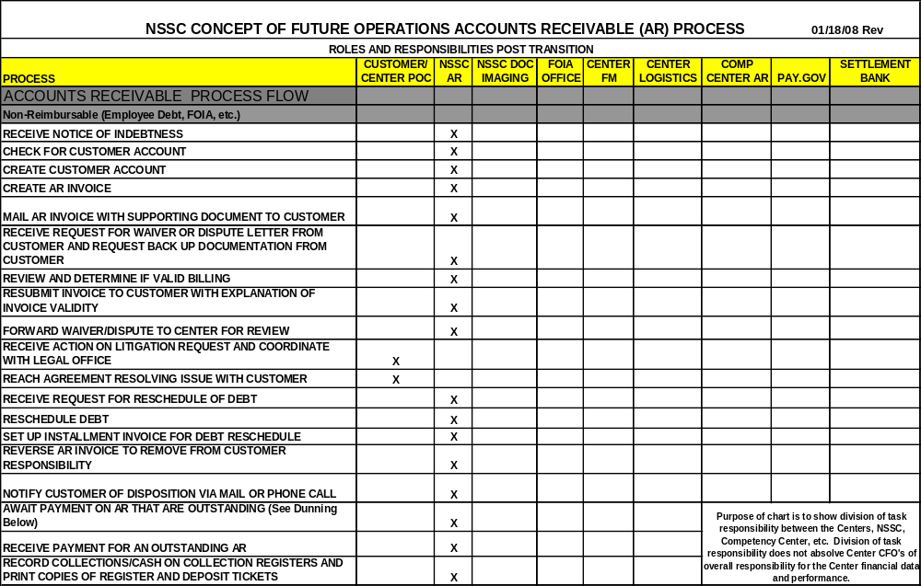

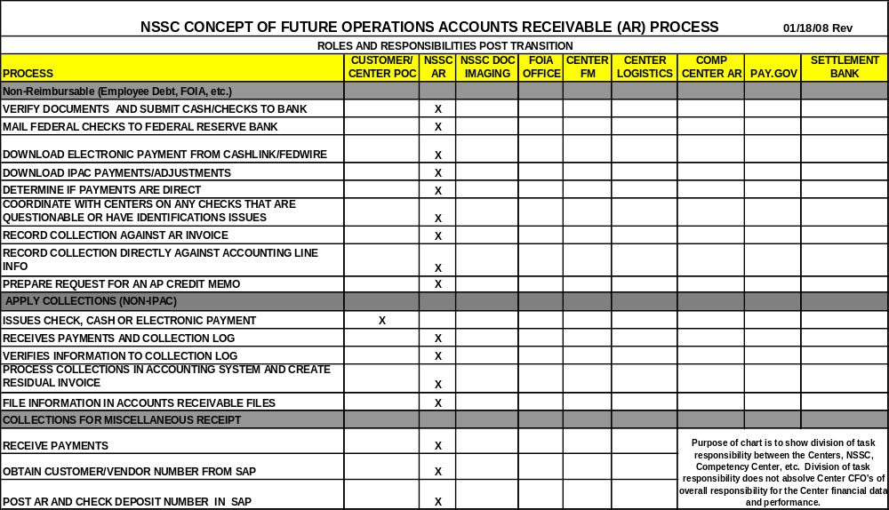

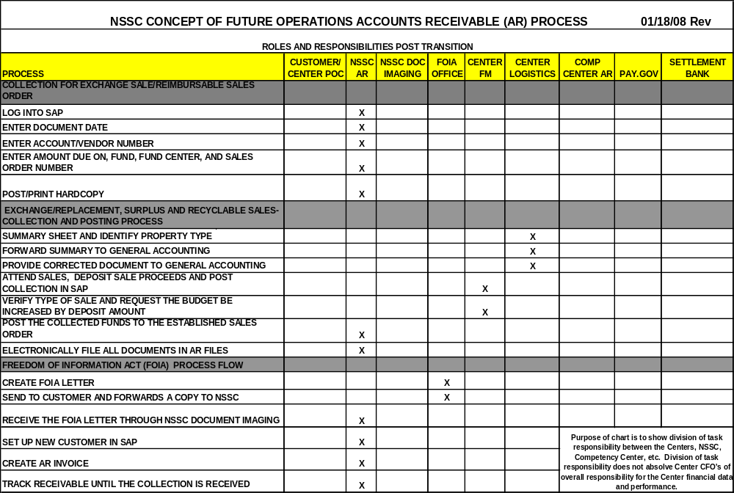

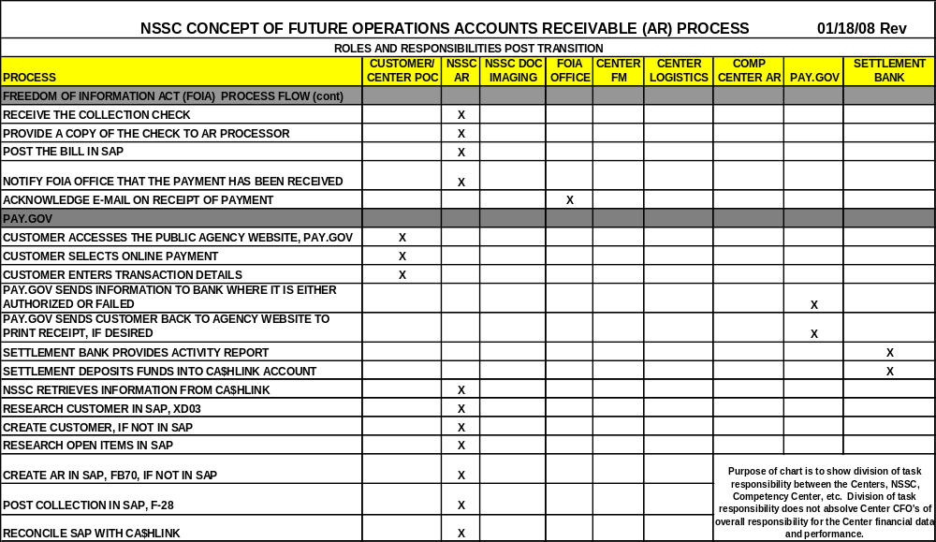

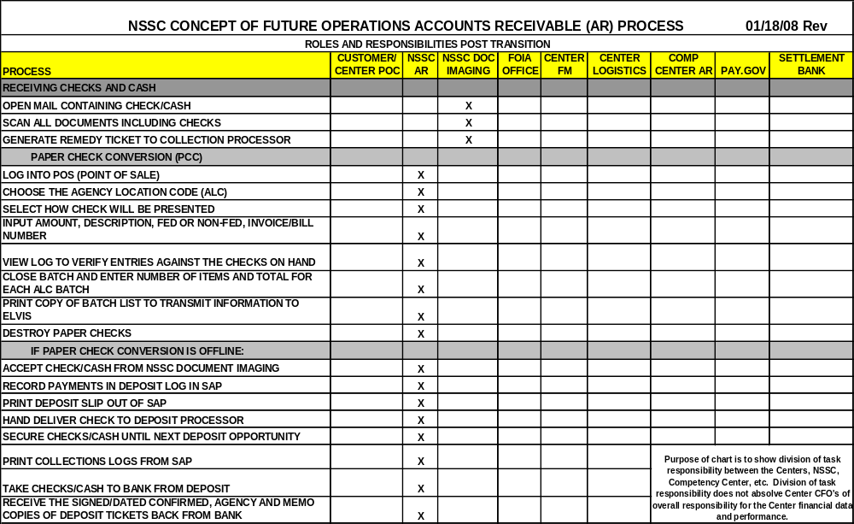

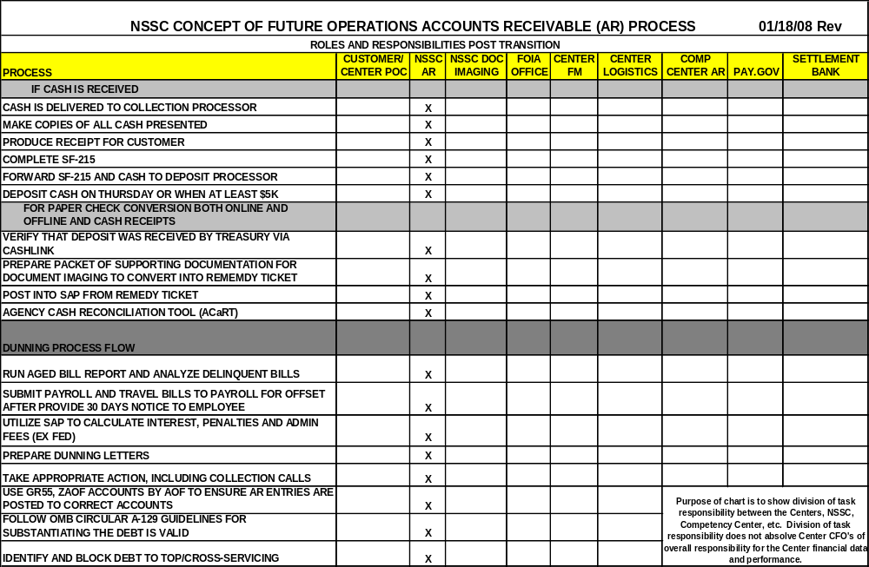

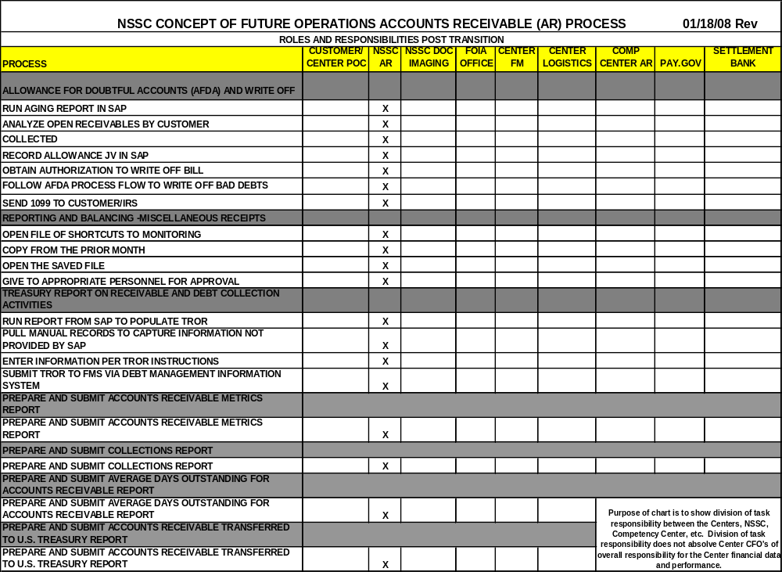

Do not put anything on this page. Remove this text box when service delivery guide is complete.

National Aeronautics and Space Administration
NASA Shared Services Center
Building 5100
Stennis Space Center, MS 39529-6000
www.nssc.nasa.gov
www.nasa.gov

