NASA Shared Services Center Service Delivery Guide



National Aeronautics and
Space Administration
NASA Shared Services Center
Stennis Space Center, MS
39529-6000
www.nssc.nasa.gov

NSSC- FM-SDG-0008 Revision B

Effective Date: May 28, 2008
Expiration Date: May 28, 2013

ACCOUNTS RECEIVABLE – NON-REIMBURSABLE (EMPLOYEE DEBT, FOIA, ETC.)

Responsible Office: Accounts Receivable

Approved by

_Signature Pending_
Joyce M. Short
Deputy Director

_______________
Date

DOCUMENT HISTORY LOG

Status (Basic/Revision Cancelled) | Document Version | Effective Date | Description of Change
Basic |  | 02/21/008 | Basic Release
Revision | A | 04/17/008 | Added Travel department audit guidelines and Payroll department guidelines for creating Receivable (p 8 & 12)
Revision | A | 04/17/008 | Added verification of Customer Master data (p 9 & 13)
Revision | A | 04/17/008 | Added Pay.gov insert in mailing (p 9 & 13)
Revision | A | 04/17/008 | Added T-Code F-28 to FOIA process (p 16)
Revision | A | 04/17/008 | Added PWC reconciliation at least weekly of deposits to CA$HLINK, etc. (p 22)
Revision | A | 04/17/008 | Added combination to safe changed semi-annually or as employee leaves, with On Demand SWR with Jacobs Technology (FOSC Contract) to include locksmith service (p 17)
Revision | A | 04/17/008 | Corrected Deposit Processor from Collection Processor (pp 17-19)
Revision | A | 04/17/008 | Enhanced PCC process (pp 17-19)
Revision | A | 04/17/008 | Added T-Code F-28 to Post Incoming Payments (p 19)
Revision | A | 04/17/008 | Added PWC observation of Deposit Reconciliation at least weekly (p22)
Revision | A | 04/17/008 | Added B of A posting procedures (pp 23-24)
Revision | A | 04/17/008 | Added FBL5N to query International Receivables monthly for NATS Report (p 33)
Revision | A | 04/17/008 | Added FIDO section in TROR Reporting Section (p 33)
Revision | A | 04/17/008 | Added PMC Chapter 4 Section (pp 33-34)
Revision | B | 06/18/008 | Added Tuition/Training BOC’s (p 19)
Revision | B | 06/18/008 | Clarified FOIA Process Customer Analysis (p 28)
Revision | B | 06/18/008 | Clarified FOIA Process Receipt/Posting of payment (p 29)
Revision | B | 06/18/008 | Clarified Receipt of Checks/Cash processes (pp 30-44)
Revision | B | 06/18/008 | Clarified Dunning Process (pp 49-50)
Revision | B | 06/18/008 | Added steps on referring debt to Treasury (pp 52-53)
Revision | B | 06/18/008 | Clarified steps on writing off bills (pp 55-56)
Revision | B | 06/18/008 | Clarified OCFO Reporting – TROR, FIDO and CMP’s (pp 59-60)

TABLE OF CONTENTS

Accounts Receivable – Non-Reimbursable (Employee Debt, FOIA, etc.) 7
Introduction 7
Legislation 9
PROCESS–Creating AR Invoice 11
Roles & Responsibilities 11
PROCESS–Creating Payroll AR Invoice 20
Roles & Responsibilities 20
PROCESS–FOIA Process 26
Roles & Responsibilities 26
PROCESS–Receipt of Checks/Cash 30
Roles & Responsibilities 30
PROCESS–Dunning 49
Roles & Responsibilities 49
PROCESS–Allowance for Doubtful Accounts 54
Roles & Responsibilities 54
PROCESS–OCFO Reporting 59
Roles & Responsibilities 59
METRICS 61
PRIVACY DATA 62
SYSTEM COMPONENTS 63
Existing Systems 63
New Systems 63
CUSTOMER CONTACT CENTER STRATEGY 64
APPENDICES 65
Appendix A-Cross Functional Flowchart Process Flow 65
Appendix B-Acronyms and Abbreviations 80
Appendix C-Improper Payments Audit SDG 83
IMPROPER PAYMENTS AUDIT 83
Introduction 83
PROCESS 84
Processes – Recovery Audit Procedures 89
Roles & Responsibilities 89
Process – Collection Procedures 92
Roles & Responsibilities 92
Process – Corrective Action Plan 96
Roles & Responsibilities 96
METRICS 97
SYSTEM COMPONENTS 98
SAMPLE OF VENDOR LETTER 99
CUSTOMER CONTACT CENTER STRATEGY 101
SAMPLE OF VISIO CROSS FUNCTIONAL 102
FLOWCHART PROCESS FLOW 102
Appendix D-Roles & Responsibility Matrix 114
Appendix E-Dunning Letters 119

Accounts Receivable – Non-Reimbursable (Employee Debt, FOIA, etc.)

Introduction

The National Aeronautics and Space Administration (NASA) Shared Services Center (NSSC) will process collections for all NASA Centers, in accordance with the following regulations:

A. Statement of Federal Financial Accounting Standard No. 1, “Accounting for Selected Assets and Liabilities”, September 1995; http://fasab.gov/pdffiles/sffas-5.pdf

B. Treasury Financial Management supplement, “Managing Federal Receivables” [Hardcopy only]

C. “Federal Claims Collection Standards” 31 CFR 900-904;
http://www.access.gpo.gov/nara/cfr/waisidx_04/31cfrv2_04.html

D. “Debt Collection Authorities under the Debt Collection Improvement Act of 1996” 31 CFR 285;
http://www.access.gpo.gov/nara/cfr/waisidx_02/31cfr285_02.html

E. OMB Circular A-129 "Policies for Federal Credit Programs and Non-Tax Receivables," November 2000;
http://www.whitehouse.gov/omb/circulars/a129/a129rev.html

F. “Debt Collection Improvement Act of 1996” [Public Law 104-134]

G. 26 CFR 1.6050P-1 (IRS 1099-C, Collection of Debt)

H. United States General Ledger; Overview: US Standard General Ledger: Publications & Guidance: Financial Management Service

I. Federal Acquisition Regulation; http://www.access.gpo.gov/cgi-bin/cfrassemble.cgi?title=200348

J. Treasury Report on Receivables (TROR); http://www.fms.treas.gov/debt/dmrpts.html

K. Financial Management Requirements: http://www.nasa.gov/offices/ocfo/references/ocfo_fmr_detail.html

In accordance with Federal regulations and NASA policy, the NSSC is responsible for billing services and required reporting for all receivables. Non-Reimbursable receivables include Freedom of Information Act receivables, Payroll/Travel Overpayments, Vendor Debt Recovery, Legal Actions, Employee Phone Bills, Lease Payments, etc. The NSSC shall provide billing services including assembling, reviewing, processing, recording, reporting, and reconciling commercial and government bills, (Intra-Governmental Payment and Collection System {IPAC’s}), etc.

The NSSC shall use Core Financial software – SAP R/3 – to perform the financial management activities. Financial Management is required to use Business Warehouse (BW) for reporting, query and reconciliation activity. NSSC is required to adhere to the NASA Financial Management Requirements (FMR), NASA’s Enterprise Performance Support System (EPSS), and other applicable Federal regulations and NASA policies and procedures. The NSSC shall process receivables from the receipt of the initial notice of indebtness to the final collection based on acceptance by NASA.

Legislation

A. National Aeronautics and Space Act of 1958 (42 U.S.C. 2451 et. seq.) This Act authorizes NASA “to enter into and perform such contracts, leases, cooperative agreements, or other transactions as may be necessary in the conduct of its work and on such terms as it may deem appropriate, with any agency or instrumentality of the United States, or with any State, Territory, or possession, or with any political subdivision thereof, or with any person, firm, association, corporation, or educational institution” Section 203. Additionally, the Act authorizes NASA “to use, with their consent, the services equipment, personnel, and facilities of Federal and other agencies with or without reimbursement, and on a similar basis to cooperate with other public and private agencies and instrumentalities in the use of services, equipment, and facilities.” In addition, Section 205 of the Act states, “The Administration, under the foreign policy guidance of the President, may engage in a program of international cooperation in work done pursuant to this Act, and in the peaceful application of the results thereof, pursuant to agreements made by the President with the advice and consent of the Senate.” Agreements using these authorities are referred to as Space Act Agreements. The NASA Space Act Agreements Manual establishes guidelines for entering into Space Act agreements.

B. Federal statutes other than the Space Act also authorize and govern reimbursable agreements for certain types of facilities and activities.

- Economy Act of 1932, 31 U.S.C. 1535. This Act provides authorization for Federal agencies to request and perform interagency reimbursable work. Under the Act, such reimbursable work must be in the best interest of the Government, and goods and services are less expensive or more conveniently provided by Federal agencies than by commercial vendors.

- Commercial Space Launch Act, 49 U.S.C. Chapter 701. This statute governs the sale, by NASA, of launch property for fair market value and the sale of launch services for direct cost only. The charge for launch services or reentry services is an amount equal to the direct costs, including the basic pay of Government civilian and contractor personnel, the Government incurred because of acquisition of the services.

- Fees and Charges for Government Services and Things of Value, 31 U.S.C. 9701. This Act requires that charges be fair; and based on (A) the costs to the Government; (B) the value of the service or thing to the recipient; (C) public policy or interest served; and (D) other relevant factors. User charges are ordinarily deposited into Treasury miscellaneous receipts, but may be retained by NASA where authorized by law. Detailed procedures for user charges are included in the Office of Management and Budget (OMB) Circular A-25.

- Land Remote Sensing Policy Act of 1992, 15 U.S.C. 5601-5602. This Act prohibits charging depreciation and other costs not specifically attributable to fulfilling users’ requests for Landsat 4 through 6 and Landsat 7 data. The Congress has directed in Section 8501(13) that data shall be made available to all users at the cost of fulfilling user requests.

- Commercial Space Competitiveness Act - Use of Government Facilities 15 USC 5807 This Act provides authority for NASA to use its space-related facilities on a reimbursable basis to support commercial space activities, and to charge only direct cost.

- National Historic Preservation Act, 16 U.S.C.470h-3. The National Historic Preservation Act provides Federal Agencies the authority to lease historic property and retain the proceeds to defray the cost of administration, maintenance, repair, and related expenses incurred by the agency with respect to property that is on the National Register.

- Enhanced-Use Lease (EUL) of Real Property Demonstration, 42 U.S.C. 2459j This section of the Space Act gives the Administrator authority to lease NASA real property to other Federal Agencies and non-federal entities and use the proceeds of the lease agreement to cover the full costs to NASA in connection with the lease. In addition, amounts received in excess of costs associated with the lease shall be available for maintenance, capital revitalization, and improvements of the real property assets of the centers selected for this demonstration program, and shall remain available until expended. The statute limits the use of this authority to no more than two NASA Centers. The Ames Research Center and Kennedy Space Center are NASA’s EUL demonstration sites.

C. In addition, various statutes govern financial accounting and reporting for reimbursable work.

- Chief Financial Officers Act of 1990, 31 U.S.C. 902. This statute requires a biennial review of costs of services provided versus charges imposed.

- Custodians of Money, 31 U.S.C. 3302. This statute requires all monies to be deposited to Treasury, unless otherwise provided by law.

PROCESS–Creating AR Invoice

(Text-Diagram process or use existing process diagram)

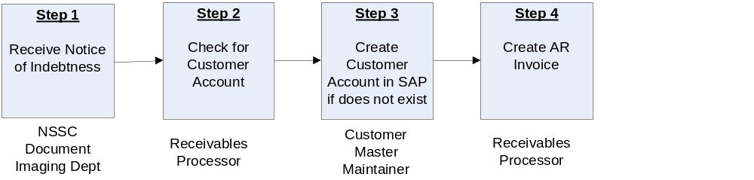

Roles & Responsibilities
Process 1 –Creating AR Invoice
Roles and Responsibilities | Action | Tips/Notes
Step 1  NSSC Document Imaging Department  Receive Notice of Indebtness | A notice of Indebtness from the Center is received by the Accounts Receivable Department via Remedy, or via SAP, employee contact, Center contact. The Accounts Receivable Department researches whether the account exists for this customer in the Open Items report, run by Receivables Processor as needed to research Customer Accounts. The notice of Indebtness includes any employee overpayment including travel, training, vendor overpayment or any other miscellaneous overpayments.  Output: Notice of Indebtness | Use T-code F-21 to Analyze Open Items.  F.21 - Analyze Open Items (End User Procedure)  Use T-code XD03 to check customer file.  Note: Travel overpayment notifications come in several ways – the employee creates a credit in Travel Manager and it passes through the interface; the employee contacts the NSSC of an overpayment; the Center contacts the NSSC about an overpayment; Travel Department audit. The NSSC Travel Department audits all travel vouchers greater than $2500, plus a random sampling of all other travel vouchers. Communication between Travel and Accounts Receivable is vital to record all indebtnesses. Bills of Collection for travel overpayments are not generated for less than $50 due to cost/benefit, per Travel Supervisor as NASA mandate. For payroll debt, the Payroll Department receives information on payroll debt through the Department of Interior (DOI) DataMart report on a bi-weekly basis.
Step 2  Receivables Processor  Check for Customer Account | Start the transaction using the menu path or transaction code XD03 to view Customer Accounts.  XD02, XD03 - Change or Display A Customer Account (End User Procedure)  Output: Verify Customer Account has been created in SAP. | Use transaction code XD03 to search for the customer’s name to determine if already established. When choosing a customer that is already established, ensure the address is the same. For a vendor, use FBL1N. Using transaction code FBL5N, check to see if the customer was previously used for reimbursable bills.  FBL5N - Customer Line Item Display (End User Procedure)  Do not use the same customer for both reimbursable and direct billings. Even though the customer may be the same, establish a separate customer account so that direct bills are not mingled with reimbursable bills.
Step 3  Customer Master Processor  Create Customer Account in SAP if it does not exist | Start the transaction using the menu path or transaction code XD01.  XD01 - Create a Federal Customer Account (End User Procedure)  Output: Customer account has been created. | If customer account needs changing, use T-Code XD02.  XD02, XD03 - Change or Display A Customer Account (End User Procedure)  Note: Due to Segregation of Duties conflict, the Customer Master Maintainer will enter/edit the account, the Receivables Processor will verify entry in SAP is correct, and sign off approval to the Customer Master Maintainer the printed copy.  Note: There is no edit in SAP to prevent two different Business Areas within customer setup. There is, however, an edit for creating multiple customers with same address to prevent duplicates, but only at the Business Area (Center). SAP does not edit check all customers across The Agency, but rather by Center. With Agency roles at the NSSC, it is  imperative to get correct Customer number. Double check the Sales Organization and Payment Supplement Method are he
Step 4  Receivables Processor  Create AR Invoice | Start the transaction using the transaction code FB70  FB70 - Create/Reverse AR Invoice (End User Procedure)  Output: Accounts Receivable invoice is created and mailed to customer. | Print and mail the invoice to the customer and place a soft copy and any backup documentation in the customer's file in TechDoc. All files will be maintained electronically; if needed, the files can be printed. Include a copy of the Pay.gov insert, located at N:\Accounts Payable_Accounts Receivable\Accounts Receivable\Pay.Gov, title Pay Gov Bill Insert.doc.  Reconcile with S_ALR_87012173 at month end  Note: To reprint bills, use FB12 to create the request, and F-64 to print the requested bill.  FB12 - Create Correspondence Bill (End User Procedure)  F.64 - Maintain Correspondence Requests (End User Procedure)  Note: To prevent possible posting errors, it is advised to create bill with one fund per bill.
What if Invoice is Deemed Not Valid?  Receivables Processor  Reverse AR Invoice | An AR Invoice may be deemed invalid for many reasons. The invoice may have been input to the incorrect customer/ALC; the traveler may have found receipts, etc. The NSSC or the Center may deem invoice invalid based upon research provided to the NSSC.  If Invoice is deemed not valid, reverse AR invoice.  FB08 - Reverse AR Invoice (End User Procedure)  If document has already cleared, will need to reset clearing document as well. Use T-Code FBRA.  FBRA - Reverse Clearing Document (End User Procedure)  Output: Invoice Reversal | Note: The only time FBRA is used to clear a document is if a payment has been posted to the bill. If the bill is invalid and a payment was received then a customer would be entitled to a refund and this is coordinated with A/P.  Note: An invalid invoice requires documentation before reversing for audit purposes. This documentation should be provided with request for reversal from NSSC or Center. This documentation will be stored with the BOC/reversal in TechDoc.  Note: If document has been cleared, then a payment has been posted against this invoice. This means that the Customer Payment Processor will have to reset and reverse the invoice.
What if Debt is Rescheduled?  Receivables Processor  Record rescheduled debt | If Customer is unable to pay, NASA may accept a written installment agreement in accordance with 14 CFR, 1261.402 and 1261.411. The debt must be paid off within 3 years at no less than $50 per installment. The current value of Funds Rate would be used to determine the interest charged and any administrative charges and/or penalties should be disclosed on the agreement as provided in FMM 9051-4e. Should installment be based on an employee voluntary payroll deduction, the following must be sent to NSSC Payroll to authorize and forward to the Department of the Interior:  - Copy of the center bill of collection.  - Amounts scheduled identifying the number pay periods to be withheld.  - For M-7 (Memorandum to collection by payroll deduction)  - These would be sent to appropriate staff for processing.  - Identify to DOI that a check is the preferred form of payment.  To create installment invoice in system, use T-Code FB01.  FB01 - Create/Update Installment (previous Installment) (End User Procedure)  Output: Debt rescheduled | Center Directors are authorized to act on compromise offers on debts of $100,000 or less; compromise offers on debts over $100,000 must be referred to the Department of Justice for further action. Compromise decisions are to be sufficiently documented in writing.  Debts may be referred to the Department of Justice in accordance with the provisions of 14 CFR 1261.417, OMB Circular A-129, and the authorities cited in 14 CFR 1261.402. Cases of fraud may be sent to Justice at any time. Debts transferred to Treasury for collection will be referred to the Department of Justice as appropriate by the Treasury Department. Centers have the option of referring delinquent Federal employee accounts to the Department of Justice to obtain a judgment in accordance with section 124 of P.L. 97-276.
What if Collection Requires an A/P Credit Memo?  Receivables Processor  Record rescheduled debt | If the original activity resides on the Vendor side (i.e. Travel, Accounts Payable, Training, etc.), the collection will require an A/P Credit Memo. When the cash is received, the AR staff with AP roles is notified via Remedy ticket and they will create the vendor credit memo and clear their outstanding Credit Memo against the Vendor. AR can create a Credit Memo and clear using T-Code F-30 (F-30 - Update Status of Receivable to Clear (End User Procedure)  .  Output: AP Credit Memo applied. | To inquire by vendor, use T-Code FBL1N.  Bankcard FBL1N Credit Report  Note: The transaction codes FB65 and F-52 (FB65 - Enter Credit Memo and Park Post (End User Procedure) and  F-52 - Post Incoming Payments Clear Credit Memo to Cash)  are performed by AR staff with A/P roles. The transaction performed by A/R roles should be to post a T-code FB75 with a DG document type. This records a credit memo against the outstanding accounts receivable, causing the two to net to zero. Whenever A/P roles record the entry for the collection, A/R records a credit memo to offset the outstanding bill amount.
What are the Steps for Tuition/Training Overpayments?  Receivables Processor  Create Tuition/Training Invoice | - The Training Office will create a notice of Indebtness for the tuition/training overpayments. This will entail the Centers choosing “Collections” from the drop down on the fax cover sheet.  - This will be faxed to the TechDoc.  - TechDoc will create a Remedy ticket with a CTI of Financial Management/Accounts Receivable/Bill of Collection.  - The Receivables Processor will create the AR Invoice using T-Code FB70, following steps 2-4 above.  Output: Tuition/Training Invoice created.

PROCESS–Creating Payroll AR Invoice

(Text-Diagram process or use existing process diagram)

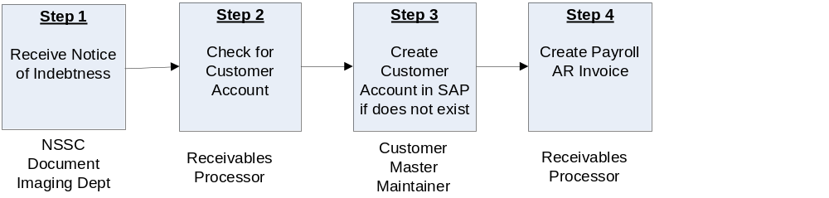

Roles & Responsibilities
Process 2 –Creating Payroll AR Invoice
Roles and Responsibilities | Action | Tips/Notes
Step 1  NSSC Document Imaging Department  Receive Notice of Indebtness | A notice of Indebtness from the Center is received by the Accounts Receivable Department via Remedy, or via SAP, employee contact, Center contact. If the notice is received by any method other than Remedy, create a Remedy ticket to document. The Accounts Receivable Department researches whether the account exists for this customer in the Open Items report.  Output: Notice of Indebtness | Use T-code F-21 to Analyze Open Items.  F.21 - Analyze Open Items (End User Procedure)  Use T-code XD03 to check customer file.  XD02, XD03 - Change or Display A Customer Account (End User Procedure)
Step 2  Receivables Processor  Check for Customer Account | Start the transaction using the menu path or transaction code XD03 to view Customer Accounts.  XD02, XD03 - Change or Display A Customer Account (End User Procedure)  Output: Verify Customer Account has been created in SAP. | Use transaction code XD03 to search for the customer’s name to determine if already established. When choosing a customer that is already established, ensure the address is the same. For a vendor, use FBL1N. Using transaction code FBL5N, check to see if the customer was previously used for reimbursable bills.  FBL5N - Customer Line Item Display (End User Procedure)  Do not use the same customer for both reimbursable and direct billings. Even though the customer may be the same, establish a separate customer account so that direct bills are not mingled with reimbursable bills.
Step 3  Customer Master Processor  Create Customer Account in SAP if it does not exist | Start the transaction using the menu path or transaction code XD01.  XD01 - Create a Federal Customer Account (End User Procedure)  Output: Customer account has been created. | If customer account needs changing, use T-Code XD02.  XD02, XD03 - Change or Display A Customer Account (End User Procedure)  Note: Due to Segregation of Duties conflict, the Customer Master Maintainer will enter/edit the account, the Receivables Processor will verify entry in SAP is correct, and sign off approval to the Customer Master Maintainer the printed copy.  Note: There is no edit in SAP to prevent two different Business Areas within customer setup. There is, however, an edit for creating multiple customers with same address to prevent duplicates, but only at the Business Area (Center). SAP does not edit check all customers across the Agency, but rather by Center. With Agency roles at the NSSC, it is imperative to get correct customer number. Double check the Sales Organization and Payment Supplement Method are the same ALC.
Step 4  Receivables Processor  Create Payroll AR Invoice | Start the transaction using T-code FB70  FB70 - Create AR Invoice for ePayroll (End User Procedure)  Output: A payroll invoice is created. | Perform this procedure upon notification that an employee owes money to NASA.  Print and mail the invoice to the employee and place a soft copy and any backup documentation in the employee's file in TechDoc. . Include a copy of the Pay.gov insert, located at N:\Accounts Payable_Accounts Receivable\Accounts Receivable\Pay.Gov, title Pay Gov Bill Insert.doc.  Reconcile with S_ALR_87012173 at month end. Run report at month end and verify that all BOC’s in Open Folder on N-drive by Center are on report. Make any necessary adjustments.  Note: The NSSC Payroll Office is currently working as a liaison for the Center with Department of Interior, not MSFC. Payroll deductions are garnishments and are not entered into on a voluntary basis. (Exception – payroll deduction can be an option of payment.)  Note: To reprint bills, use FB12 to create the request, and F-64 to print the requested bill.  FB12 - Create Correspondence Bill (End User Procedure)  F.64 - Maintain Correspondence Requests (End User Procedure)  Note: To prevent possible posting errors, it is advised to create bill with one fund per bill.
What if Invoice is Deemed Not Valid?  Receivables Processor  Reverse AR Invoice | If Invoice is deemed not valid, reverse AR invoice.  FB08 - Reverse AR Invoice (End User Procedure)  If document has already cleared, will need to reset clearing document as well. Use T-Code FBRA.  FBRA - Reverse Clearing Document (End User Procedure)  Output: Invoice Reversal | Note: The only time FBRA is used to clear a document is if a payment has been posted to the bill. If the bill is invalid and a payment was received then a customer would be entitled to a refund and this is coordinated with A/P.  Note: An invalid invoice requires documentation before reversing for audit purposes. Documentation stored with BOC in TechDoc.  Note: If document has been cleared, then a payment has been posted against this invoice. This means that the Customer Payment Processor will have to reset and reverse the invoice.

PROCESS–FOIA Process

(Text-Diagram process or use existing process diagram)

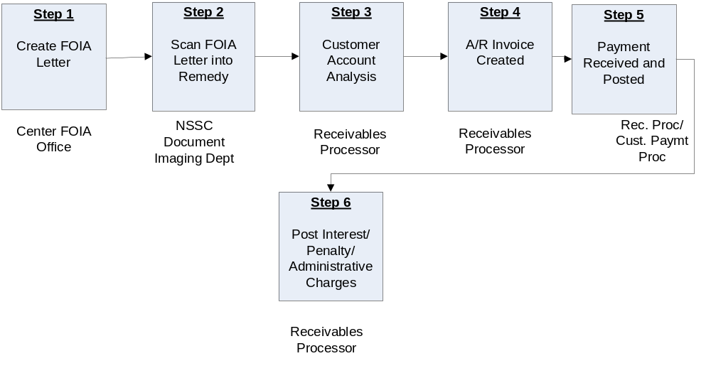

Roles & Responsibilities
Process 3 –FOIA Process
Roles and Responsibilities | Action | Tips/Notes
Step 1  Center FOIA Office  Create FOIA Letter | - The FOIA Office at the Center creates the FOIA Letter/Bill.  - The FOIA Office then sends the letter/bill to the customer, and forwards a copy to the NSSC Document Imaging Department.  Output: FOIA Letter. | Need to establish FOIA POC’s for each center.
Step 2  NSSC Document Imaging Department  Scan FOIA Letter into Remedy | - The NSSC Document Imaging Department receives the FOIA letter/bill in the mail, and scans it into the Tech Doc system.  - The NSSC Receivables Processor receives the FOIA letter/bill via a Remedy ticket, with a CTI of Financial Management/Accounts Receivable/Bill of Collection.  Output: Remedy Ticket for FOIA Letter created in Tech Doc system.
Step 3  NSSC Receivables Processor  Customer Account Analysis | - The NSSC Receivables Processor will determine if a customer account needs to be established. Query Customer list using XD03 to see if customer exists. If Customer does not exist, forward Remedy ticket to Customer Master Maintainer to create Customer. T-Code XD03 will display Customer Account information.  XD02, XD03 - Change or Display A Customer Account (End User Procedure)  - If the customer account has not been created, the Receivables Processor will provide the necessary information to the Customer Master Maintainer to create a new customer account in SAP.  Output: Customer Account Verified/Created | Use T-Code XD03 to query customer list. Query by name using asterisk as wild card at front and end of section of name.  XD02, XD03 - Change or Display A Customer Account (End User Procedure)  Use T-Code XD01 to create Customer Account  XD01 - Create a Federal Customer Account (End User Procedure)  Note: Due to Segregation of Duties conflict, the Customer Master Maintainer will enter/edit the account, the Receivables Processor will verify entry in SAP is correct, and sign off approval to the Customer Master Maintainer the printed copy.  Note: Store approved Customer Master sheet with BOC in TechDoc.
Step 4  NSSC Receivables Processor  A/R Invoice Created | - Once the Customer Account has been verified/created, the Receivables Processor creates the A/R Invoice. The Customer number derives the debit (a 1310 account), credit 5993.0000, debit 5994.0000, and credit 2985.0000.  - The Customer Payment Processor tracks the receivable until the collection is received  Output: A/R Invoice | Use T-Code FB70 to create A/R Invoice  FB70 - Create AR Invoice (End User Procedure)  Note: FOIA information is sent to the customer along with the bill; create the Receivable once the letter has been received by the NSSC.
Step 5  NSSC Receivables Processor/Customer Payment Processor  Payment is Received and Posted | - Use T-Code FD11 to analyze account detail  FD11 - Analyze Delinquent Bills (End User Procedure)  - Use T-Code F-28 to post payment to receivable.  F-28 - Post Incoming Payments (End User Procedure)  - After check is received and posted, notify the FOIA office at the center that generated the letter via e-mail to FOIA office.  Output: Customer payment is received and posted against customer account | Note: The combination to the safe(s) should be changed on a semi-annual basis or as employees leave to maintain security integrity.  Note: Deposit Processor Supervisor will review and reconcile the deposit log, Paper Check Conversion Summary Report, check batch listing, SF-215 and CA$HLINK Report at least weekly.

PROCESS–Receipt of Checks/Cash

(Text-Diagram process or use existing process diagram)

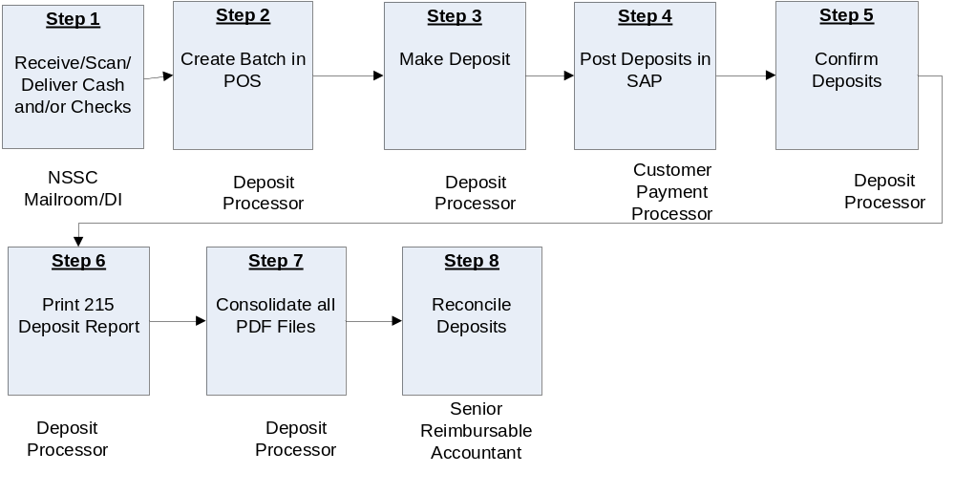

Roles & Responsibilities
Process 4 –Receipt of Checks/Cash
Roles and Responsibilities | Action | Tips/Notes
Step 1  NSSC Mailroom Personnel/  Document Imaging  Receive/Scan/  Deliver Cash and/or Checks | - Mail is delivered daily to the NSSC secure mailroom and all checks are scanned into TechDoc.  - A check arrives at the NSSC, and is scanned into TechDoc by Document Imaging.  - Document Imaging creates a Remedy ticket for the check routing to Level 2 (SP), and also provides a courtesy call to the CS.  - The SP Customer Payment Processor (CPP) receives the Remedy ticket, and researches to verify that the check should be deposited by the NSSC. The SP CPP will document this information by completing the Center and Type of Receivable fields on the AR tab of the Remedy ticket. For researching purposes, enter, also on the AR tab, the Customer Name, Customer Address, Dollar Amount (of the check received), Date of Check (Date check was written), and mark <Yes> if Unidentified Check. Inserts comments if Unidentified Check is marked yes.  - The SP CPP will then route the Remedy ticket to Level 3, so the CS Deposit Processor (DP) can process the check through Paper Check Conversion (PCC).  - Upon processing through PCC, the CS DP will record on the AR tab of the Remedy ticket the Deposit Ticket number (voucher number if a Pay.gov payment) and the check sequence number. On Activity Tab, in work log, enter the following: Batch ID, Line Number, Auto generated Batch number at top of page, Date of deposit, and IRN number for check. If payment by Pay.gov, enter the voucher number from transaction statement. The CS will then route back to Level 2 (SP CPP)  - The CS DP will send a copy of the deposit information to Document Imaging to attach to the original Remedy ticket.  - If the deposit should be posted in SAP by the NSSC, the SP CPP will post based upon the information provided on the AR tab in Remedy. If the Center is to post the deposit in SAP (i.e. Advance), the Remedy ticket will be matched with the Advance notification Remedy ticket, and an e-mail will be automatically generated to the Center. (If no Advance notification was sent by the Center, a manual e-mail will have to be created by the CPP to the Center detailing the Batch ID and the Check Sequence number.)  - Upon posting in SAP by the NSSC, the SP CPP will record the SAP document number on the AR tab and resolve the Remedy ticket. If the Center posts the deposit, the Item is changed to “Accounts Receivable”, and resolved.  - Mail run occurs at 3:00 pm each day. Collections will be compiled in batch format, recorded in log book, and held in locked safe/cabinet overnight, for distribution the following business day. Collections of less than $5,000 may be accumulated and deposited when the total reaches $5,000; however, deposits will be made by Thursday of each week, regardless of the amount accumulated. For auditing purposes, reports will be generated to ensure accuracy and accountability.  Output: Open, scan and deliver checks/cash to SAP Deposit Processor and Remedy ticket created. | Note: All checks must be processed through Document Imaging. If the NSSC receives a check outside of this process, the check must be immediately sent to the Document Imaging Department for proper processing.  Only the Collection Agent and his Alternate and the NSSC’s Security Department will have the combination to the Safe.  Note: The combination to the safe(s) should be changed on a semi-annual basis or as employees leave to maintain security integrity. . The NSSC has a standing On Demand Service SWR (Stennis Work Request) with Jacobs (FOSC Contract) to include lock smith service. E-mail Jacobs POC that the combination lock on a Mosler safe needs to be changed or serviced.  Note: Cutoff for Check processing is 4:00 p.m. daily. If Accounts Receivable is notified after 4:00 p.m., the checks will be processed the next appropriate time.
Step 2  NSSC Deposit Processor  Create batch in POS | - The Collection Processor accepts Remedy ticket.  - For Paper Check Conversion (PCC) the Deposit Processor receives the checks, and logs into POS (Point of Sale).  - To find the next consecutive batch number, log into CA$HLINK, select <Inquiry>, then <Agency Voucher Query>. Enter the ALC, then enter the voucher date range of beginning of current fiscal year through present date. Check for origin “FRB PCC”, and use the next available number as the deposit ticket number.  - Select Center (location) from the Agency Location Code (ALC) drop down on the right side of the screen. Select <Customer Not Present>. Select either <non-personal> or <personal> check. Select <Start Scan>.  - Enter amount of check, customer name, center name from drop down box, select type of payment from drop down box, enter agreement number if available, and enter batch identification (id) (the number determined from step 3 above). Place check on scanner with the number (routing, check & account) facing up and to the right side. The light must be green. Wait for the check copy to appear on screen. Hit enter. This franks (or “stamps”) the check. Remove check.  - If you receive an error reading the check, click <Manual Input> and enter the following: Letter “O” check # Letter “o” space Letter “t” Routing Number Letter “t” space Account Number Letter “O”.  - Repeat Step 4 for all additional checks for same location.  Output: Batch Created in POS | Research which Center funds belong via SAP, e-mail, phone calls, web forms, etc.
Step 3  Deposit Processor  Makes Deposits | - Click Batch List on the right side of the screen. Do not select this until all batches have been processed. Verify that dollar amount and count (number of checks processed) on batch list matches actual checks on hand.  - Save Batch List to Adobe PDF.  - Print Batch List, select <Done>, and click Batch Close. Click Close All, and select Yes to confirm.  - Save as Adobe PDF (batch will not close if this step is not completed). Batch will begin to upload.  - Follow prompts on screen. Open Batch Manager. Check status of transmission (status should be Acknowledge). Exit.  - Keep one copy of Batch List and attach one to check and backup information if printed.  - Secure checks until deposit is confirmed via CA$HLINK next a.m.  - Print copy of batch list to transmit information to ELVIS, which will print the SF-215.  - Verify Change Request has been created in Remedy and input information into Deposit Spreadsheet. Check link image and verify this is the correct link (check).  Output: Deposits made and verified.
Step 4  Deposit Processor  Confirms Deposits | Confirm deposits on CA$HLINK after 9:30 a.m. CST.  - Log into CA$HLINK (this is a web based software loaded on desktop).  - Select Inquiries.  - Select FRB Preliminary Voucher. (This will give you what was deposited the previous day.)  - Enter ALC number (This creates one report for each ALC.) Do not enter multiple ALC numbers. Print one page for each ALC.  - Enter voucher date as the next business day after deposit was made.  - Select process period as “All”.  - Click <Submit>.  - Verify that amounts match Batch List/Pay.gov.  - Save as PDF file.  - Choose Printer Icon.  - Under printer option, change Name: dropdown to Adobe PDF.  - Save file to N:\Accounts Payable_Accounts Receivable\Accounts Receivable/Check Collections/Deposit Confirmations.  - Name as CL (Center) MMDDYYYYPCC.  - Select Agency Voucher Query. (This will show you any additional collections, i.e. Pay.gov, credit card collections, stop payments on collections, etc.)  - Enter ALC number. (Creates one report for each ALC.) Do not enter multiple ALC numbers. Print one page for each ALC. (Check all ALC’s).  - Enter a date range for the previous few days to confirm there have been no collections from another source or any stop payments.  - Click <Submit>.  - verify that amounts match Batch List/Pay.gov  - Save as pdf.  - Choose Printer icon.  - Under printer option, change Name: dropdown to Adobe PDF  - Save file to: N:\Accounts Payable_Accounts Receivable\Accounts Receivable\Check Collections\Deposit Confirmations.  - Name as: CL (Center) MMDDYYYYPCC.  Output: Deposits Confirmed
Step 5  Deposit Processor  Print 215 Deposit Report | Print 215 Deposit Report.  - Log into web based PCC (ELVIS) https://www.pccotc.gov/pcc5webapp/  - Select <Reports> icon on the left side of the page.  - Select <215 Deposit Ticket Report>.  - Verify date is current date, Center is NASA, and Include Subordinates box is checked.  - Submit request.  - Save as PDF.  - Choose File/Print.  - Under printer option, change Name: dropdown to Adobe PDF.  - Save file to: N:\Accounts Payable_Accounts Receivable\Accounts Receivable/Check Collections/Deposit Confirmations  - Name as: 215 DEP MMDDYYYY.  - Select 5515 Debit Voucher Report  - Verify date is current date, Center is NASA, and Include Subordinates box is checked.  - Submit request.  - Save as pdf.  - Choose>File>Print  - Under printer option, change Name: dropdown to Adobe pdf  - Save file to: N:\Accounts Payable\Accounts Receivable\Accounts Receivable\Check Collections\deposit Confirmations.  - Name as: 5515 DEBIT MMDDYYYY  - Log out of PCC.  Output: 215 Deposit Report printed. | Note: There will not be a 215 for any Pay.gov payments.
Step 6  Deposit Processor  Consolidate all PDF Files | Consolidate all PDF files into one file for each Center.  - Open PDF of 215 Deposit for that date.  - Go to Menu>Document>Insert pages.  - Find CA$HLINK file for that date/Center.  - Insert pages “AFTER”.  - Choose OK.  - Repeat steps to add Batch List PDF for that Center.  - Save file as “(Center) Recon Pkg MM/DD/YYYY”.  - Create new folders:  - Recon Pkg – save all Reconciliation Packages for each Center in this folder.  - Back up – save all back up information for all Centers in this folder.  - Corrections – save any corrections into this folder.  Output: All PDF files are consolidated.
Step 7  NSSC Customer Payment Processor  Post Deposits in SAP | The Deposit Processor creates a reconciliation packet and saves to TechDoc. The packet will contain PCC summary report, the PCC batch listing, the PCC SF215, and the FRB Preliminary Voucher Report from CA$HLINK. The Customer Payment Processor will post information from remedy ticket into SAP.  F-28 - Post Incoming Payments (End User Procedure)  Once the check has been posted in SAP, update the Remedy CH ticket to reflect the posting information and resolve the CH ticket. Enter the SAP Document number on the AR tab. Also enter the SAP Document number in the Activity log along with the customer or vendor number.  Deposit Processor will run Remedy Report twice weekly to verify that all checks have been posted and the document number was entered into the Remedy Change Request.  Output: Deposits posted in SAP | Agency shall safeguard and destroy the original paper check processed through PCC OTC that was received through the mail or at a “drop box” location no later than fourteen (14) days after the settlement date checks will be destroyed by shredding after receipt of checks is verified via the FRB preliminary voucher report.  T Code: F-28  If FOIA non app fund  Note: To post Jury Duty payments, use T-Code F-30.  F-30 - Update Status of Receivable to Clear (End User Procedure)  A spreadsheet is located on the N-drive detailing the WBS/Fund/Center, etc. to post by Center.  Note: All checks must be posted within 7 days of receipt. If checks are found to be over 7 days, the CS will contact the SP to identify the problem and assist with resolution.
Step 8  Senior Reimbursable Accountant  Reconciles Deposits | The Senior Reimbursable Accountant (or Supervisor) will review and reconcile the deposit log, Paper Check Conversion Summary Report, check batch listing, SF-215 and CA$HLINK Report at least weekly.  Output: All deposits are reconciled. | ACaRT – Agency Cash Reconciliation Tool
What if Payment is Made By Cash?  Collection Processor/Deposit Processor  Cash Receipt | If payment of debt is made by cash, the cash is delivered to the Collection Processor. The Collection Processor makes a copy of all cash presented, produces a receipt for the customer, and completes an SF-215. The Collection Processor then forwards the SF-215 and the cash to the Deposit Processor, who deposits the cash on Thursday or when at least $5K. If it is not Thursday or at least $5K, it is stored in the secure vault.  Output: Receipt of cash is accepted. | Per Bureau of Engraving, bills may be photocopied if reproduced at 75% image size or less or 150% image size or more. Photocopy one side only. Bureau of Engraving link http://www.bep.treas.gov/document.cfm/18/117  Reference for CFR Title 18, Section 504 governing black & white photocopy of cash:  http://uscode.house.gov/uscode-cgi/fastweb.exe?getdoc+uscview+t17t20+366+0++%28black%20and%20white%29%20%20AND%20%28%2818%29%20ADJ%20USC%29%3ACITE%20AND%20%28USC%20w%2F10%20%28504%29%29%3ACITE%20%20%20%20%20%20%20%20%20
What if Paper Check Conversion is Offline?  Collection Processor/Deposit Processor  Manual Deposit of Checks | If Paper Check Conversion is offline, Collection Processor records payment in Deposit Log in SAP, T-Code FF68, and prints SF-215 Deposit Slip from SAP in accordance with Financial Management Requirements (FMR) Volume 15, Chapter 4, and immediately hand delivers the checks to the Deposit Processor. The Deposit Processor will put all checks in the FM A/R Safe until next deposit opportunity. The Deposit Processor will also print the SF-215 from SAP, make copies of the checks, and take to the bank for deposit. The Deposit Processor will receive the signed/dated Confirmed Copy, Agency Copy, and Memo tickets back from the Bank. The day after the deposits are made, the Deposit Processor verifies in CA$HLINK that checks were received by the Treasury. The Deposit Processor prepares a packet for TechDoc containing SAP Check log, CA$HLINK Report, confirmed, Agency and Memorandum copies of the Deposit ticket, and any other supporting documentation.  Output: Deposit made outside of Paper Check Conversion.
How is the Bank of America Rebate Check Posted?  Customer Payment Processor  Bank of America Rebate Check Posted | Bank of America (BOA) Rebate checks arrives to the AR department via Remedy ticket,  Customer Payment Processor will receive JV voucher number from Civil Servant. Customer Payment Processor will complete NSSC journal voucher and submit to Lead Operations and Budget Management for approval.  Payment Processor will use the following steps to post the JV into SAP using T-Code FB50:  Document Date: Date of Deposit  Reference: Paper check conversion ID plus line (XXXXXXXX-XXX)  Document Header Text: JV Number, BOA rebate check (month)  Document Type: SA  Enter the following in the fields on the Accounting Distribution portion of the screen.  Select Simulate to go to the Document Overview screen.  Review the simulation results and verify that the accounting line data is correct. Make any necessary adjustments and Click to post the document.  Output: Bank of America rebate check is posted. | BOA mails the rebate in the month following the month of charges qualifying for the rebate.  Note: BOA Check will be deposited like all other checks.
  Field Name | G/L Account | G/L Account
  GL acct | 1010.5215 | 6100.2520
  D/C | Debit | Credit
  Amount | XXX.xx | XXX.xx
  Business Area | 10 | 10
  Trading Partner | NONFED | NONFED
  WBS Element |  | 384161.01.02.01
  Funds Ctr | 10 | 10
  Cmt Item | CASH | 2520
  Fund | WCNX04546R | WCNX04546R
  Cost Center |  | 10XB000
  Order # |  | FC000000
What are the Steps for entering Journal Vouchers (JV’s)?  NSSC Receivables Processor/Customer Payment Processor  Journal Vouchers entered | To enter any Journal Vouchers (including the BOA JV), open the JV Log spreadsheet, located at N:\Financial Accounting Branch\JV log\FY 2008 JV Log, titled “JV Log.xls”. Complete all necessary information to claim next JV # assigned. Complete the JV Template on the next tab, and print completed template. For Accounts Receivable, have Senior Accountant sign before appropriate Approving Official signs.  Output: Journal Vouchers are entered in SAP. | Note: Follow FMR Volume 6, Chapter 11, JV Policy dated 11/08/07, located at N:\Accounts Payable_Accounts Receivable\Accounts Receivable\Miscellaneous, titled “FMR Vol 6 Ch 11 JV POLICY 11-08-07 Signed.pdf” and  “JF POLICY COVER MEMO.pdf”.  Note: Journal vouchers are used for posting BOA rebates and recording payroll deductions.
What if a Payment Comes Via Pay.gov?  Deposit Processor  Payment received via Pay.gov | The Deposit Processor will monitor the Pay.gov website daily to pull payments made via the web. When these payments are found, the Deposit Processor will generate a pdf file of the payment, and attach to the newly created Remedy ticket.  Create TechDoc file for any payments from Pay.gov.  - Have the PDF file saved from Pay.gov open to use for information purposes when populating the fields in the TechDoc file.  - Open TechDoc.  - Go to folder FM/AR/Pay.gov.  - At menu on left side of page, click <Create Document>.  - Populate the following fields:  - Number (FM_AR_PG_mm-dd-yy_hh.mm.ss)  - Title (use the name of the person/company where payment originated).  - Doc Type (AR-Accounts Receivable).  - Doc Category (PrivAct – Privacy Act Information).  - Uncheck both boxes (Distribution List/Notification List).  - Point of Contact (enter your name).  - Organization (FM – Financial Management).  - Web Search (Campus).  - Reason (Backup Documentation).  - Click <Next>.  - Amount Received (amount of payment).  - Date Issued.  - Payor Name.  - Official Record (yes).  - Vital Record (no).  - Click <Next>.  - Access (check owner “O” and Shared Lists).  - Add in Shared Lists the following:  - FM FSB-SP.  - FM FSBIG.  - IT>DM.  - Click <Next>.  - Click <OK>.  - Release from menu on left.  - Generation (01).  - Revision (1).  - New Doc.  - Click <OK>.  Output: Payment received via Pay.gov. | Note: To pull payments made via Pay.gov, access pay.gov at https://www.pay.gov/paygov/. Enter user name and password. Click <Login>. Click <Report List> on left side of screen. Open “Collection Search Query”. Enter effective to and from date range in mm/dd/yyyy format. Click <Submit>. Click <Download>. Click <Save Report>. Click <Save>. Name report as a PDF file, and save in the Deposit Confirmation file located on the N-drive. Payments will be listed as credit card or debit. The naming convention is “Paygov(Center) MMDDYYYY”.  Create Remedy Change Request for any payments from Pay.gov and assign to AR-Checks L2. Add link to TechDoc file.  Note: The Deposit Processor runs a report on a weekly basis to validate that all Pay.gov payments have been captured.
How do I Upload Documents to TechDoc?  Deposit Processor  Documents uploaded to TechDoc | Upload documents to TechDoc.  - Log into TechDoc.  - Go to: FM>AR>CHECK_COLLECTIONS (find file associated with check you are processing) OR: FM>AR>PAY.GOV.  - Click on White Paper Icon – this will open the revisions.  - Go to left column and choose <Reserve>.  - Enter reason (ex. Attaching additional documentation).  - Click <OK>.  - Go to left column and choose <Replace>.  - Enter reason (ex. Attaching additional documentation).  - Browse for file (N:\Accounts Payable_Accounts Receivable\Accounts Receivable\Check Collections\Deposit Confirmations).  - Leave box unchecked.  - <Normal Fetch Access>.  - Click <OK>.  - Go to left column and choose <Release>.  - Enter version not revision (any file not release will populate generation field).  - Enter reason (ex. Attaching additional documentation).  - Uncheck <Watermark> box.  - Click <OK>.  - Repeat steps for each Center for which a deposit was processed.  Output: Documents uploaded to TechDoc. | Note: After backup documentation has been uploaded into TechDoc, take backup documentation and place in locked shredder box.  Note: Shred checks using shredder.
What If a Check Needs to be Returned?  Deposit Processor  Return check to customer | Follow the below procedures to return a check to a Customer.  - Check will be returned to Customer via Federal Express.  - The Tracking number and delivery confirmation number will be added to the Remedy Change Request for documentation.  - Print out of Federal Express Tracking information should be scanned and uploaded to TechDoc and attached to the check.  - Checks must be returned to original payer with an explanation of why check is being returned.  - You must have a physical address for return. No P.O. Boxes are accepted by Federal Express.  - Contact the Customer and verify the physical address listed on the check and notify them that a check is being returned and reason.  Output: Check returned to Customer.
What If a Check Is Posted to the Incorrect ALC?  Deposit Processor  Correct ALC Posting of Check | If a check is posted to the incorrect Agency Location Code (ALC), follow the below procedures.  - Contact the PCC (Paper Check Conversion) Help Desk at 1-800-624-1373.  - You will need IRN number of check and ALC’s for both Centers (to/from).  - Retain all documentation regarding this transaction.  Output: Check posted to correct ALC. | Note: You will need to ask prior to making correction.
What If a Payment is Made via FedWire?  Deposit Processor  Receipt of FedWire Payment | For payments made via Fedwire, follow instructions above to access CA$HLINK. If a payment is made via Fedwire, it will appear in the Origin column as “FEDWIRE”. Click on the <Details> button in the “REX/ACH Info or Agency Fedwire Message Info column”. This will take you to the Agency Fedwire Message Summary Report screen. Click on the <Details> button again. The next screen will be entitled “Agency Fedwire Message Detail Report For Fedwire ID XXXXXXX”. To download the Report, click on the printer icon and the report is saved as a pdf file. Save to the N-drive as noted above.  Output: Receipt of FedWire payment.
What Is the Process for Stop Payments (Returned Checks)?  Deposit Processor  Stop Payment (Returned Check) Process | - Deposit Processor must verify on a weekly basis that no checks have been returned or a stop payment placed on the funds.  - Log into PCC OTC (ELVIS) https://www.pccotc.gov/pcc5webapp/  - On the left side of the page choose “Reports”  - Under “Select Reports” choose 5515 Debit Voucher Report  - Location Name will default to NASA  - Choose date range.  - Click Submit Request  - This will generate a report of any payments which have been debited to NASA and it will list the center location name, settlement date, debit voucher number, IRN number, date, original Ca$hlink voucher number, amount of debit, who made the original deposit and the Return Reason Code. You can access a list of Reason Codes at the following link: https://www.pccotc.gov/pccotc/pcc/usingpcc/about.htm  - Create a PDF of this page and save to the Deposit Confirmation folder on the N:/drive.  - Choose>File>Print  - Under printer option, change Name: dropdown to Adobe PDF  - Save file to: N:\Accounts Payable_Accounts Receivable\Accounts Receivable\Check Collections\Deposit Confirmations  - Name as: Debit Voucher_MM\DD\YYYY (Center)  - Log in to Cashlink  - Click on Inquires/Agency Voucher Query to search for the voucher.  - Enter ALC and date range.  - Verify that Process Period is “View All” and Account Type is “All”  - Save document as PDF file as directed in previous step.  - Combine Debit voucher and Cashlink document using the following steps:  - Consolidate all PDF files into one file for each center. (CS)  - Open PDF of 5515 Debit Voucher file.  - Go to Menu>Document>Insert pages  - Find Cashlink file for that date/center  - Insert pages “AFTER”  - Choose OK  - Save file as (Center) Debit MM/DD/YYYY.  - Upload this file to Tech Doc  - Have the PDF file saved from Pay.gov open to use for information purposes when populating the fields in the Tech Doc file.  - Open Tech Doc  - Go to folder FM/AR/Returned Collections  - At menu on left side of page click Create Document  - Populate the following fields:  - Number (FM_AR_DEBIT_mm-dd-yy_hh.mm.ss)  - Title (use the name of the person/company where payment originated)  - Doc Type (AR-Accounts Receivable)  - Doc Category (PrivAct – Privacy Act Information)  - Uncheck both boxes (Distribution List/Notification List)  - Point of Contact (enter your name)  - Organization (FM-Financial Management)  - Web Search (Campus)  - Reason (Backup documentation)  - Click Next  - Amount Received (amount of debit)  - Date Issued  - Payor Name  - Official Record (yes)  - Vital Record (no)  - Click next  - Access (check owner “O” and Shared Lists)  - Add in Shared Lists the following:  - FM FSB2-SP  - FM FSIG  - IT>DM  - Click Next  - Click OK  - Release from menu on left  - Generation (01)  - Revision (1)  - New Doc  - Click OK  - Create a Remedy Case and link the Tech Doc file.  - Assign this Remedy Case to L2 for processing.  Output: Stop Payment (Returned Check) Process

PROCESS–Dunning

(Text-Diagram process or use existing process diagram)

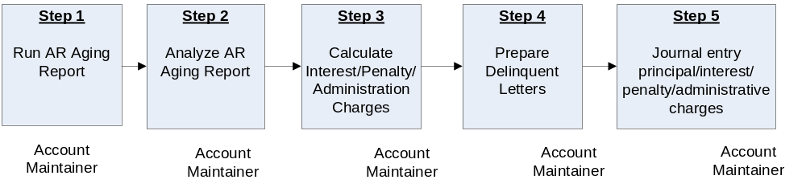

Roles & Responsibilities
Process 5 –Dunning
Roles and Responsibilities | Action | Tips/Notes
Step 1  Account Maintainer  Run AR Aging Report | - Run the A/R Aging Report, using T-Code ZCF_ARAging.  - NASA allows a 15 day grace period for all customers; therefore the aging report should be run on the 45th, 75th, and 105th day after bill date.  Output: A/R Aging Report. | Use T-Code ZCF_ARAging to run A/R Aging Report. Run the report on the 16th of every month for Reimbursable billing; run as needed for Non-Reimbursable billing, based upon open bills. Aging should be run 45 days after date of invoice.
Step 2  Account Maintainer  Analyze AR Aging Report | - To ensure that all receivables have been accounted, review A/R Aging Report for accuracy, comparing to Bill of Collections Open Receivables Folder maintained on the N-drive, located at N:\Accounts Payable_Accounts Receivable\Accounts Receivable\Bills of Collections, with a separate folder for each Center.  - Use T-Code FBL5N to review customer accounts in detail.  FBL5N - Customer Line Item Display (End User Procedure)  Output: Analyzed AR Aging Report | Folder will include BOC’s that contain date of original bill, customer name, and amount for each open receivable.
Step 3  Account Maintainer  Calculate Interest/Penalty Charges | Run SAP Dunning via T-Code F150.  F150 - Run Dunning Process (End User Procedure)  Output: Calculate Interest/Penalty charges. | The Dunning Report (T-Code F150) calculates the interest and penalty per overdue invoices and prints the letters.  Note: Administration charges are not calculated by SAP. E-mail sent requesting standard calculation for NSSC.
Step 4  Account Maintainer  Prepare delinquent letters | SAP prints delinquent letters. Until approval by NSSC Legal, prepare appropriate letter for each customer. Store completed letters in TechDoc in appropriate customer folder.  Output: Delinquent letters sent to customers and NSSC has electronic records of all correspondence with customers. | Note: Use SSC delinquent letters, stored on N-drive at N:\Accounts Payable_Accounts Receivable\Accounts Receivable\Monthly Billing\Dunning Letters
Step 5  Account Maintainer  Journal entry principal/interest/penalty charges | - Start the transaction using the menu path or T-code FB70.  FB70 - Post Interest and Penalty (complex posting) (End User Procedure)  Output: Principal, interest, and/or penalties charges posted in SAP. | Use T-Code FB70 for interest and penalty calculated by the Dunning Program journal voucher.  Perform this procedure when a customer's bill becomes delinquent.  The dunning process calculations are cumulative. Therefore, if the dunning process is run for a bill when it is 45 days old and when it is 75 days old (as it should be), the amount calculated in the run on the 75th day will contain interest for both the 45th and 75th days (e.g. if a bill has been included in more than one dunning run, the calculation from previous runs must be subtracted from the amount calculated in the current run to obtain the current amount that should be posted). Because penalty isn't calculated until a bill is 105 days old, no adjustment to the penalty amount calculated in the dunning process is necessary.  Note: SAP does not calculate Administration charges. Process to be determined for calculation and will be added to SDG.
What If Aged Debt is from Current NASA Employee?  Customer Payment Processor  Aged Debt from Current NASA Employee submitted to Payroll for payroll deduction | If aged debt is from a current NASA employee, after providing 30 days notice to employee, submit payroll and travel bills to payroll for offset. Post when notified payment deducted from Payroll.  Payroll Actions and Receivables (Job Aid)  Output: Debt referred to NASA Payroll for payroll deductions for current NASA employees.
What If Debt has not been collected over 180 days?  Account Maintainer  Uncollected Aged debt Referred to Treasury for Collection. | If no payment has been received after Final Notice is sent and bill is 180 days delinquent, non-federal customers owing more than $100 are turned over to Treasury for Collection (Treasury Form SF-329). If under $100 is owed, amount can be written off with approval of Deputy CFO.  - Log into Treasury system at https://ssologin4.fms.treas.gov/esso/smfmsloginesso.fcc?TYPE=33554433&REALMOID=06-c664ff47-7b85-102c-bb62-844dc5910000&GUID=&SMAUTHREASON=0&METHOD=GET&SMAGENTNAME=5XYkLQxDISzDXrHDWpVtYNugR4H1IOHgZpY11Br36i7FFJmAENczuiCSOzgAob6a&TARGET=$SM$HTTPS%3a%2f%2ffeddebt%2efms%2etreas%2egov%2fFedDebtWeb%2f%3ftimezoneOffset%3d-6 Enter your login and password.  - Click on Create a new debt, debtor or case on the left hand side of the screen.  - Enter the Agency Code, Bureau Code, Referring Office Code, Program Code, and Agency Debt ID. If no duplicate is found within the database by FedDebt, the “Add a Debt” screen is displayed.  - Enter Debt Type, Debt Description, Date debt occurred, delinquent date, expiration date, and balance referred to Treasury as required fields, and any optional information you may have. Click the Next Page button.  - The Debt Summary Screen is displayed. Verify all information was entered correctly. If any information need correction, click on Edit Debt button.  - When all information is correct, click on Add a Debt button.  Output: Debt referred to Treasury via Treasury website. | Debts are written off at 2 years mandatory and remain at Treasury for 6 years.  Note: The DCFO will provide via Contact Center approval for write-offs for any amount under $100. Documentation will be stored in TechDoc with BOC.
What If Debt transferred to Treasury has been collected?  Account Maintainer  Debt transferred to Treasury has been collected | If debt that has been transferred to the Treasury has been collected by the Treasury, use T-Code F-30 to record payment in SAP. Will receive notification via IPAC.  F-30 - Update Status of Receivable to Clear (End User Procedure)  Output: Debt collected by Treasury recorded in SAP.

PROCESS–Allowance for Doubtful Accounts

(Text-Diagram process or use existing process diagram)

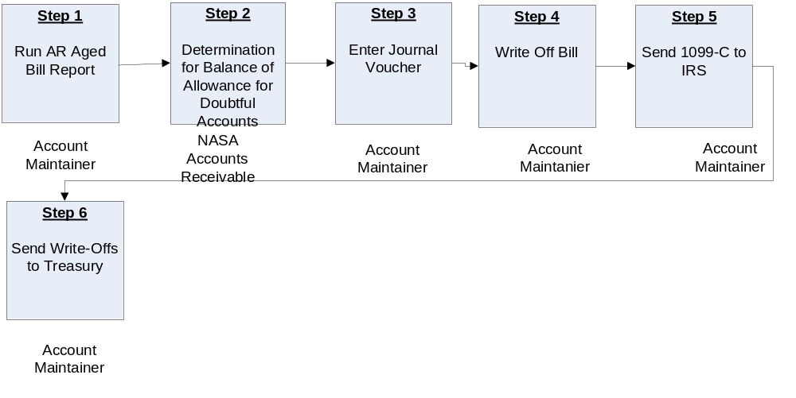

Roles & Responsibilities
Process 6 –Allowance for Doubtful Accounts
Roles and Responsibilities | Action | Tips/Notes
Step 1  Account Maintainer  Run AR Aged Bill Report | Run the Aged Bill Report, and analyze delinquent bills. Use T-Code FD11 to analyze open receivables. (Awaiting guidance on how often AFDA updated, and exact procedures for calculations.)  FD11 - Analyze Delinquent Bills (End User Procedure)  Output: AR Aged Bill Report | Use T-Code ZCF_ARAGING for aging report.  https://epssprod01.ifmp.nasa.gov/nav/index.htm
Step 2  NASA Accounts Receivable  Determination for Balance of Allowance for Doubtful Accounts | Based upon the input from the OCFO, the NSSC NASA Accounts Receivable personnel will determine the Allowance for Doubtful Accounts balance. This amount will be input into SAP.  Output: Balance updated for Allowance for Doubtful Accounts.
Step 3  Account Maintainer  Enter Journal Voucher | The NSSC Account Maintainer Processor receives information from the NSSC NASA Accounts Receivable, and enters the journal voucher into SAP, using T-Code FB50, in the amount determined in Step 2 above.  Output: Journal voucher entered into SAP | Use T-code FB50 is used to enter journal voucher  FB50 - Record Allowance for Doubtful Accounts (End User Procedure)
Step 4  Account Maintainer  Write Off Bill | The NSSC Account Maintainer Processor receives authorization, and then enters the journal voucher in SAP to write off the bill. Use T-Code F-30 to write off delinquent Accounts Receivable deemed uncollectible. F-30 - Write Off Bad Debts (End User Procedure)  Approval will be stored in TechDoc under Debt Collection/Due Process.  Output: Delinquent bill written off | If the customer is non-federal, and the amount is less than $100, the Deputy CFO can approve write-off. If less than $20,000 is owed, the CFO has the authority for write-off. Amounts between $20,000 and $100,000 need approval from NASA Headquarters in order to be written off after the Treasury collection process finds it uncollectible. For debts that exceed $100,000, only the Department of Justice has the authority to suspend or terminate collection actions. Use document type WO (in the Type field of the second screen) to enable search capabilities should the customer pay NASA in the future. Use GL accounts 1319 (principal), 1349 (interest), and 1369 (penalty). Use special G/L Indicator Codes Y (penalty/admin fee) or Z (interest).  Reference Chapter 14 of the Code of Federal Regulations (CFR) 1261.417.  Write-off is mandatory for public delinquent debt that has not been collected within two (2) years.  Debts will be eligible for write-off when the following conditions exist:  - Reasonable collection efforts have been exhausted. (Interpreted to mean “demand letters” have been sent in 30-day increments with no success.)  - The item is delinquent by 180 days or more.  - There is more than a 50% chance that the receivable will result in a loss.  - The cost of further collection action will probably exceed the amount that could be collected.  Criteria for more than a 50% chance that the receivable will result in a loss are as follows:  - The agency is unable to collect any substantial amount through its own efforts or through the efforts of others;  - The agency is unable to locate the debtor;  - Costs of collection are anticipated to exceed the amount recoverable;  - The debt against the debtor has been discharged in bankruptcy.
Step 5  Account Maintainer  Send 1099-C to IRS | The NSSC Account Maintainer Processor reports all accounts receivable write-offs to the IRS via Form 1099-C, located at http://www.irs.gov/pub/irs-pdf/f1099c.pdf.  Output: 1099-C is sent to the IRS | Reference Internal Revenue Service (IRS) Instructions for form 1099-C located at http://www.irs.gov/instructions/i1099ac/index.html
Step 6  Account Maintainer  Send Write-Offs to Treasury | The NSSC Account Maintainer Processor logs on to the Treasury website and enters all information for write-offs per Treasury instructions. (Need instructions here.)  Output: The Write-Offs are sent to the Treasury Department via internet entry.

PROCESS–OCFO Reporting

(Text-Diagram process or use existing process diagram)

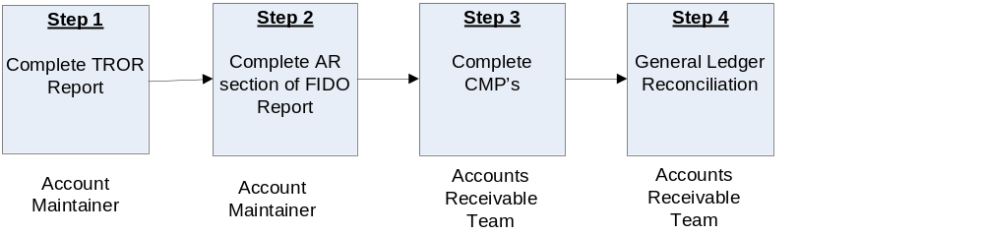

Roles & Responsibilities
Process 7 –OCFO Reporting
Roles and Responsibilities | Action | Tips/Notes
Step 1  Account Maintainer  Complete TROR Report | Follow February 2008 Treasury Report on Receivables and Debt Collection Activities Procedures, located at N:\Accounts Payable_Accounts Receivable\Accounts Receivable\TROR, titled “NASA TROR Procedures FY08.doc”.  Output: Completed TROR Report | Instructional online workbook is located at http://www.fms.treas.gov/debt/trorworkbk.html  EPSS Job Aid  General - Treasury Report on Receivables (TROR) Due From the Public (Job Aid)  Note: Use FBL5N to query International Receivables monthly for NATS report.  TROR report is due by the 3rd working day after month end. All 4th quarter reports are due by November 15th. Upload to NATS by 4th day.
Step 2  Account Maintainer  Complete AR Portion of FIDO Report | Based upon the information from reports generated in Step 1 above, complete the AR section of the FIDO Report, Metric #3. Provide to Accounts Payable via e-mail to Center POC the following information: a. Month-End Balance of Receivables (>) Greater than 180 Days, Previous month value, b. Month-End Balance of All (Total) Receivables and previous month value, and c. Total Percentage of (a/b) and previous month value. Explain any variances greater than +/- 10% from last month.  Output: Completed AR Section of FIDO Report. | Note: Use the information gathered for the TROR to complete Section 3 of the FIDO report. Accounts Payable/FBWT will complete all other sections.
Step 3  Accounts Receivable Team  Complete CMP’s (Continuous Monitoring Program) | Complete Chapters 3.1, 3.2, 3.3, 3.4, 7.4, & 7.5 of instructions located at N:\Accounts Payable_Accounts Receivable\Accounts Receivable\CMP's. CMP’s are due by the third business day of the month for the previous month’s activity.  Output: Completed CMP’s

METRICS
Initiating Office/Entity | Deliverable (Output) | Receiving Office/Entity | Metric
NSSC Accounts Receivable | [Name of deliverable] | [Name of office/entity] | Number of checks/cash received  Goal = [Describe]
NSSC Business Office | [Name of deliverable] | [Name of office/entity] | [Describe metric]  Goal = [Describe]
NSSC Debt Collection Agent

PRIVACY DATA

All participants involved must ensure protection of all data covered by the Privacy Act.

SYSTEM COMPONENTS

Existing Systems
[Use system descriptions from RFP J-03 Technical Exhibit 9 (TE 9 – Existing IT Systems).]
IT System Title | IT System Description | Access Requirements | IT System Interfaces
Remedy | System for receiving and tracking receipts | User role at NSSC
SAP | Integrated Financial Management System | User role at NSSC
TechDoc | System for storing, reporting and documenting data | User role at NSSC

New Systems
[Use system descriptions from RFP J-03 Technical Exhibit 8 (TE 8 – New IT Systems).]
IT System Title | IT System Description | Access Requirements | IT System Interfaces

CUSTOMER CONTACT CENTER STRATEGY

The NSSC Contact Center Delivery Guide provides details regarding menu positioning, routing, and escalation of inquiries for this activity.

APPENDICES

Appendix A-Cross Functional Flowchart Process Flow
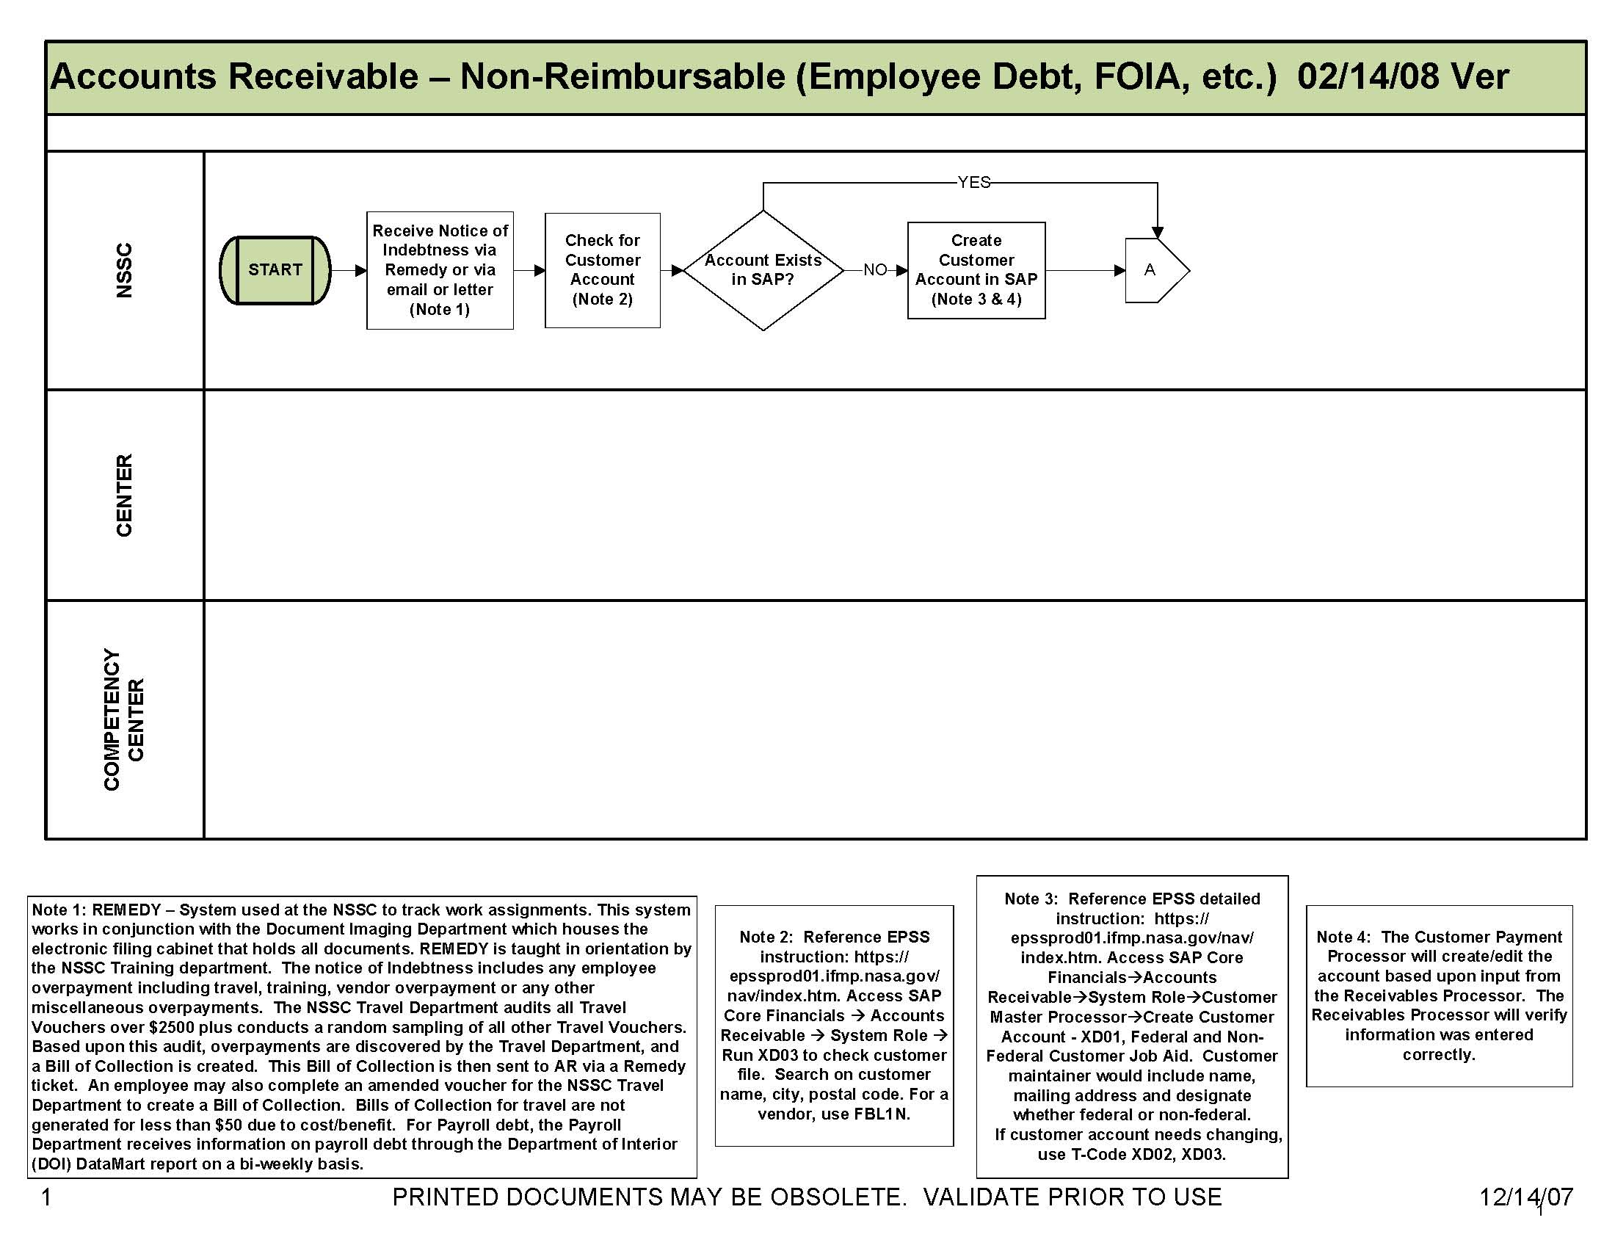
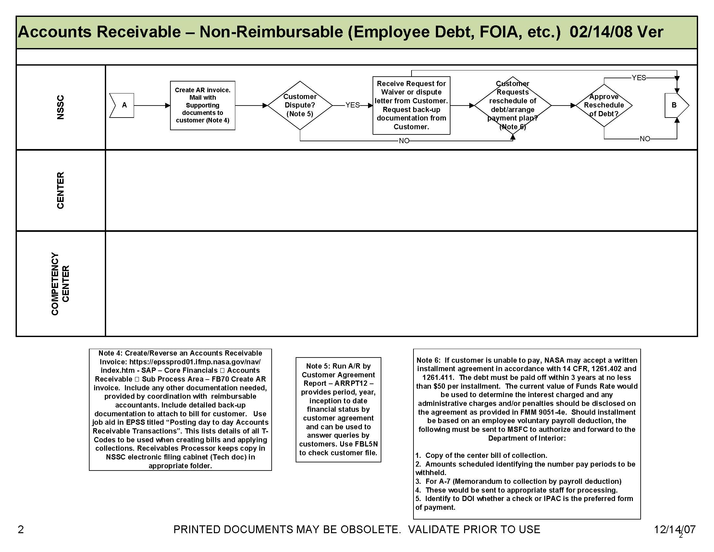
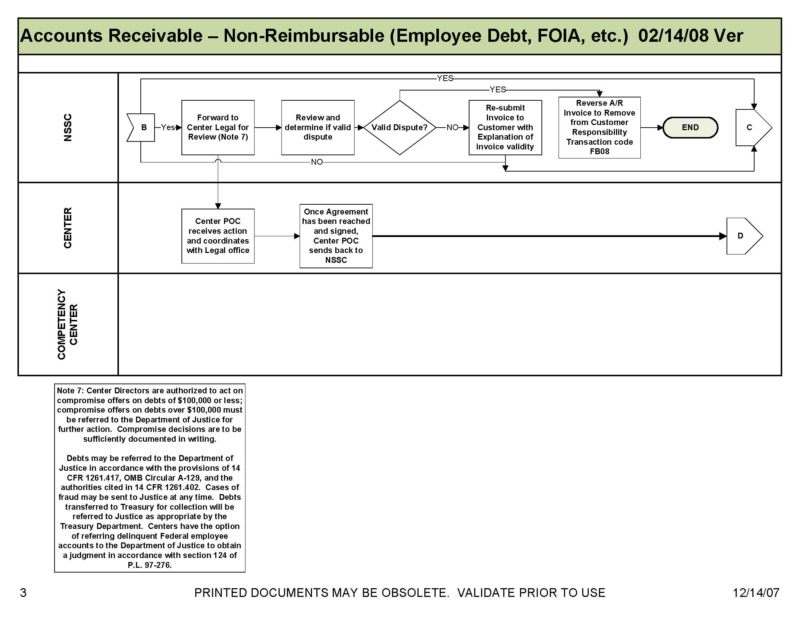
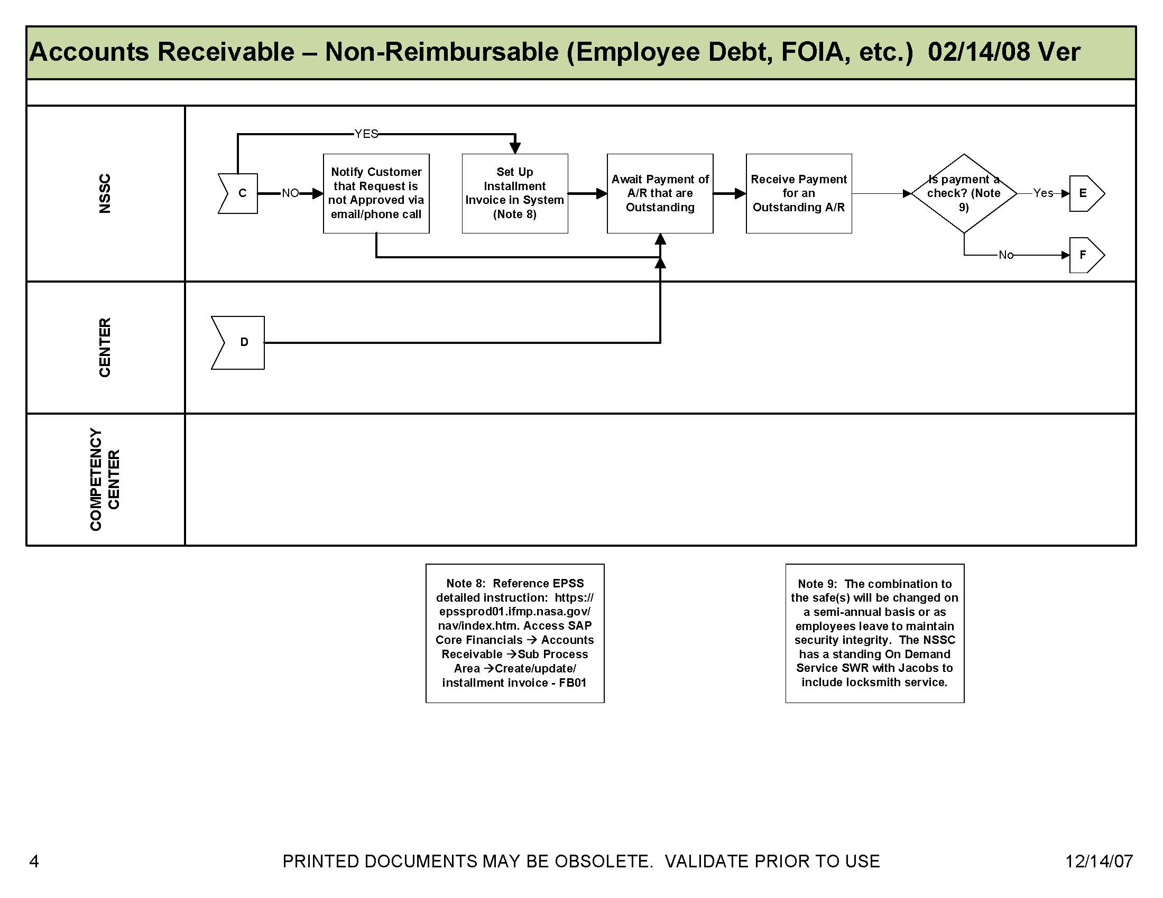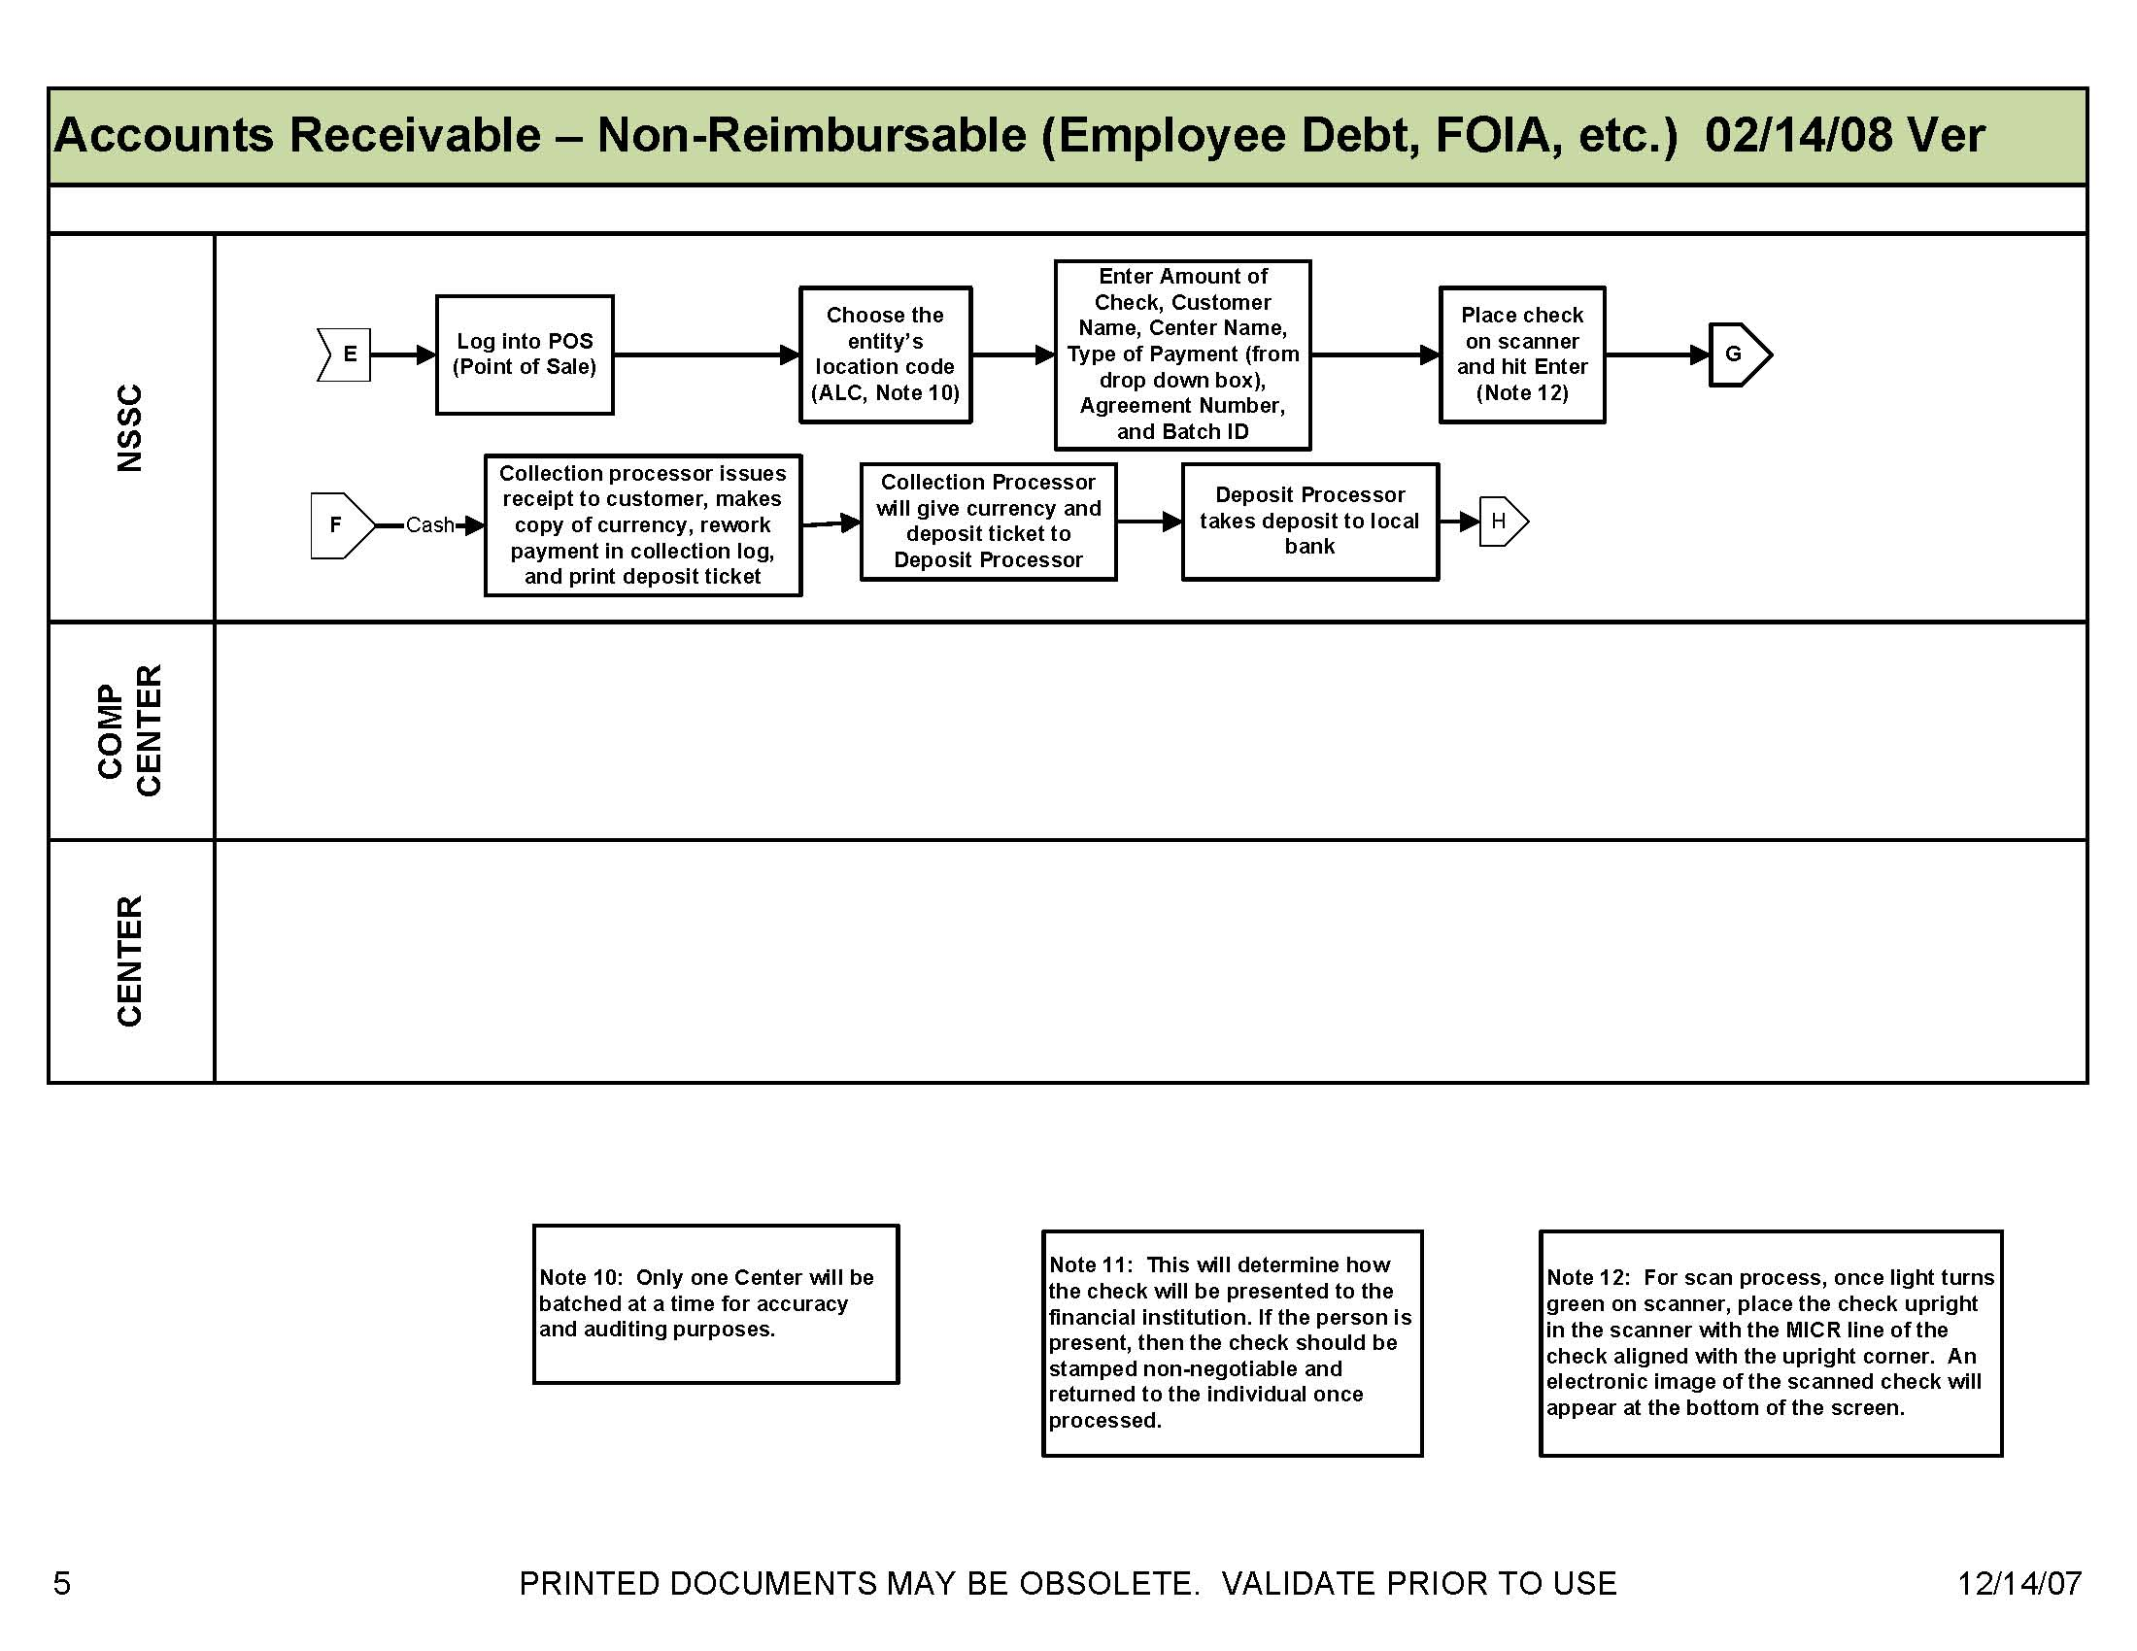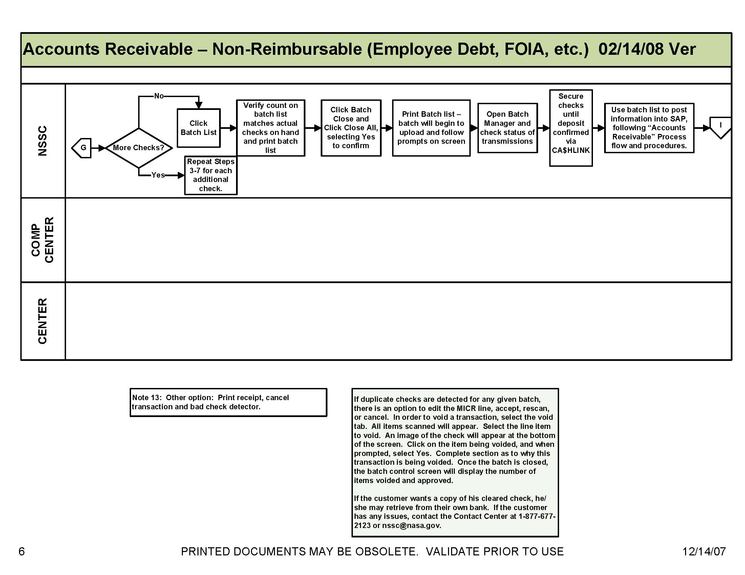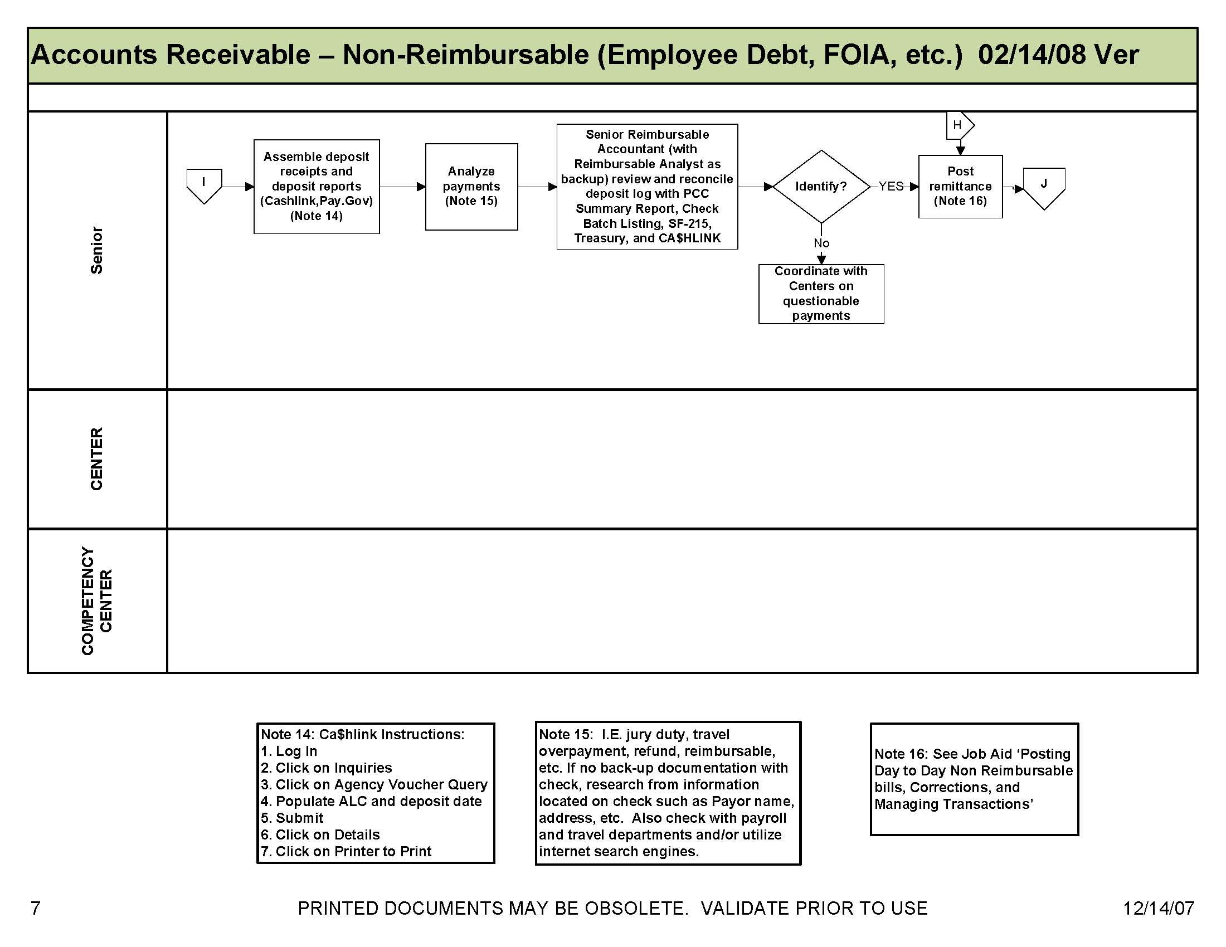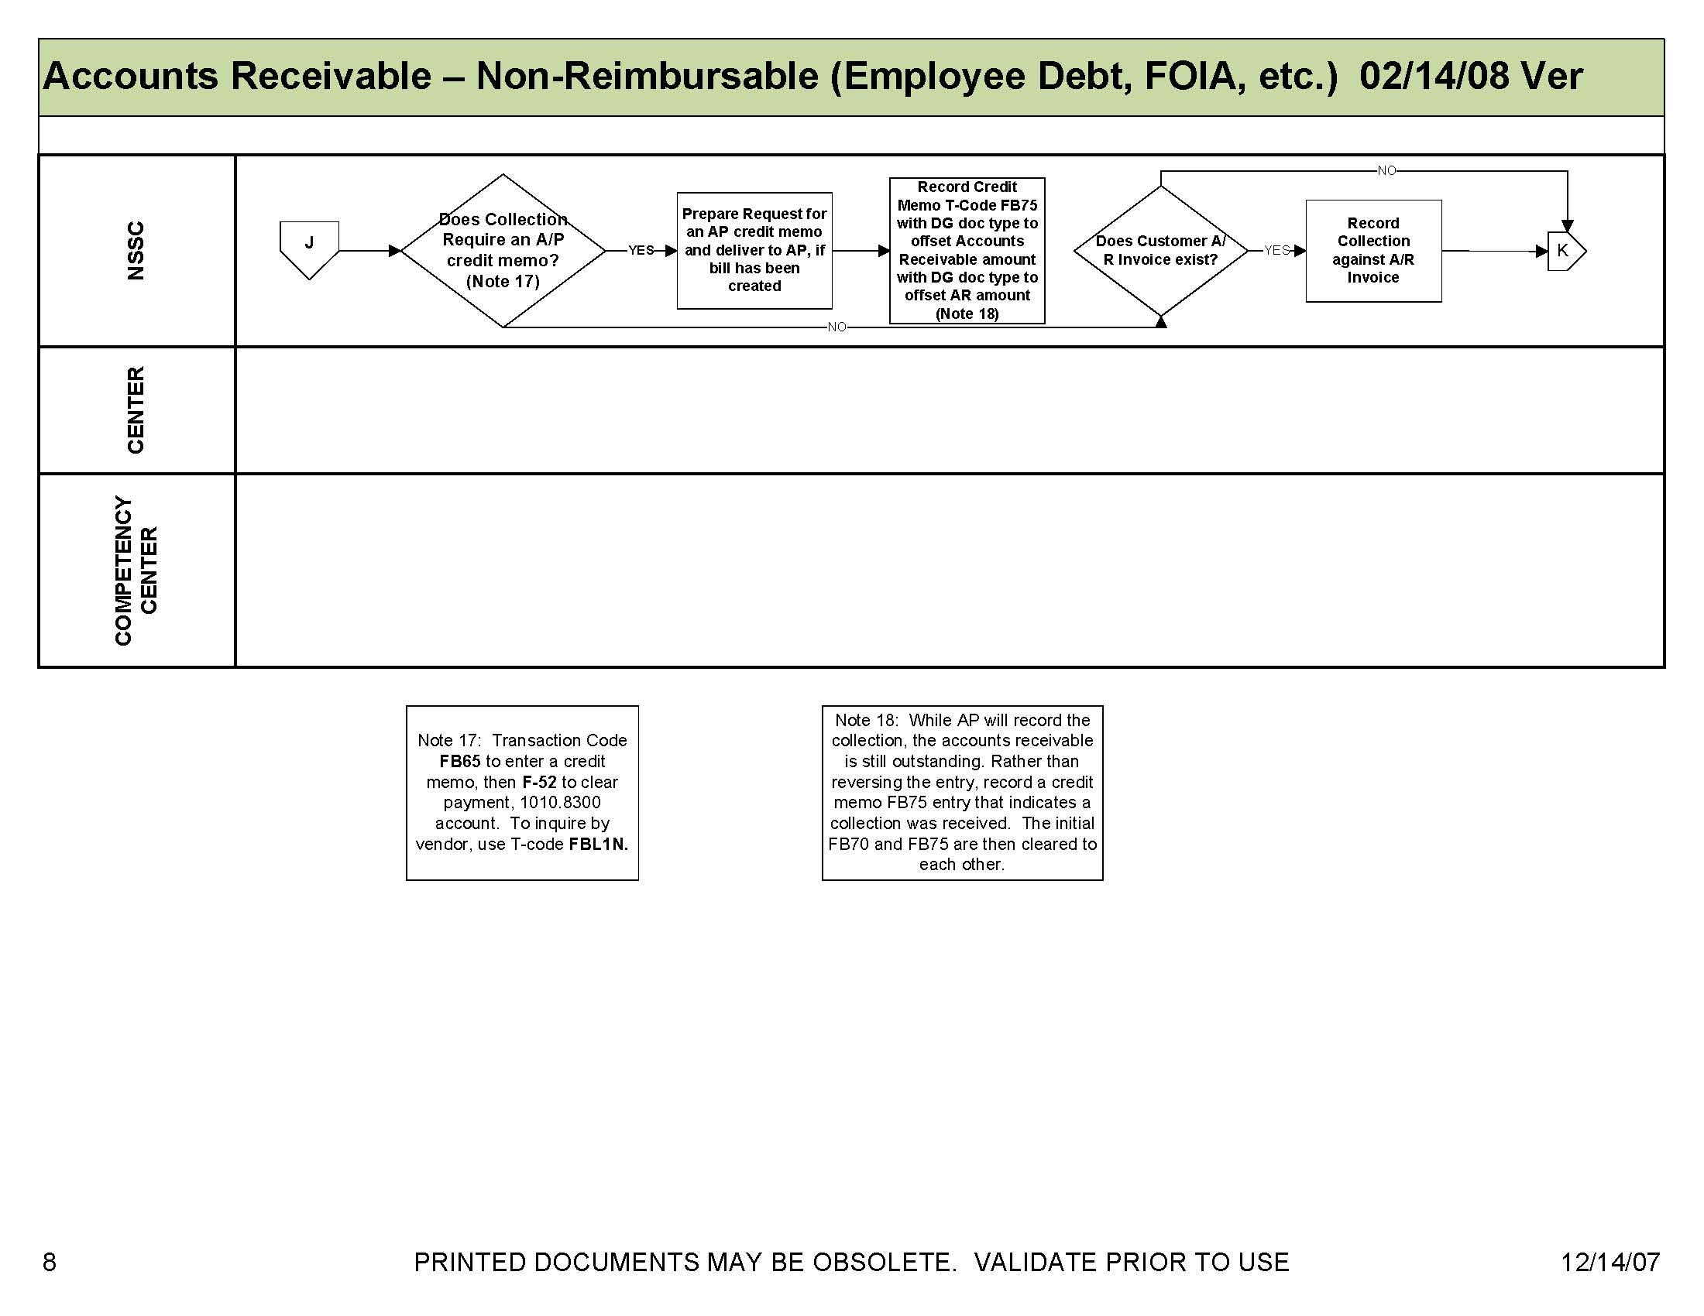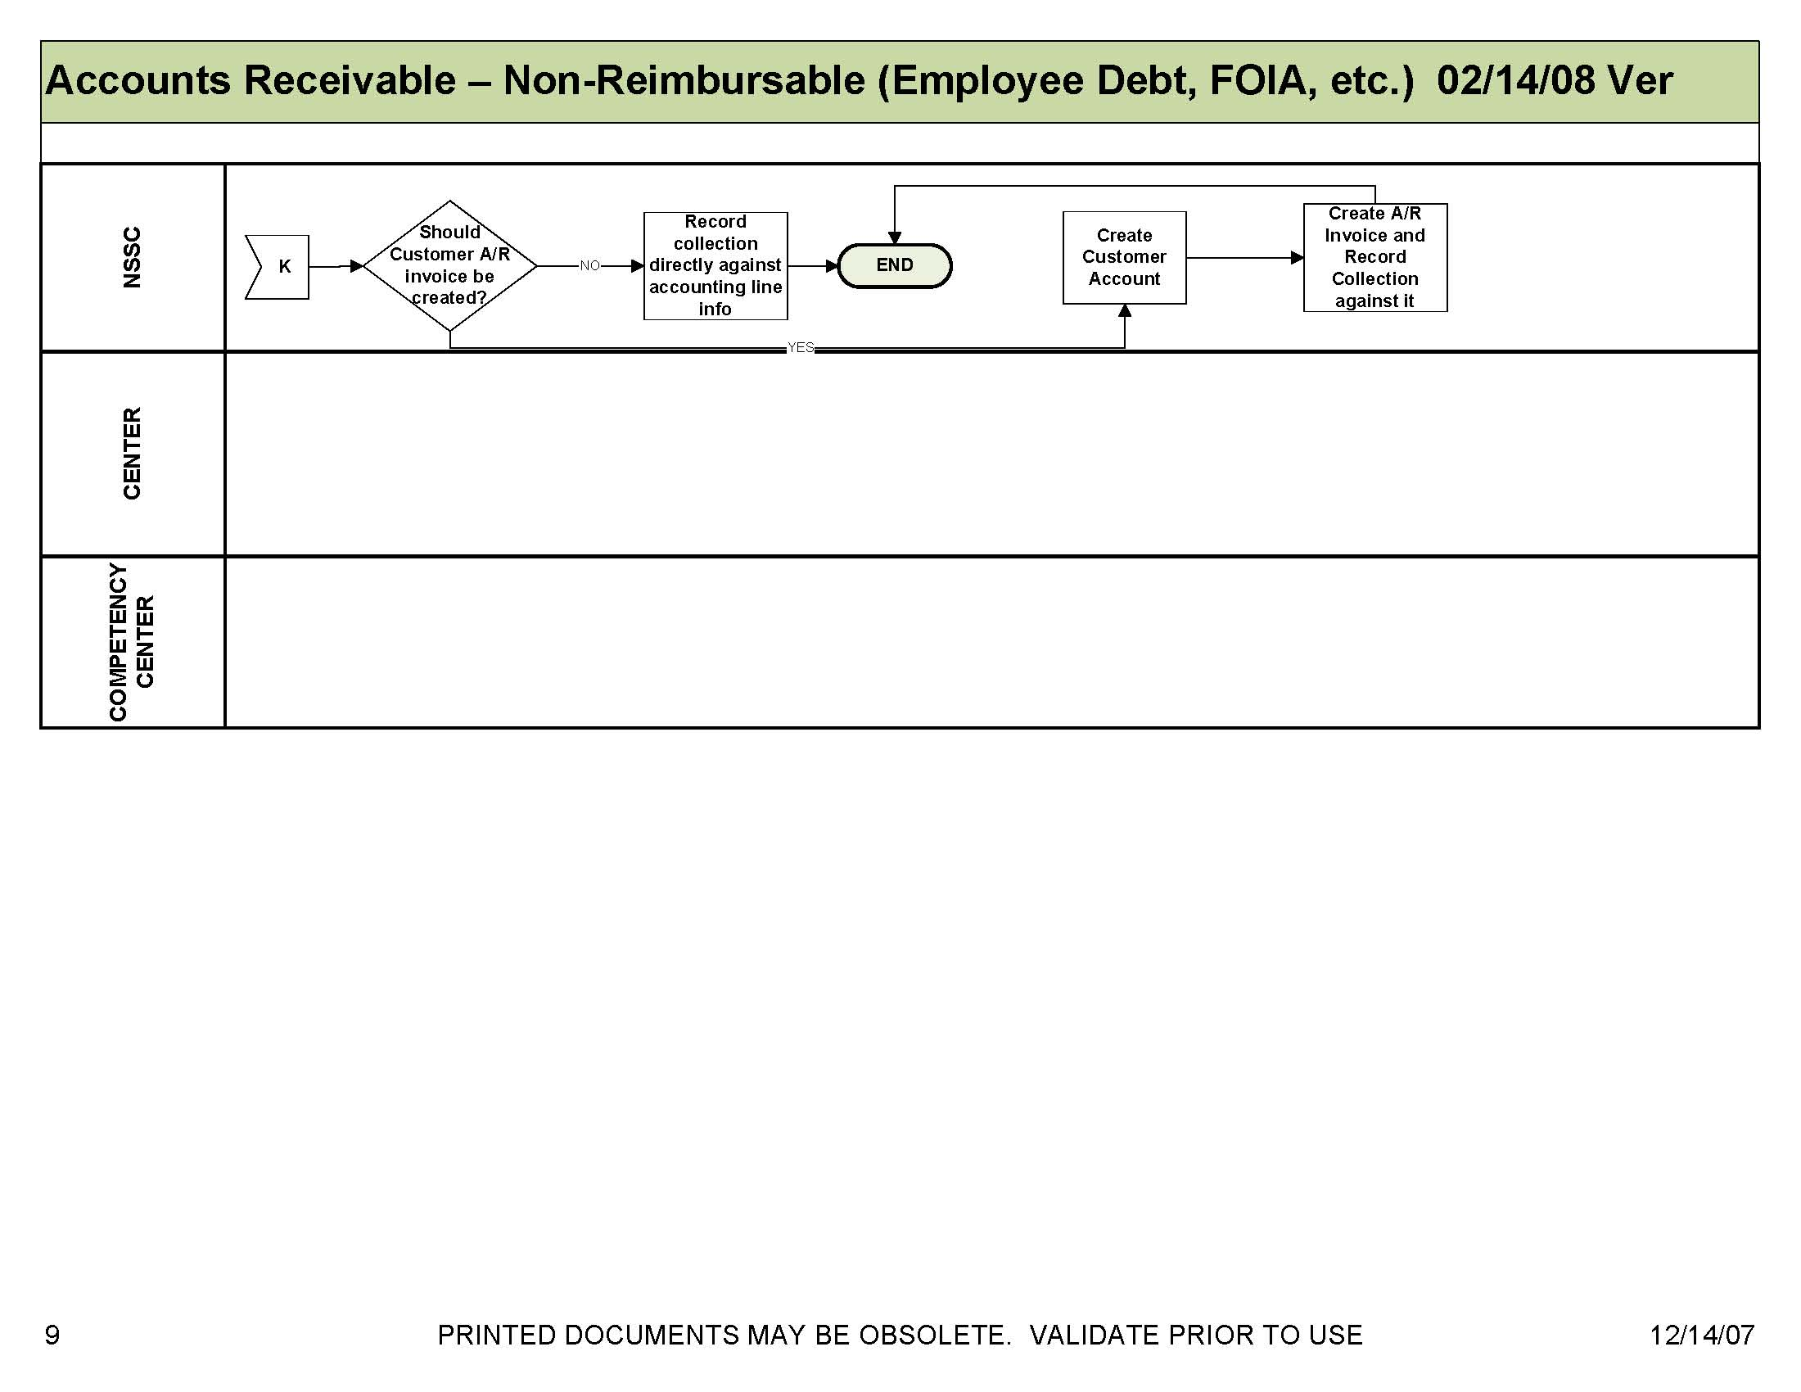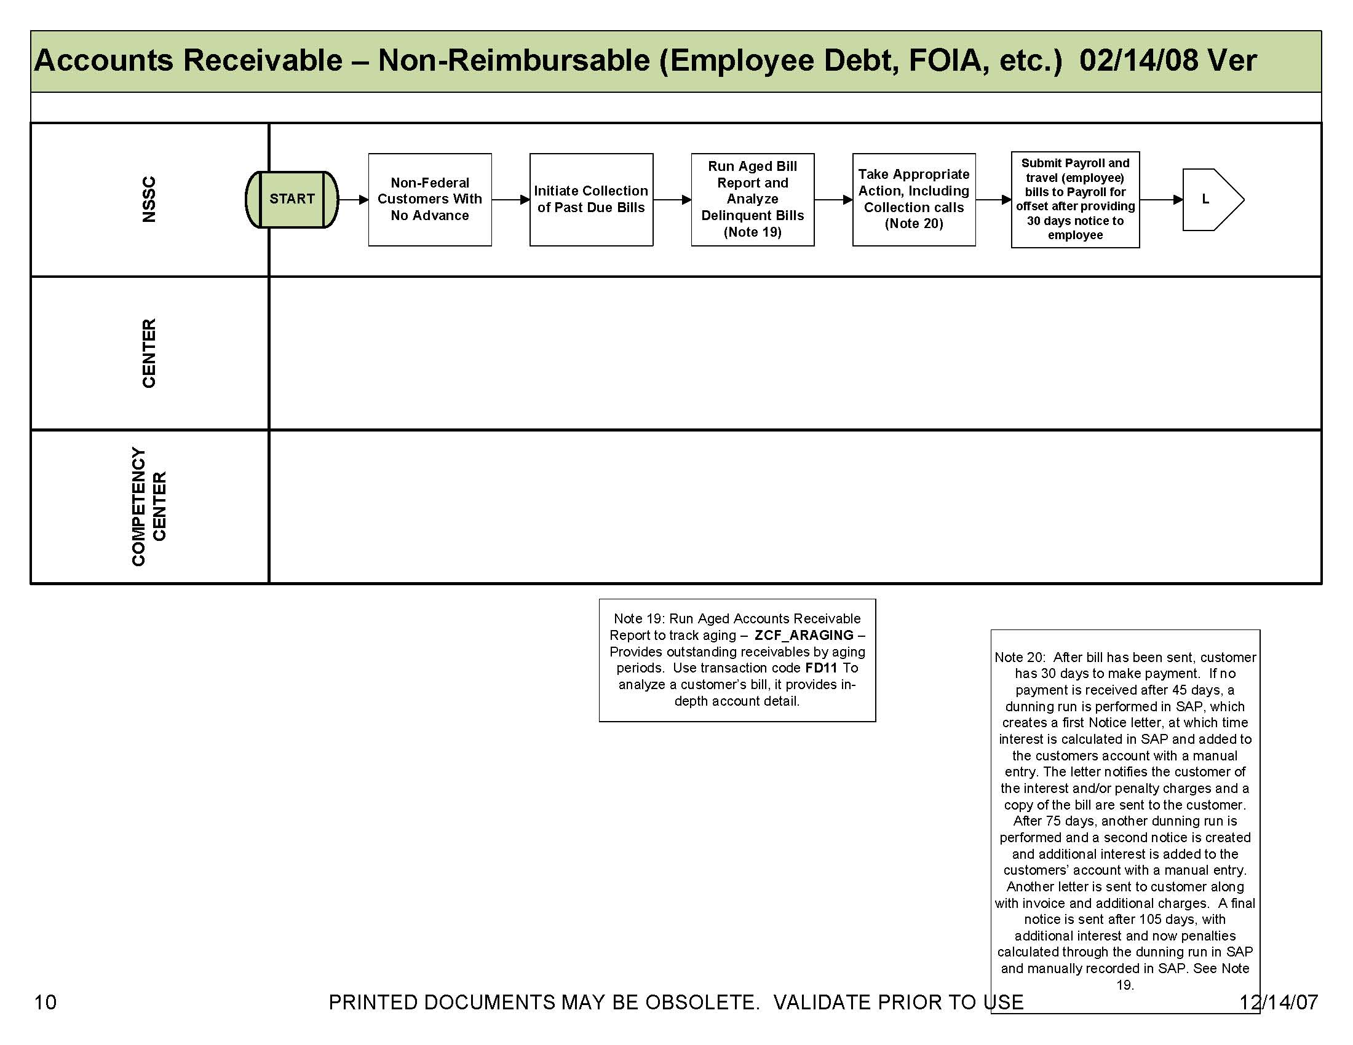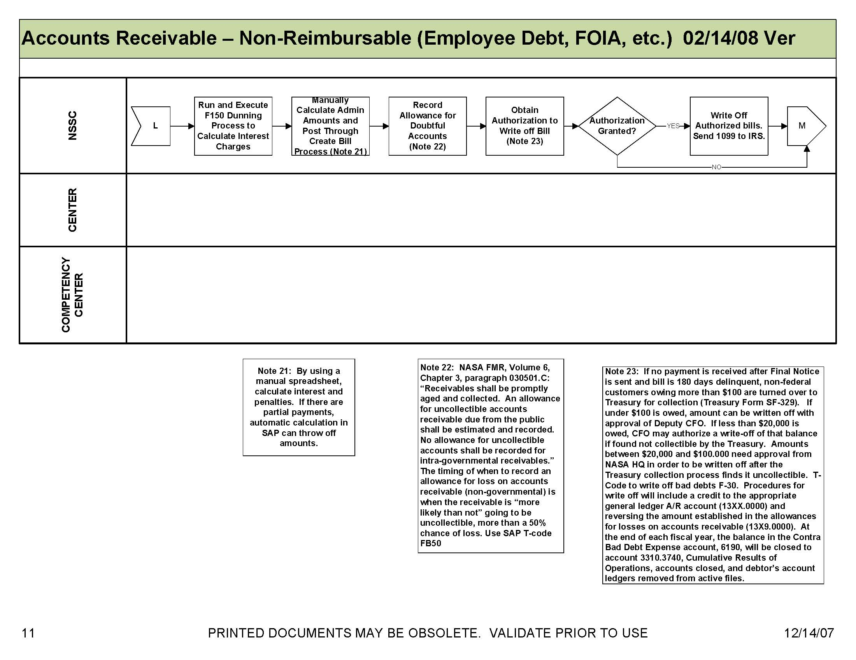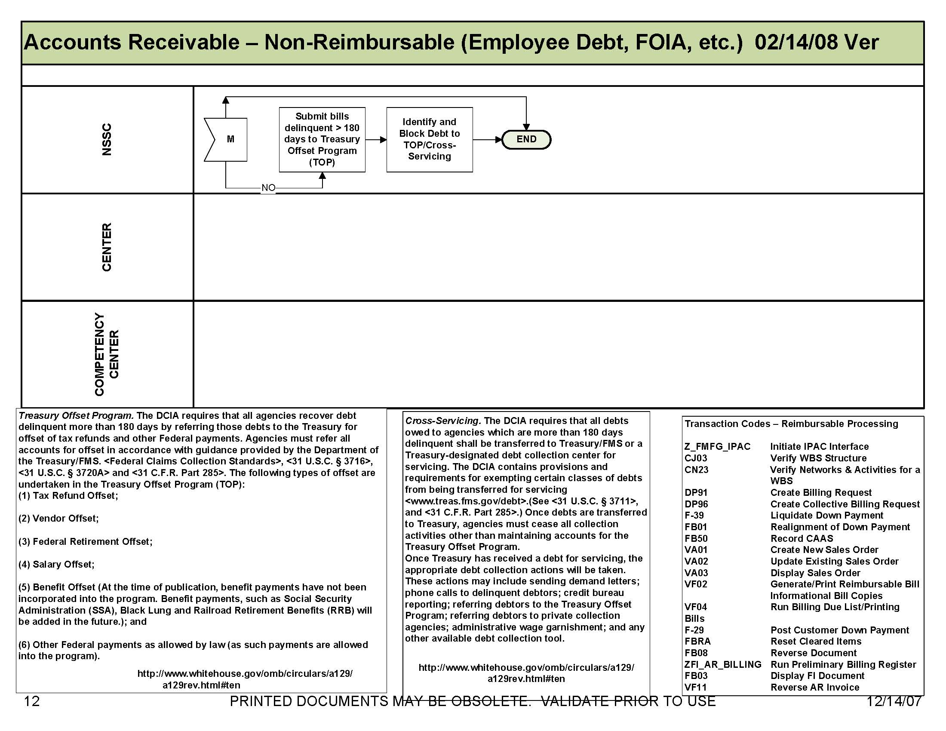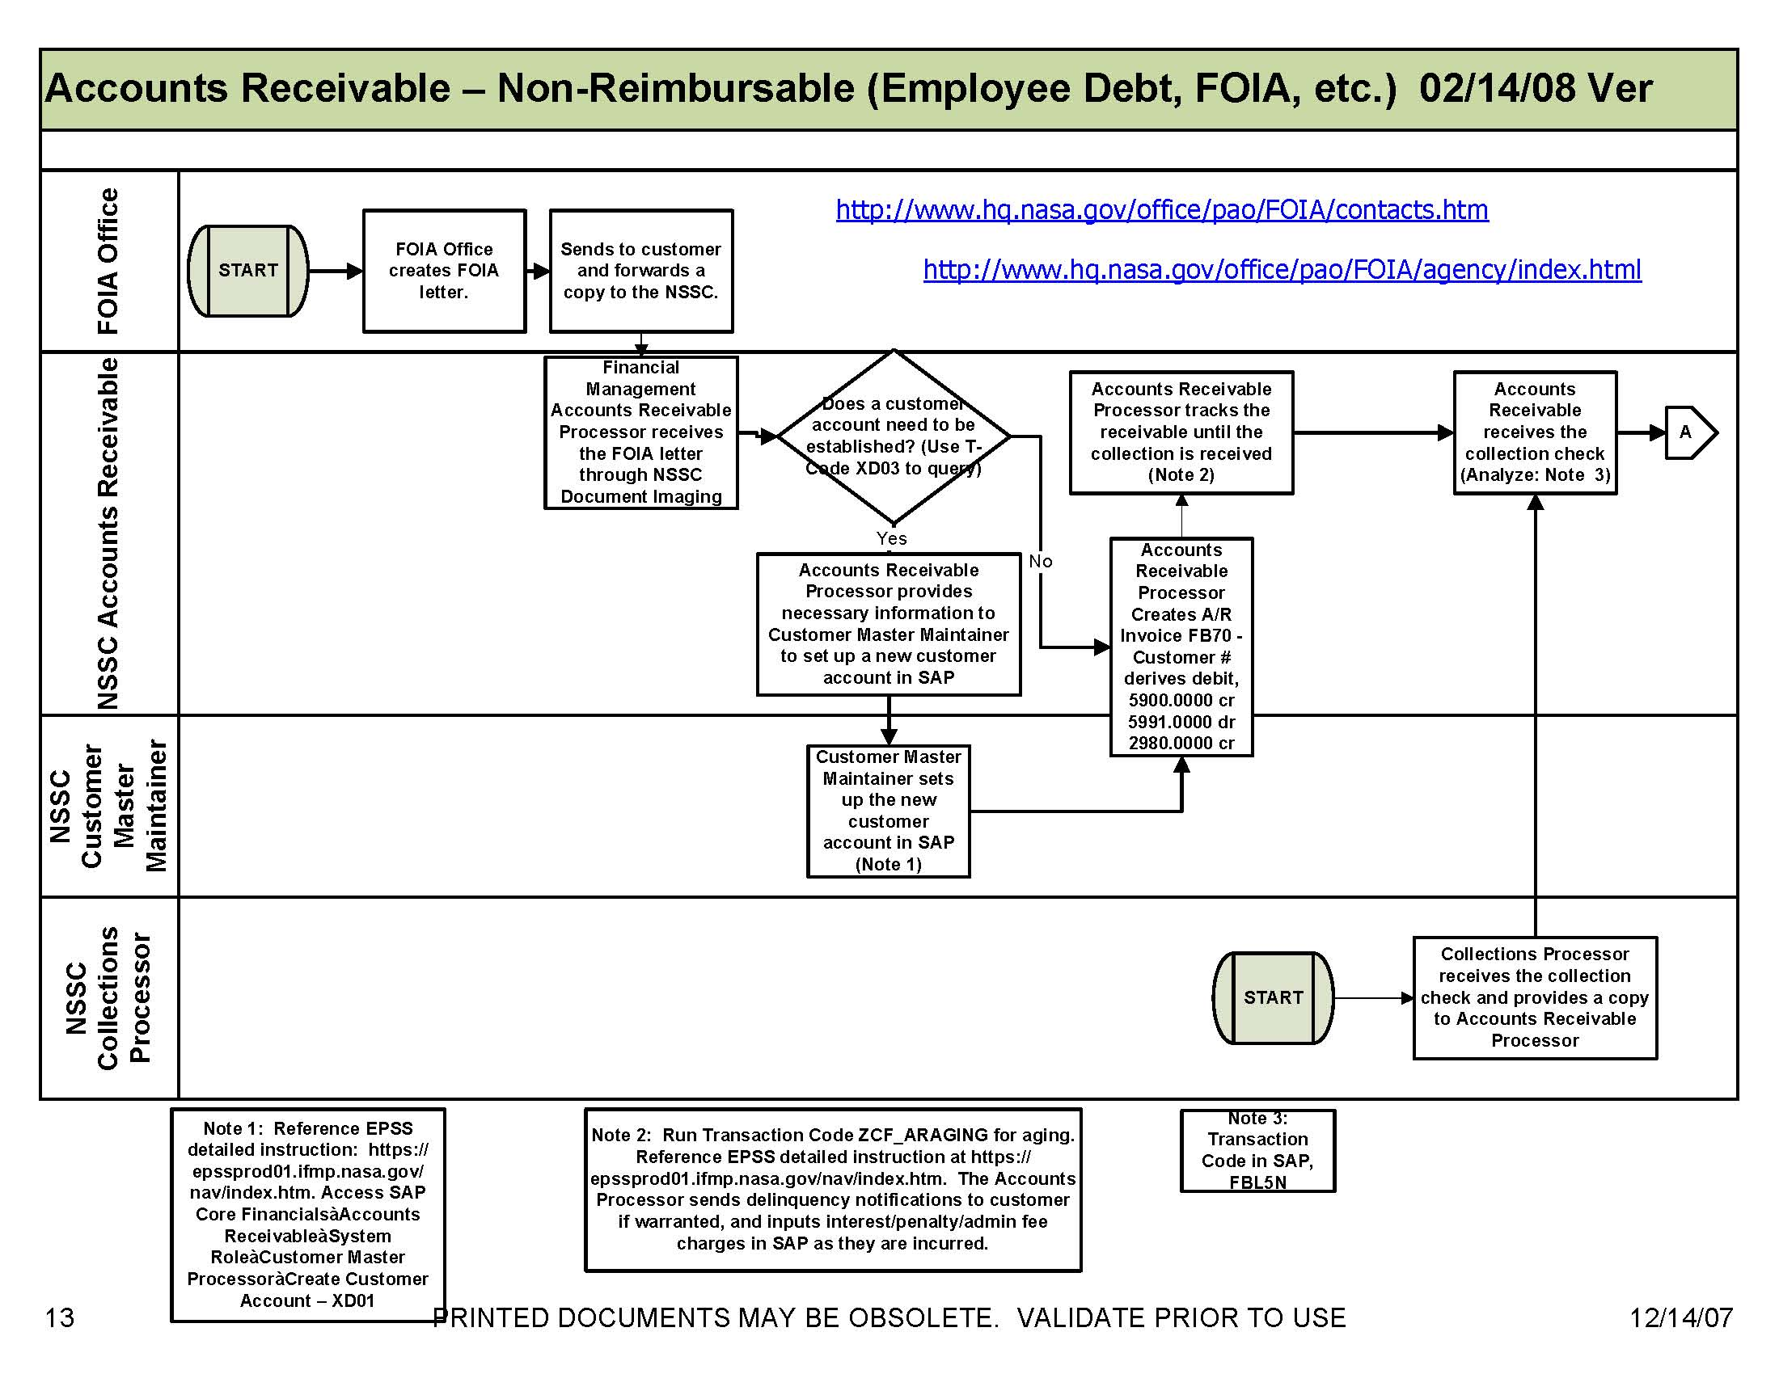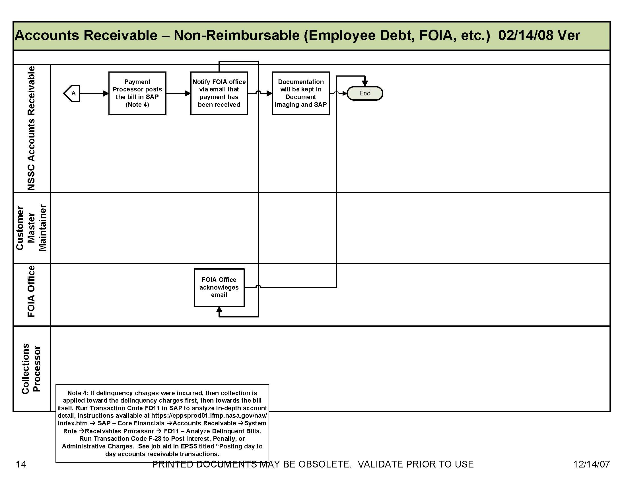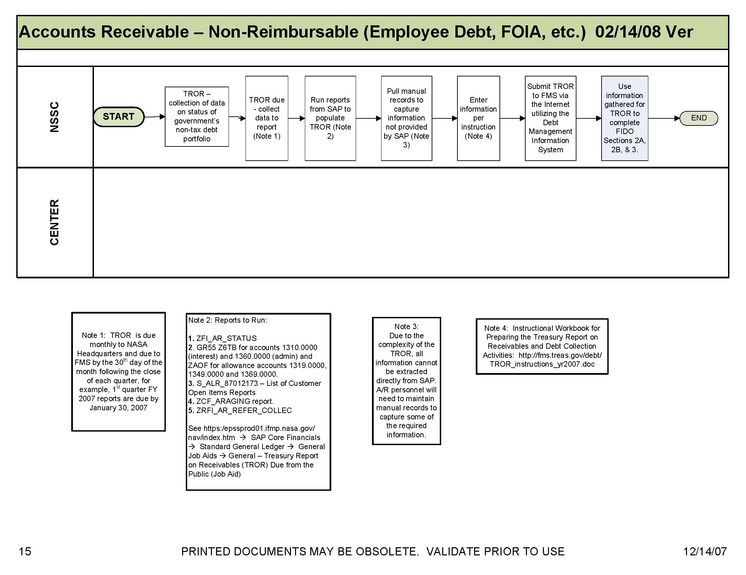

Appendix B-Acronyms and Abbreviations

ACH | Automated Clearing House
ACaRT | Agency Cash Reconciliation Tool
AMS | Acquisition Management System
AP | Accounts Payable
AR | Accounts Receivables
BW | Business Warehouse
CFO | Chief Financial Officer
CRCS | Central Resources Control System
CS | Civil Servant
DAB | Data Analysis Branch
DCFO | Deputy Chief Financial Officer
DIT | Disbursement in transit
EDI | Electronic Data Interface
EFT | Electronic Funds Transfer
EDM | Electronic Document Management
EPSS | Enterprise Performance Support System
ETM | Electronic Travel Manager
FAR | Federal Acquisition Regulation
FBWT | Fund Balance with Treasury
FI | Financial Invoice
FIDO | Federal Interagency Databases Online
FM | Financial Management
FMD | Financial Management Division
FMR | Financial Management Regulations
FMS | Financial Management Services
FTE | Full -Time Equivalent
GAO | Government Accountability Office
GOALS | Government On-Line Accounting Link System
GWA | Government Wide Accounting
HHS | Health and Human Services
HQ | Headquarters
IDOC | Interface Document
IEMP | Integrated Enterprise Management Program
IPAC | Intra-Governmental Payment and Collection System
IT | Information Technology
JV | Journal Voucher
LOC | Letter of Credit
MIPR | Military Interdepartmental Purchase Request
NAMIS | NASA Aircraft Management Information System
NATS | NASA Audit Tracking System
NPD | NASA Policy Directive
NSMS | NASA Supply Management System
NSSC | NASA Shared Services Center
NTE | Not to Exceed
OCFO | Office of the Chief Financial Officer
OJT | On the job training
ORR | Operational Readiness Review
OQA | Office of Quality Assurance
PBI | Policy and Business Integration Office
PCC | Paper Check Conversion
PMS | Payment Management System
POC | Point of Contact
RFO | Regional Finance Office
SAP | Systems, Application and Products in Data Processing
SF | Standard Form
SGL | Standard General Ledger
SPS | Secure Payment System
SP | Service Provider
SVU | SAP Version Update
TROR | Treasury Report on Receivables due from the Public
TWAI | Treasury Web Application Infrastructure
ULO | Un-Liquidated Obligations
VIP | Vendor Invoice Processor
VPP | Vendor Payment Processor
WFE | Work-Force Equivalent
WYE | Work Year Equivalent

Appendix C-Improper Payments Audit SDG

IMPROPER PAYMENTS AUDIT

Introduction

The National Aeronautics and Space Administration (NASA), Office of the Chief Financial Officer (OCFO) is responsible for complying with the Improper Payments Information Act of 2002 (Public Law No. 107-300). This law requires agencies to annually identify programs and activities susceptible to improper payments, estimate the annual amount of improper payments and submit that estimate to Congress. For improper payments that exceed $10 million, the agency must report the actions it is taking to reduce improper payments and address the root causes for the improper payments.

The Defense Authorization Act for Fiscal Year 2002 added a new subchapter to the 4 U.S. Code (31 U.S.C. §§3561-3567) that requires agencies that enter into contracts with an annual total value in excess of $500 million to carry out a cost-effective program to identify errors made in paying contractors and to recover amounts erroneously paid to contractors.

Federal agency guidance for adherence to these two laws is provided by the Office of Management and Budget (OMB) Circular A-123, Management’s Responsibility for Internal Control, Appendix C, Requirements for Effective Measurement and Remediation of Improper Payments. This OMB guidance governs the improper payment risk assessment process and reporting, and the recovery audit program of all Federal agencies.

This document provides internal NASA guidance on the implementation of NASA’s Recovery Audit Program.

References

Section 831 of the Defense Authorization Act (2002) “Recovery Auditing Act” U.S. Code (31 U.S.C. §§3561-3567)

OMB Circular A-123, Appendix C “Requirements for Effective Measurement and Remediation of Improper Payments”

NASA Financial Management Requirements Volume 15, Chapter 6 “Prompt Payment”

NASA Accounts Receivable and Write-Off interim policy dated June 12, 2007

PROCESS

Scope of Recovery Audit

The recovery audit will examine only completed fixed-price and time and material contract payments within a given fiscal year. Cost-type contract payments are excluded from this effort because these are already examined by DCAA and resolved through the contract closeout process.

Terms

Recovery Audit is a review and analysis of the agency’s books, supporting documents, and other available information supporting its payments that are specifically designed to identify overpayments or duplicate payments to contractors that result from payment errors.

Payment errors result from errors in invoices or financing requests; failure to reduce payments by applicable sales discounts, cash discounts, rebates or other allowances; payments for items not received; mathematical or other errors in determining payment amounts and executing payments; and the failure to obtain credit for returned merchandise.

Overpayment is any payment in excess of the amount that should not have been made under statutory, contractual, administrative, or other legally applicable requirements. Examples of overpayments include but are not limited to: (1) a payment that is greater than the contractual value of goods received or services performed (2) an early or accelerated payment for goods or services (The payments referenced refer to payments made in advance of contractual or statutory agreement. This does not refer to payments where all the proper documentation has been received, approved, and the regularly scheduled payment date is moved up to facilitate month end reporting.), (3) a payment that does not properly deduct the full available discount.

Note: (2) Per FMR Vol. 15 Chapter 6: NASA shall make payments no more than seven days prior to the payment due date, but as close to the due date as possible, unless the agency head or designee has determined on a case-by-case basis for specific payments. The Deputy Chief Financial Officer for Finance (DCFO (F)) must use this authority cautiously, weighing the benefits of making the payment early against the good stewardship inherent in effective cash management practices. Written determinations to approve early payments shall be retained in the payment file.

Note: (3) SAP system configuration deducts discounts for credit memorandums from the Net amount of the invoice versus the Gross; this constitutes a full discount.

Collections for the purpose of the guidance include activities undertaken by the NASA Shared Service Center to recover amounts erroneously paid to contractors.

Communication

The following outlines guidelines for communications between HQ, Contractor, and the Centers during the Recovery Audit.

The HQ Office of the Chief Financial Officer is responsible for the management of the Recovery Audit Program. HQ CFO provides input to the contracting officer in the selection of the Recovery Audit Contractor. Management of the audit is delegated to the Director, Office of Quality Assurance (OQA). The Director, OQA oversees preparation of the audit plan and facilitates communications between the Contractor and Center personnel to obtain electronic and hard copies of documents. Recovery Audit issues that cannot be resolved between the Contractor and Center CFO are elevated to the Director, OQA for resolution.

An entrance conference will be held at each Center prior to the commencement of Recovery Audit activities. The purpose of the meeting is to clearly define the Contractor, Center, and HQ
roles and responsibilities. The Center CFO will designate a Recovery Audit Liaison as the point of contact for all information requests.

The Director, OQA will provide periodic updates to the Center CFOs on the status of the Audit Recovery work and findings. The Center CFO will provide the Director, OQA with a monthly status report by the 15th day of each month for the previous month on recommended debts submitted by the Contractor for validation and status of collection activities.

The Recovery Audit Contractor shall not make direct contact (verbally or in writing) with the agency’s contractors/vendors. All communications are to go through the NSSC, Center CFO or designee.

Roles and Responsibilities

- The Office of the Chief Financial Officer (OCFO) has primary responsibility for general program oversight to include acting as the contracting officer technical representative (COTR), giving guidance to Center CFO organizations, and ensuring that Centers properly and consistently carry out their assigned responsibilities.

- The OCFO, Office of Quality Assurance, ensures the execution of the program objective. This includes preparation of Agency guidelines, criteria for the determination, collection, and disposition of funds recovered.

- The Center Chief Financial Officer reviews Contractor findings/evidence and makes final determination whether recommended debts will be posted for collection following agency guidelines/criteria. The NSSC will handle all activities related to the collection of funds, including all correspondence with the agency’s contractors.

- The Contractor prepares and implements an audit recovery plan to sample transactions, analyze discrepancies, and identify overpayments (i.e., payment errors) that are submitted to Center Chief Financial Officer (CFO) for review in accordance with NASA guidelines. The Recovery Audit Liaison designated by Center CFO will be the point of contact for inquiries/requests from the OQA/Contractor. Unless otherwise specified, all documentation requests, submission of overpayment packages, dissemination of information, and correspondence with Contractors is routed through the Liaison.

- NASA Shared Services Center (NSSC) is responsible for mailing out the initial inquiry letters to selected vendors requesting a statement/reconciliation of NASA accounts. When debts are identified by the Contractor and validated by the Center CFO the NSSC will conduct collection activities to recover funds. After funds are received, the NSSC shall carry out appropriate disposition of the funds.

Recovery Audit Procedures

The following information describes NASA’s procedures to identify, analyze, post, and collect erroneous payments on completed fixed-price and completed time and materials contract payments made within a given fiscal year for the current period of the contingency contract performance.

NASA uses a Contractor to perform recovery audit services on a contingency basis. The Contractor shall employ statement and transaction audit procedures to identify possible
payment errors. The Recovery Auditor develops and implements the strategy for identifying contract overpayments.

Collection Procedures

NSSC shall carry out the collection of debts identified during the recovery audit. Collection activities shall follow the NASA Accounts Receivable and Write-Off interim policy dated June 12, 2007. Posting of the collections in the core financial system shall be in accordance with the Improper Payment Options document.

All funds collected, all administration expenses incurred, and contingency fee payments made as part of the recovery audit program shall be specifically accounted for. The identity of all funds recovered shall be maintained as necessary to facilitate the crediting of recovered funds to the correct appropriations and identify applicable time limitations associated with the funds recovered. The NSSC will provide a monthly accounting of all identified debts, amounts collected, and disposition of funds. Note: discuss with NSSC process of posting, alerting Center about recoveries, and paying the Contractor.

Use of Funds Collected
Note: Need to discuss with NSSC process of verifying appropriate disposition of funds and tracking.
Funds collected under the recovery audit program shall be available for the following purposes:

- To reimburse the actual expenses incurred by NASA to administer the program.

- To pay contractors for recovery audit services.

Recovered funds that are not used to reimburse incurred administrative expenses or pay contingency fee to the recovery audit contractor:

- Shall be credited to the appropriations from which the overpayment was made, and will be available for the purposes and period for which such appropriations are available; or

- If no such appropriations remain available, the funds recovered shall be deposited in the Treasury as miscellaneous receipts.

In the event amounts recovered due to interim payment errors made under ongoing contracts (i.e., duplicate progress payments or cost reimbursement claims) are not available to pay the recovery audit fee, because these amounts are still needed to make subsequent payments under the contract; NASA will pay contractor out of the appropriate Center administrative funds.

When required or authorized by other provisions of law, any funds remaining after reimbursement of incurred administration expenses and paying recovery audit contractors, shall be credited to a non-appropriated fund, revolving fund, working capital fund or trust fund.

Recovery Audit Contractor Contingency Fee Payment

The Collections are to be tracked separately to facilitate (1) payment to the recovery audit contractor once the funds are actually recovered by NASA and (2) credit of any excess funds to the correct appropriation. OMB guidance requires all funds collected and all direct administration expenses incurred as part of the recovery audit program shall be specifically accounted for.

Following the recovery of the funds, the NSSC shall calculate the payment to the recovery audit contractor based upon contractual contingency fee percentage. The percentage shall be applied only to the principal amount collected. Interest or penalty resulting from debt collections shall not be factored into the contingency fee payment.

Corrective Action Plans

For each overpayment determined valid by the Center CFO, the recovery audit contractor shall analyze the reason payment error occurred, and recommend cost effective controls to prevent such overpayments in the future, as a normal part of their contract work. The Center CFO in consultation with OQA is responsible for taking appropriate action(s) to address the identified control deficiency to preclude future reoccurrence of the payment error. A corrective action plan shall be prepared and maintained detailing the following:

- Payment error identified
- Root cause of error
- Planned actions to address deficiency
- Responsible official
- Target completion date
- Actual completed date
- Evidence root cause has been eliminated

Corrective action plans shall be provided to the OQA no later than 30 days after the debt is determined to be valid by the Center CFO. Quarterly updates shall be provided to OQA on the status of corrective actions (January 10, April 10, July 10, and October 10). Unless otherwise approved by the OCFO/OQA, all corrective actions shall be implemented within one year of the Center OCFO debt determination.

Processes – Recovery Audit Procedures

Roles & Responsibilities
Roles and Responsibilities | Action | Tips
Recovery Audit Procedures  Step 1  Recovery Auditor – Contractor  Prepares and implements an audit recovery plan | Purpose  The Recovery Auditor – Contractor prepares and implements an audit recovery plan to sample transactions, analyze discrepancies, and identify overpayments (i.e., payment errors) that are submitted to Center Chief Financial Officer (CFO) for review in accordance with NASA guidelines. | The Recovery Audit Liaison designated by Center CFO will be the point of contact for inquiries/requests from the OQA/Contractor. Unless otherwise specified, all documentation requests, submission of overpayment packages, dissemination of information, and correspondence with Contractors is routed through the Liaison.
Step 2  Recovery Auditor - Contractor  Initial Listing and Letter | Prepare initial listing and letter to selected vendors requesting a statement/reconciliation of NASA accounts.
Step 3  NASA Shared Services Center – Civil Servant/SP  Mailing initial letter | NASA Shared Service Center is responsible for mailing out the initial inquiry letters to selected vendors requesting a statement/reconciliation of NASA accounts.
Step 4  Recovery Auditor – Contractor  Follow-up to initial letter | The Recovery Auditor will follow-up via letter/fax/phone to non-responding contractors/vendors. | Note: This is a standard industry practice used by Recovery Audit Contractors to identify payment errors. Based upon the level of response and information received NASA management in consultation with the Contractor will make a determination whether to conduct further audit of payments for the period being audited. If management decides to pursue further Recovery Audit activity, the following guidelines/process will be followed.
Step 5  Recovery Auditor – Contractor  Request documentation | The Recovery Auditor will submit document requests related to possible payment errors to the appropriate NASA Center thru the NASA Audit Tracking System (NATS). Requests should be provided at least one week prior to the requested due date. Documentation that may be requested by the Contractor includes; contracts, invoices, purchase orders, receiving documents, and the actual payment(s) to identify possible payment errors. In the performance of this work the Contractor is prohibited from:  - Requiring production of any records or information by the agency’s contractors. Only duly authorized employees of the agency can compel production of information in accordance with contract terms;  - Establishing or otherwise having a physical presence on the property or premises of any other agency contractor for the purpose of performing the contract;  - Acting as an agent for the Federal Government in the recovery of funds erroneously paid to contractors;  - Using or sharing sensitive financial information with any individual or organization, whether associated with the Federal Government or not, that has not been released for use by the general public;  Disclosing any information that identifies an individual, or reasonably can be used to identify an individual, for any purpose other than performing the recovery audit.
Step 6  Recovery Auditor – Contractor  Calculates the proper amount | Once a payment error is identified, the Contractor calculates the proper amount to be collected. The information along with supporting evidence of the payment error is provided to the Center Chief Financial Officer (Center CFO) for validation.
Step 7  NASA Center CFO or Designee – Civil Servant  Validate debt/payment error | NASA Center CFO’s or designees will review and validate whether recommended debts are posted for collection or deemed invalid, within 90 days depending on the extent of verification required. | The Center has a maximum of 90 days to validate whether the payment is an error. Depending upon the amount of investigation required by the Center the time required to validate debts submitted by the Contractor will vary.
Step 8  NSSC – Civil Servant/SP  Collection of debt | If the center CFO determines the debt to be valid, the item is referred to the NSSC for collection. NSSC is responsible for all collection, tracking, and reporting activities related to Recovery Audit funds. | Note: a special mail stop for collections should not be set up at the Center.
Step 9  Recovery Auditor – Contractor  Prepare a Weekly Summary of Recoveries | The Contractor will provide a “Weekly Summary of Recoveries” report on the status of ongoing recovery activities. The Contractor will provide an annual report to the OCFO by September 14 of each year, on the results of the recovery audit. The results of each year’s recovery audit effort will be reported in the NASA Performance and Accountability Report. | The report is submitted to the Director OQA. Only those debts submitted and approved by the Center CFO shall be reported for collection purposes.
Step 10  Director, OQA – Civil Servant  Prepare periodic updates on the status of the audit | The Director, OQA will provide periodic updates to the Center CFOs on the status of the Audit Recovery work and Findings. | The type of information to be included in this report to the Centers and the frequency of this report is TBD.
Step 11  Center CFO – Civil Servant  Prepare monthly status report for the previous month on recommended debts | The Center CFO will provide the Director, OQA with a monthly status report by the 15th day of each month for the previous month on recommended debts submitted by the Contractor for the validation and status of collection activities. | OQA will prepare a template for this report to be used by all Centers.

Process – Collection Procedures

Roles & Responsibilities
Roles and Responsibilities | Action | Tips
Collection Procedures  Step 1  NSSC – Civil Servant/SP  Collection of validated debts | NSSC shall carry out the collection of debts identified during the recovery audit. Collection activities shall follow the NASA Accounts Receivable and Write-off interim policy dated June 12, 2007 and the DRAFT Accounts Receivable Service Delivery Guides for Direct and Reimbursable activity.
Step 2  NSSC – Civil Servant/SP  Post collection of Improper Payments/Recovery Audit Funds | Posting of the collections in the core financial system shall be in accordance with the following Improper Payment Options.
Improper Payment Options  Step 2a  NSSC – Civil Servant/SP  Scenario I  Posting of Collection when the  - Contract is open  - Project is open  - Fund is either unexpired or expired. | - A/R sets up a receivable for the vendor.  T-code: FB70  - A/P creates a credit memo against the contract for the amount recovered less the percent to be paid to the Recovery Audit Contractor.  T-code: MIRO  Clear Credit Memo to cash: F-52  - A/P creates a credit memo for the Recovery Audit Contractor percentage of the payment  T-code: FB65  The credit memo will be against the vendor that received and repaid the improper payment.  Clear Credit Memo to Cash: F-52  - A/R reverses the receivable in step 1  - A/P pays the Recovery Audit Contractor percentage using a FI Invoice T-code: FB60  Pay Invoice: F110 | Notes:  - Any collections for improper payment related to a cancelled appropriation should be collected into 803200 (Collection of Receivables from Cancelled Accounts). Subsequent payments to the Recovery Audit Contractor will be made from the current appropriation (1% set aside for payment of cancelled payables)  Recovery of improper payments against an open contract will result in a shortage of available funds for disbursement if the contract is paid in full at the current contract value. Additional funds will need to be obligated to cover the fee that is being charged for the recovery of the improper payment.
Step 2b  NSSC – Civil Servant/SP  Improper Payment Options Scenario 2  Posting of Collection when the  - Contract is closed  - Project is closed  - Fund is either unexpired or expired. | - A/R sets up a receivable for the Recovery Audit Contractor  T-code: FB70  - A/P creates a credit memo citing the vendor that received the improper payment. The credit will be used to process the payment for the Recovery Audit Contractor against the project WBS.  The vendor should be in SAP even though the contract is closed. If the vendor master record does not exist the center will need to submit an SR to have it added.  Clear Credit Memo to cash: F-52  - A/R reverses the receivable in step 1  - A/P pays the Recovery Audit Contractor percentage using a FI Invoice  T-code: FB60  Pay Invoice: F110 | Notes:  - Any collections for improper payment related to a cancelled appropriation should be collected into 803200 (Collection of Receivables from Cancelled Accounts). Subsequent payments to the Recovery Audit Contractor will be made from the current appropriation (1% set aside for payment of cancelled payables)  - Recovery of improper payments against an open contract will result in a shortage of available funds for disbursement if the contract is paid in full at the current contract value. Additional funds will need to be obligated to cover the fee that is being charged for the recovery of the improper payment.
Step 2c  NSSC – Civil Servant/SP  Improper Payment Options Scenario 3  Posting of Collection when the  - Contract is closed  - Project is closed  - Fund is expired. | - A/R sets up a receivable for Recovery Audit Contractor  T-code: FB70  - Use JV to process the amount for percentage to Recovery Audit Contractor  - Use JV to process the amount for Misc. Receipts if refund can not be identified against a specific WBS  - A/P pays Recovery Audit Contractor percentage using FI Invoice  T-code FB60  - Pay Invoice: F110  Reverse Receivable. | Notes:  - Any collections for improper payment related to a cancelled appropriation should be collected into 803200 (Collection of Receivables from Cancelled Accounts). Subsequent payments to the Recovery Audit Contractor will be made from the current appropriation (1% set aside for payment of cancelled payables)  - Recovery of improper payments against an open contract will result in a shortage of available funds for disbursement if the contract is paid in full at the current contract value. Additional funds will need to be obligated to cover the fee that is being charged for the recovery of the improper payment.
Step 3  NSSC – Civil Servant/SP  Prepare a monthly accounting of all identified debts, amounts collected, and disposition of funds. | NSSC will provide a monthly accounting of all identified debts, amounts collected, and disposition of funds.
Step 4  NSSC – Civil Servant/SP  Calculate the payment to the recovery audit contractor | Following the recovery of the funds, NSSC shall calculate the payment to the recovery audit contractor based upon contractual contingency fee percentage. The percentage shall be applied only to the principal amount collected. Interest or penalty resulting from the debt collections shall not be factored into the contingency fee payment.

Process – Corrective Action Plan

Roles & Responsibilities
Roles and Responsibilities | Action | Tips
Corrective Action Plan  Step 1  Recovery Auditor – Contractor  Prepare corrective action plan | For each overpayment determined valid by the Center CFO, the recovery audit contractor shall analyze the reason payment error occurred, and recommend cost effective controls to prevent such overpayments in the future.  A corrective action plan shall be prepared and maintained detailing the following:  - Payment error identified  - Root cause of error  - Planned actions to address deficiency  - Responsible official  - Target completion date  - Actual completed date  - Evidence root cause has been eliminated  Corrective action plans shall be provided to the OQA no later than 30 days after the debt is determined to be valid by the Center CFO.
Step 2  NASA Center - CFO/NSSC/OQA  Implement the corrective action plan | The Center CFO in consultation with OQA is responsible for taking appropriate action to address the identified control deficiency to preclude future reoccurrence of the payment error.  Quarterly updates shall be provided to OQA on the status of corrective actions (January 10, April 10, July 10, and October 10). Unless otherwise approved by the OCFO/OQA, all corrective actions shall be implemented within one year of the Center OCFO debt determination. | Until the AP function transitions to the NSSC, the Centers will be responsible for implementing appropriate corrective action. Decisions related to process controls will be determined by the NSSC Transition Team in consultation with NASA Management.

METRICS

Initiating Office/Entity | Deliverable (Output) | Receiving Office/Entity | Metric
[Name of office/entity] | [Name of deliverable] | [Name of office/entity] | [Describe metric]  Goal = [Describe]
[Name of office/entity] | [Name of deliverable] | [Name of office/entity] | [Describe metric]  Goal = [Describe]
[Name of office/entity] | [Name of deliverable] | [Name of office/entity] | [Describe metric]  Goal = [Describe]

SYSTEM COMPONENTS

Existing Systems
[Use system descriptions from RFP J-03 Technical Exhibit 9 (TE 9 – Existing IT Systems).]

IT System Title | IT System Description | Access Requirements | IT System Interfaces
 |  | [List roles that receive access.]
[Remove unused rows]

New Systems
[Use system descriptions from RFP J-03 Technical Exhibit 8 (TE 8 – New IT Systems).]

Generic System Title | Business Requirements for System | Access Requirements | IT System Interfaces
SAP | System used to process financial transactions | Current NASA Government employees and SP will have access to SAP | SAP/IEMP
Remedy | System used to track all incoming documents to the NSSC; supports internal activities. | Current NASA Government Employees and SP will have access to Remedy | Tech Doc Document Management System
NASA Audit Tracking System (NATS) | System used to submit document requests to the appropriate NASA Center | Current NASA Government Employees and Recovery Audit Contractor

SAMPLE OF VENDOR LETTER
National Aeronautics and Space Administration 
Headquarters
Washington, DC 20546-0001

<Date>

<Vendor Name>
<Rem_1>
<Rem_2>
Vendor #:<Vendor_nbr>
Attention: Credit Manager

Sir/Madam:

As part of an effort to identify improper payments, NASA is conducting a review of our outstanding Accounts Payables. Since your company is one of our vendors, we are requesting your assistance and cooperation in providing our contractor, PRG Schultz, with a current statement of our account(s) showing all open transactions. This should include all open invoices, open credit memos, unapplied cash, erroneous payments, duplicate payments, allowances, charge backs, rebates, and items in dispute.

Should you not be able to provide an open item statement, please send us a copy of your aged trial balance of our account(s) or any other source that will allow us to review all open items. If there is a zero balance on our account(s), please indicate such below.

Since this is an Accounts Payable special project, we have established a separate mailing address for this request. Please return the requested information, along with this letter to:

NASA – Improper Payments Project
C/O PRG-Schultz
Attn: Amie Bourgoine
2233 S. Presidents Dr. Suite F
West Valley City, UT 84120
Phone #: 877-258-4516 x 6629
Fax#: 800-763-8771

Please continue to mail all invoices, regular monthly statements, and other correspondence, as usual, to the current NASA address on file.

Please return this letter (or a copy of it) indicating your name, title, phone, e-mail and fax number with the requested correspondence as soon as possible. Please do not send copies of invoices to the above address. Questions regarding this request should be directed to Amie Bourgoine at 877-258-4516 x 6629.

Sincerely, 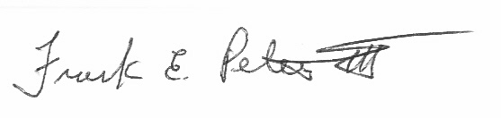
Frank E. Petersen, III
Director, Office of Quality Assurance
NASA, Office of the Chief Financial Officer
Suggested Vendor Contact:

Name: ___________________

Title:_____________________

Telephone: _______________

Fax: ____________________

E-mail address: ___________

___ Place an (x) here to indicate account has no outstanding invoices, debits, or credits.

CUSTOMER CONTACT CENTER STRATEGY

The NSSC Contact Center Service Delivery Guide provides details regarding menu positioning, routing, and escalation of inquiries for this activity.

SAMPLE OF VISIO CROSS FUNCTIONAL

FLOWCHART PROCESS FLOW



Office of the
Chief Financial Officer

Recovery Audit Program Administration Guidance

February 19, 2008
The National Aeronautics and Space Administration (NASA), Office of the Chief Financial Officer (OCFO) is responsible for complying with the Improper Payments Information Act of 2002 (Public Law No. 107-300). This law requires agencies to annually identify programs and activities susceptible to improper payments, estimate the annual amount of improper payments and submit that estimate to Congress. For improper payments that exceed $10 million, the agency must report the actions it is taking to reduce improper payments and address the root causes for the improper payments.

The Defense Authorization Act for Fiscal Year 2002 added a new subchapter to the 4 U.S. Code (31 U.S.C. §§3561-3567) that requires agencies that enter into contracts with an annual total value in excess of $500 million to carry out a cost-effective program to identify errors made in paying contractors and to recover amounts erroneously paid to contractors.

Federal agency guidance for adherence to these two laws is provided by the Office of Management and Budget (OMB) Circular A-123, Management’s Responsibility for Internal Control, Appendix C, Requirements for Effective Measurement and Remediation of Improper Payments. This OMB guidance governs the improper payment risk assessment process and reporting, and the recovery audit program of all Federal agencies.

This document provides internal NASA guidance on the implementation of NASA’s Recovery Audit Program.

References

Section 831 of the Defense Authorization Act (2002) “Recovery Auditing Act” U.S. Code (31 U.S.C. §§3561-3567)

OMB Circular A-123, Appendix C “Requirements for Effective Measurement and Remediation of Improper Payments”

NASA Financial Management Requirements Volume 15, Chapter 6 “Prompt Payment”

NASA Accounts Receivable and Write-Off interim policy dated June 12, 2007

Terms

Recovery Audit is a review and analysis of the agency’s books, supporting documents, and other available information supporting its payments that are specifically designed to identify overpayments to contractors that result from payment errors.

Payment errors are errors resulting in duplicate payments; errors on invoices or financing requests; failure to reduce payments by applicable sales discounts, cash discounts, rebates or other allowances; payments for items not received; mathematical or other errors in determining payment amounts and executing payments; and the failure to obtain credit for returned merchandise.

Overpayment is any payment in excess of the amount that should have been made under statutory, contractual, administrative, or other legally applicable requirements. See attached list of “Examples of overpayment types”. Examples of overpayments include but are not limited to: (1) a payment that is greater than the contractual value of goods received or services performed (2) an early or accelerated payment for goods or services, (3) a payment that does not properly deduct the full available discount.

Note: (2) Per FMR Vol. 15 Chapter 6: NASA shall make payments no more than seven days prior to the payment due date, but as close to the due date as possible, unless the agency head or designee has determined an earlier date is beneficial to the Government, on a case-by-case basis for specific payments. The Deputy Chief Financial Officer for Finance (DCFO (F)) must use this authority cautiously, weighing the benefits of making the payment early against the good stewardship inherent in effective cash management practices. Written determinations to approve early payments shall be retained in the payment file.

Note: (3) SAP system configuration deducts discounts for credit memorandums from the Net amount of the invoice versus the Gross amount. This is the result of a system configuration that is currently being addressed by NASA and therefore resulting errors should not be considered overpayments for recovery auditing.

All Collection activities for the purpose of the guidance will be performed by the NASA Shared Services Center to recover amounts erroneously paid to contractors.

Roles and Responsibilities

- The Office of the Chief Financial Officer (OCFO) has primary responsibility for general program oversight to include acting as the contracting officer technical representative (COTR), giving guidance to Center CFO organizations, and ensuring that Centers properly and consistently carry out their assigned responsibilities.

- The OCFO, Quality Assurance Division (QAD), ensures the execution of the program objective. This includes preparation of Agency guidelines, criteria for the determination, collection, and disposition of funds recovered.

- The Center Chief Financial Officer (CFO) reviews Contractor findings and supporting documentation and makes final determination whether recommended debts will be posted for collection following agency guidelines/criteria. See attached “Roles and Responsibilities”. The NASA Shared Services Center (NSSC) will handle all activities related to the collection of funds, including all correspondence with the agency’s contractors.

- The Contractor prepares and implements a recovery audit execution plan. The recovery audit execution plan includes methodology to; sample transactions, analyze discrepancies, and identify overpayments (i.e. payment errors) that are submitted to the Center CFO for review in accordance with NASA guidelines.

- The Recovery Audit Liaison designated by Center CFO is the point of contact for inquiries/requests from the QAD/Contractor. Unless otherwise specified, all documentation requests, submission of overpayment packages, dissemination of information, and correspondence with Contractors is routed through the Recovery Audit Liaison.

- The NSSC is responsible for mailing out the initial inquiry letters to selected vendors requesting a statement/reconciliation of NASA accounts. When debts are identified by the Contractor and validated by the Center CFO the NSSC will conduct collection activities to recover funds. After funds are received, the NSSC shall carry out appropriate disposition of the funds.

Scope of Recovery Audit

The recovery audit will focus only on completed fixed-price contract payments within a given fiscal year. Cost-type contract payments are excluded from the recovery audit scope because these contracts are already examined by DCAA and resolved through the contract closeout process.

Recovery Audit Procedures

The following information describes NASA’s procedures to identify, analyze, post, and collect erroneous payments on completed fixed-price contract payments.

NASA uses a Contractor to perform recovery audit services on a contingency basis. The Contractor shall employ statement and transaction audit procedures to identify possible payment errors. The Recovery Auditor develops and implements the following strategy for identifying contract overpayments.

- Prepare initial listing and letter to selected vendors requesting a statement/reconciliation of NASA accounts. The Contractor will follow-up via letter/fax/phone to non-responding contractors. Note: This is a standard industry practice used by Recovery Audit Contractors to identify payment errors. The Recovery Auditor is generally prohibited from making direct contact with Agency contractors; however, this exception is approved to expedite the gathering of needed information.

- The contractor will submit document requests related to possible payment errors to the appropriate NASA Center thru the NASA Audit Tracking System (NATS). Requests should be provided at least one week prior to the requested due date. Documentation that may be requested by the Contractor includes; contracts, invoices, purchase orders, receiving documents, and the actual payment(s) to identify possible payment errors. In the performance of this work the Contractor is prohibited from:

  - Requiring production of any records or information by the agency’s contractors. Only duly authorized employees of the agency can compel production of information in accordance with contract terms;
  - Establishing or otherwise having a physical presence on the property or premises of any other agency contractor for the purpose of performing the contract;
  - Acting as an agent for the Federal Government in the recovery of funds erroneously paid to contractors;
  - Using or sharing sensitive financial information with any individual or organization, whether associated with the Federal Government or not, that has not been released for use by the general public;
  - Disclosing any information that identifies an individual, or reasonably can be used to identify an individual, for any purpose other than performing the recovery audit.

- Once a payment error is identified, the Contractor calculates the amount of the overpayment. For any overpayment greater then $300, the information along with supporting documentation of the payment error is provided to the Center CFO for validation.

- NASA Center CFO’s or their designees will review and validate whether recommended debts are to be referred for collection or deemed invalid within 90 days, less time may be needed depending on the extent of verification required.

- If the Center CFO determines the debt to be valid, the item is referred to the NSSC for collection. NSSC is responsible for all collection, tracking, and reporting activities related to Recovery Audit referrals for collection. Note: a special mail stop for recovery audit collections should not be set up at the Center or at the NSSC.

- The Contractor will provide a “Weekly Summary of Recoveries” report on the status of ongoing recovery activities. The Contractor will provide an annual report to the OCFO by mid September of each year, on the results of the recovery audit. The results of each year’s recovery audit effort will be reported in the NASA Agency Financial Report.

Collection Procedures

NSSC shall carry out the collection of debts referred as a result of the recovery audit. Collection activities shall follow the NASA Accounts Receivable and Write-Off policy. Posting of collections in the core financial system shall be made in accordance with the Improper Payment Options document [see attachment 1].

Funds collected, administration expenses incurred, and contingency fee payments made as part of the recovery audit program shall be specifically accounted for. The identity of all funds recovered shall be maintained as necessary to facilitate the crediting of recovered funds to the correct appropriations and identify applicable time limitations associated with the funds recovered. The NSSC will provide a monthly accounting of all identified debts, amounts collected, and disposition of funds.

The Recovery Audit Contractor shall not make direct contact (verbally or in writing) with the agency’s contractors without consent from the Director QAD. All communications are to go through the Recovery Audit Liaison, NSSC, Center CFO or designee.

Use of Funds Collected

Funds collected under the recovery audit program shall be available for the following purposes:

- To reimburse the actual expenses incurred by NASA to administer the program.

- To pay contractors for recovery audit services.

Recovered funds that are not used to reimburse incurred administrative expenses or pay contingency fee to the recovery audit contractor:

- Shall be credited to the appropriations from which the overpayment was made, and will be available for the purposes and period for which such appropriations are available; or

- If no such appropriations remain available, the funds recovered shall be deposited in the Treasury as miscellaneous receipts.

In the event amounts recovered due to interim payment errors made under ongoing contracts (i.e., duplicate progress payments) are not available to pay the recovery audit fee, because these amounts are still needed to make subsequent payments under the contract; NASA will pay contractor out of the appropriate Center administrative funds.

Communication

The following outlines guidelines for communications between HQ, Contractor, and the Centers during the Recovery Audit.

The HQ Office of the Chief Financial Officer is responsible for the management of the Recovery Audit Program. HQ CFO provides input to the contracting officer in the selection of the Recovery Audit Contractor. Management of the audit is delegated to the Director, Quality Assurance Division (QAD). The Director, QAD oversees preparation of the audit plan and facilitates communications between the Contractor and Center personnel to obtain electronic and hard copies of documents. Recovery Audit issues that cannot be resolved between the Contractor and Center CFO are elevated to the Director, QAD for resolution.

An entrance conference will be held at each Center prior to the commencement of Recovery Audit activities. The purpose of the meeting is to clearly define the Contractor, Center, and HQ roles and responsibilities. The Center CFO will designate a Recovery Audit Liaison as the point of contact for all information requests.

The Director, QAD will provide periodic updates to the Center CFOs on the status of the Recovery Audit progress and audit results. The Center CFO will provide the Director, QAD with a monthly status report by the 15th day of each month for the previous month on recommended debts submitted by the Contractor for validation and status of collection activities.

Recovery Audit Contractor Contingency Fee Payment

Recovery Audit Collections are to be tracked separately; (1) to reimburse actual expenses incurred by NASA to administer the program (2) for calculation of the payment to the recovery audit contractor once the funds are actually recovered by NASA and (3) to ensure proper credit of any excess funds to the correct appropriation. OMB guidance requires all funds collected and all direct administration expenses incurred as part of the recovery audit program shall be specifically accounted for.

Following the recovery of the funds, the NSSC shall calculate the payment to the recovery audit contractor based upon contractual contingency fee percentage. The percentage shall be applied only to the principal amount collected. Interest or penalty resulting from debt collections shall not be factored into the contingency fee payment.

Corrective Action Plans

For each overpayment determined valid by the Center CFO, the recovery audit contractor shall analyze the reason payment error occurred, and recommend cost effective controls to prevent such overpayments in the future, as a normal part of their contract work. The Center CFO, in consultation with QAD, is responsible for taking appropriate action(s) to address the identified control deficiency to preclude future reoccurrence of the payment error. A corrective action plan shall be prepared and maintained detailing the following:

- Payment error identified
- Root cause of error
- Planned actions to address deficiency
- Responsible official
- Target completion date
- Actual completed date
- Evidence root cause has been eliminated

Corrective action plans shall be provided to the QAD no later than 30 days after the debt is determined to be valid by the Center CFO. Quarterly updates shall be provided to OQA on the status of corrective actions within the first two weeks of: January, April, July, and October. Unless otherwise approved by the OCFO/QAD, all corrective actions shall be implemented within six months of the Center OCFO debt determination.

ROLES AND RESPONSIBLITLIES CENTER CFO’S

- Recovery Audit Liaison

Center CFO’s will assign a recovery audit liaison to research recommended overpayments provided by the recovery audit contractor.

- Review of Proposed Overpayments

If the Center CFOs disagree with the contractor’s determination of an overpayment, they shall provide adequate documentation for justification of their determination of why they disagree with the contractor’s determination of an overpayment and maintain this documentation at the Center in accordance with retention requirements for official payment records.
A copy of the documentation justifying the invalidity of the proposed claim will be sent to the recovery audit contractor as requested.

- NSSC

Once debt has been validated, the NSSC will conduct collection activities to recover funds. After funds are received, the NSSC shall carry out appropriate disposition of the funds.

EXAMPLES OF OVERPAYMENT TYPES

- Invoices containing incorrect mathematical calculations
- Incorrect payment of invoice (i.e. incorrect vendor, payment of voided invoice, payment on closed contract, unauthorized charges on invoice)
- Multiple payments of one invoice
- Multiple invoices for a single charge due to different invoice numbers
- Multiple invoices for a single charge due to multiple mailing addresses
- Multiple invoices for a single charge with inconsistent product description
- Invoice containing improper taxation
- Invoice containing improper transportation charges
- Non-receipt of products/services contained in the invoice
- Restocking charge paid in error
- Payments made against an invoice and also paid by credit card or manual check
- Cash/Trade Discount Earned not Taken
- Cash/trade discount deducted at wrong rate
- Cash/trade discount repaid on return
- Cash/trade discount deducted repaid in error
- Cash/trade discount repaid credit memo
- Open credits/credit memos not deducted
- Interest penalty paid at wrong amount
- Interest penalty paid in error

Appendix D-Roles & Responsibility Matrix
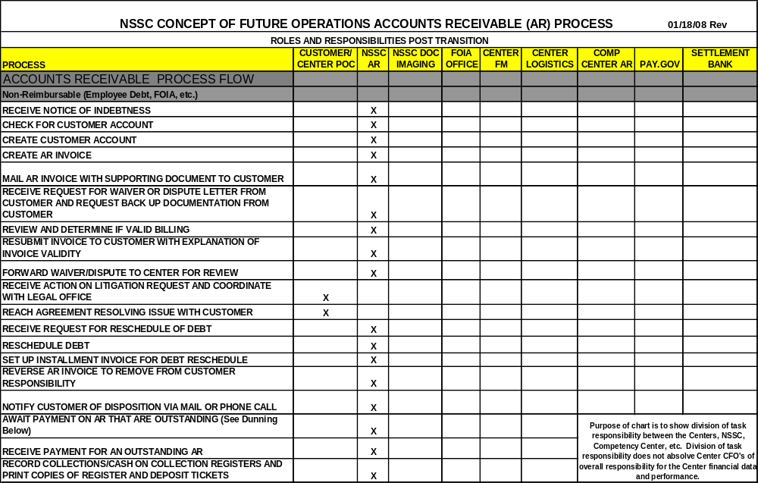
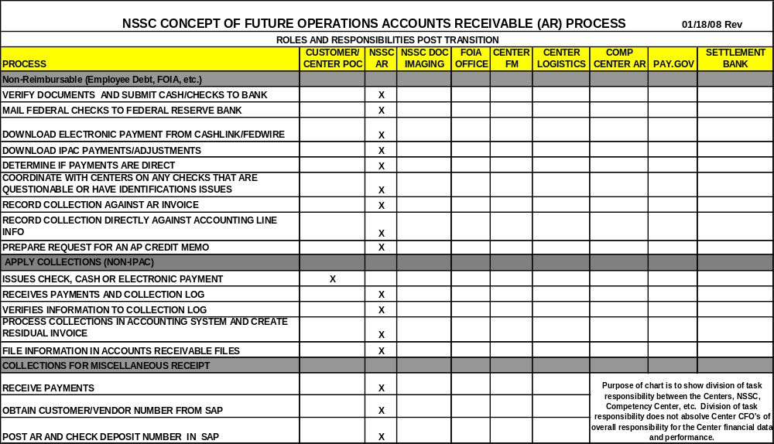
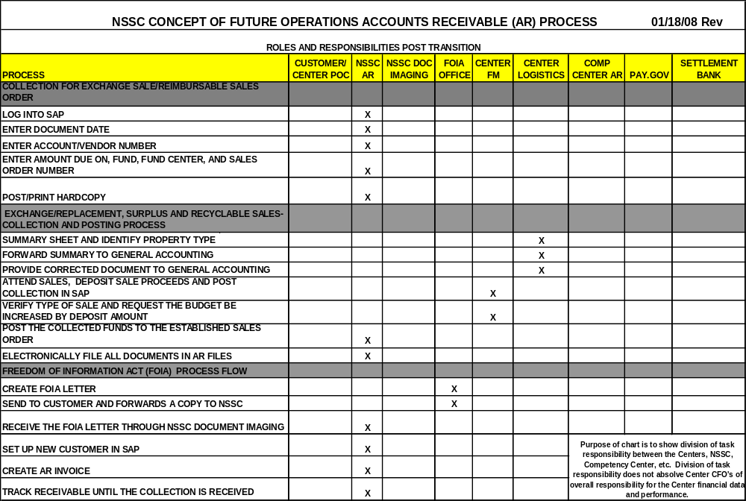
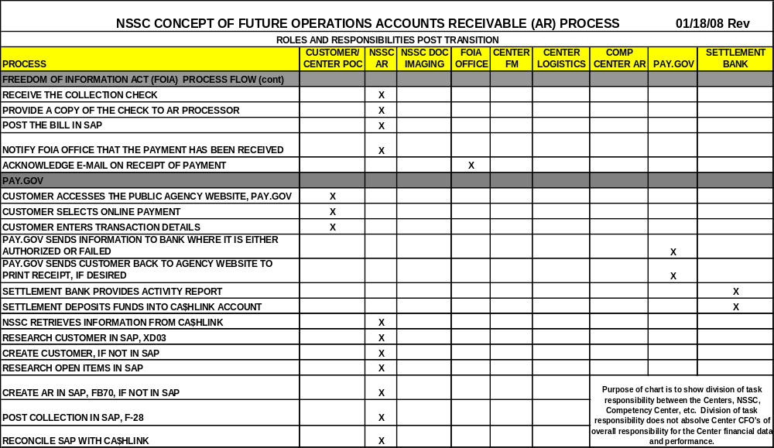
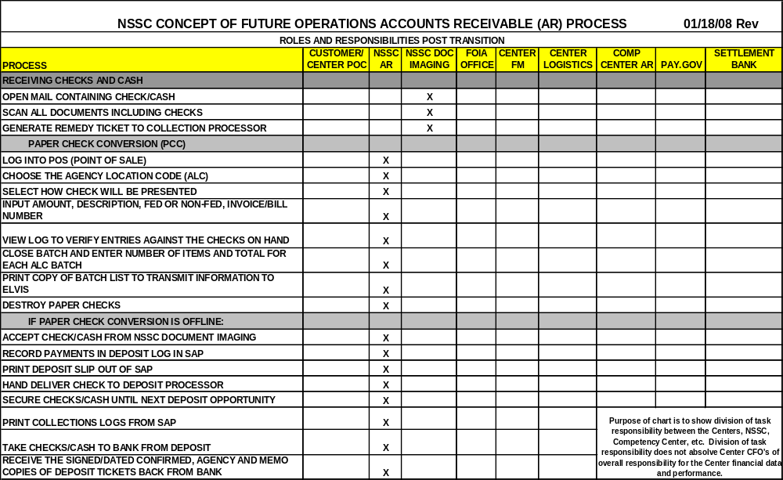
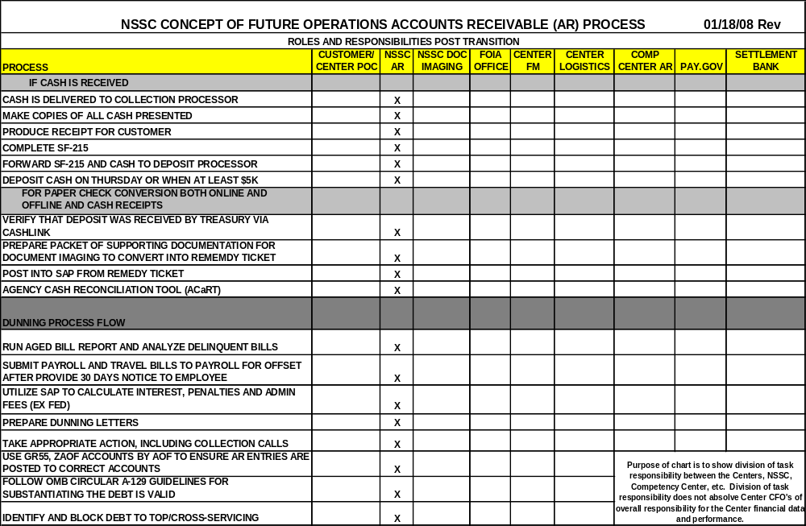
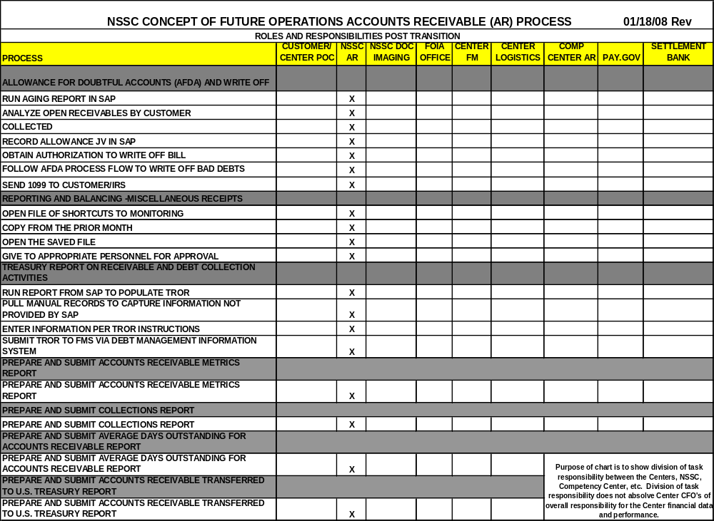

Appendix E-Dunning Letters
Date

_______ Center

Customer Number

Customer Contact
Customer Name
Customer Address
City, State Zip

FIRST NOTICE

Dear Madam,

This letter is to inform you that NASA has not received payment for the following past due bill:

Bill  Date | Bill  No. | Invoice  No. | Principal  Amount | Payment  Received | Interest  Accrued | Penalty  Accrued | Total  Amount
11/30/2007

Payment must be received immediately to preclude further interest charges as well as penalty and administrative charges.

Failure to pay a debt to the United States Government will result in referring your delinquent account to credit reporting agencies and initiating Federal offset. Additionally, NASA is required by the Debt Collection Improvement Act of 1996 to transfer any debt delinquent over 180 days to the Department of the Treasury for collection proceedings.

Please contact SSC Receivables Collector at 228-688-1628 with any questions or concerns you may have on this matter.

Sincerely,

Pamela Holloway, Senior Accountant
NSSC Accounts Receivable
________ Center Date

Customer Contact
Customer Name
Customer Number
Customer Address
City, State Zip

SECOND NOTICE

Dear Madam,

This letter is to inform you the following bill is seriously past due:

Bill | Bill | Principal | Payment | Interest | Penalty | Admin | Total
Date | Number | Amount | Received | Accrued | Accrued | Charge | Amount Due
10/30/2007

Interest is charged on your delinquent account as shown above. Additional charges will be assessed on payments received after the due date, including:

- Administrative charges; and
- Penalties, not to exceed 6% per year on any portion of the debt delinquent for more than 90 days, accrued from the date the debt became delinquent.

Remit payment immediately to:

NASA – Stennis Space Center
ATTN: Code BA22 – Collection Agent
Bldg 1100
SSC, MS 39529-6000

Failure to pay a debt to the United States Government will result in referring your delinquent account to credit reporting agencies and initiating Federal offset. Additionally, NASA is required by the Debt Collection Improvement Act of 1996 to transfer any debt delinquent over 180 days to the Department of the Treasury for collection proceedings.

Please contact SSC Receivables Collector at 228-688-2606 with any questions or concerns you may have on this matter.

Sincerely,

Pamela Holloway, Senior Accountant
NSSC Accounts Receivable
____________ Center Date

Customer Number

Customer Name
ATTN: Customer Contact
Customer Address
Customer Address
City, State Zip

THIRD NOTICE

Dear Madam,

This letter is to inform you the following bill is seriously past due:

Bill | Bill | Principal | Payment | Interest | Penalty | Admin | Total
Date | Number | Amount | Received | Accrued | Accrued | Charge | Amount Due
07/31/2007

Interest is charged on your delinquent account as shown above. Additional charges will be assessed on payments received after the due date, including:

- Administrative charges; and
- Penalties, not to exceed 6% per year on any portion of the debt delinquent for more than 90 days, accrued from the date the debt became delinquent.

Remit payment immediately to:

NSSC – FMD Accounts Receivable
ATTN: For the Accounts of __________Center
Bldg 1111, C Road
Stennis Space Center, MS 39529-6000

Failure to pay a debt to the United States Government will result in referring your delinquent account to credit reporting agencies and initiating Federal offset. Additionally, NASA is required by the Debt Collection Improvement Act of 1996 to transfer any debt delinquent over 180 days to the Department of the Treasury for collection proceedings.

Please contact NSSC contact Center at 877-677-2123 with any questions or concerns you may have on this matter.

Sincerely,

Pamela Holloway, Senior Accountant
NSSC Accounts Receivable

